BookTitle: Debt Chains: Breaking Free from Africa's Financial Struggles

Table of Contents
Chapter 1: The Historical Context of Debt in Africa 5
Overview of Africa's economic history and colonial legacy. 6
A Progression of African Economic History 7
- The Impact of Colonialism on African Economies and the Establishment of Debt. 8
IMPACT 10
- Key historical events that shaped Africa's financial landscape. 11
The enslaved person trade 11
The Scramble for Africa 11
Colonialism 12
The role of international financial institutions (the IMF and the World Bank) in African debt. 14
Who are the World Bank and IMF? 16
Policies from Bretton Woods Institutions 17
Interest Rates 18
Poverty: Debt Cycle of African Countries 18
There are Alternatives to Austerity 21
Solutions 22
In Summary 23
Change is possible 24
Jubilee 2000 - debt cancellation as a stepping stone 25
Climate reparations 26
Chapter 2: Understanding Debt: Types and Implications 29
Revisiting the Past 29
The Current Context 31
Fig: Sovereign Debt (% of GDP), 2010-2024 32
Composition of Sovereign Debt Service, 2000-2023 32
UNCERTAINTY ABOUT THE SOURCES OF NEW FINANCING 33
G20 DEBT SERVICE SUSPENSION INITIATIVE (DSSI) 33
COMMON FRAMEWORK FOR DEBT TREATMENT BEYOND DSSI 34
Who Lends to Africa? Types of Creditors 34
Multilateral Creditors 34
The International Monetary Fund 34
GENERAL RESOURCES ACCOUNT (GRA) 35
POVERTY REDUCTION AND GROWTH TRUST (PRGT) 35
RESILIENCE AND SUSTAINABILITY TRUST (RST) 36
The World Bank Group 36
THE INTERNATIONAL BANK FOR RECONSTRUCTION AND DEVELOPMENT (IBRD) 36
The World Bank's IDA owns most of Africa's external public debt held by multilateral creditors 36
THE INTERNATIONAL DEVELOPMENT ASSOCIATION (IDA) 37
THE MULTILATERAL INVESTMENT GUARANTEE AGENCY (MIGA) 37
THE INTERNATIONAL FINANCE CORPORATION (IFC) 37
THE INTERNATIONAL CENTRE FOR SETTLEMENT OF INVESTMENT DISPUTES (ICSID) 37
The African Development Bank Group 38
THE AFRICAN DEVELOPMENT BANK 38
THE AFRICAN DEVELOPMENT FUND 38
THE NIGERIAN TRUST FUND 38
Official Bilateral Creditors 38
AFRICA'S PUBLIC DEBT: THE MAIN CHALLENGE, 53 NOT PROPERLY ADDRESSED 39
Africa at risk of debt crisis due to debt servicing costs and structure 40
Debt crisis: multiple definitions give different accounts of the debt story 42
Debt and sovereignty: the "original sin 43
Tackling African countries' 500% debt premium 44
Africa: external public debt servicing cost as a share of government spending (2009-2024) 46
Africa's borrowing costs are too high 46
IMF conditionalities and surcharges further restrict African budgets 47
Top 20 countries: external public debt servicing cost as a share of total revenue (2024) 48
World regions: external public debt servicing cost as a share of total revenue (2024) 49
Chapter 3: AFRICA AND THE SUSTAINABLE DEVELOPMENT GOALS 54
Africa: total external public debt owed by creditor type (2009-2022) 54
Debtor-creditor relationship imbalance 54
African Eurobonds: foreign currency and credit rating risks 55
Africa: top 10 private creditors by ownership share of external public debt (2022) 55
China owns most of Africa's public debt held by bilateral creditors , 55
Africa: top 10 bilateral creditors by ownership share of external public debt (2022) 56
Debt restructuring, debt forgiveness, debt swaps 56
The G20's Common Framework: slow process, no common ground among multiple creditors: 56
Multilateral Development Banks: the need for more concessional loans: 57
Disagreements delay debt restructuring: Paris Club vs China 57
The Finance for Development Labs proposal: delayed debt repayment for greater fiscal space 57
SOMALIA: Somalia's debt: one of a kind 58
Foreign Direct Investment to the Rescue? 58
Foreign Direct Investment (FDI) vs Foreign Portfolio Investment (FPI) 59
Top 10 African countries: recipients of FDI (2022) 60
FDI to Africa declined by 44% between 2021 and 2022 61
African regions: FDI received (2021-2022) 61
Africa has some of the highest rates of return on investment globally , 62
African FDI remains mainly concentrated in the extractives and energy industries 63
G7 countries & China: total FPI in Africa (as of June 2023) 64
Top 10 African countries: FPI received from G7 countries & China (as of June 2023) 64
CASE STUDY: Investment in Africa: the growing prominence of Gulf investors 65
Africa: investments from Gulf countries by type of project (2022-2023) 65
AFRICAN RISK ASSESSMENT AND CREDIT RATINGS: THE PROBLEM CHILD 66
African countries: credit rating status (2023) 67
Top 10 African Countries: FDI inflows (2022) & credit rating from S&P, Moody's and Fitch (2024) 68
Only two African countries are classified as "investment grade" 69
How to improve ratings: Moody's viewpoint 69
Africa has more "speculative" rather than "investment grade" rated countries , 70
World regions: share of investment and non-investment ratings by S&P (2023) 71
Is there a Perception Premium? 71
Quis custodiet ipsos custodes? 72
Barriers to further investments 75
SPOTLIGHT: "Building bigger and better financial institutions: really?" 77
Selected world regions & countries: share of IMF voting rights (2024) 78
The World Bank's new "playbook" 78
IDA21 replenishment: the need to triple concessional finance to Africa 79
Progress is still slow for about 60% of MDB reform agenda items 79
Selected MDBs: progress across reform categories (2024) 80
Conclusion 80
CHAPTER 4: ASSESSING THE NEEDS: SDGs? 83
Let's turn to debt carrying capacity. 85
DEVELOPMENT: TRILLIONS NEEDED BY 2030 85
Africa: estimated financial needs and gaps from various sources ($ billion) (2020-2040) 87
Though highly variable, all figures point to substantial financial needs 88
Africa: annual GDP & SDG gross financial needs and net gaps ($ billion) (latest year available) 88
Africa: estimated financial needs by SDG (latest data year) 88
Infrastructure development in Africa: $360 billion needed by 2040 under the Programme for Infrastructure Development in Africa (PIDA) 91
The UN's SDGs: where do we stand two-thirds of the way to 2030? 91
World countries: SDG Index overall score (2023) 92
Is progress towards development-related SDGs ruling out progress in climate-related SDGs? 93
AU Agenda 2063 – 20 Goals 94
AU Agenda 2063 – 20 Goals 94
Selected African countries: Agenda 2063 FTYIP implementation progress (2022) 95
The Second Ten-Year Implementation Plan (STYIP) 96
CLIMATE: A COMPLEX FRAMEWORK, SEVERELY 23 UNDERFUNDED 97
First, a loss of continental GDP, up to $50 billion annually by 2030 98
Selected figures for climate-related costs 98
Between 2020-2030, to fulfil its NDCs Africa needs $2.8 trillion 98
Adaptation vs mitigation: in Africa, adaptation should get the lion’s share of climate finance 100
Africa: reported climate finance needs by type (2020-2030) 101
World regions: mitigation and adaptation financial needs as expressed in NDCs (2022) 103
World: development & climate finance (2009 & 2020) 104
Major emitter countries provide no financial figures to implement their NDCs 105
In the US' NDC, the following key sections are marked with "N/A": 106
Confronting Incoherence in Development Financing Discussions 106
Conclusion 108
CHAPTER 5: UNLOCKING DOMESTIC RESOURCES IN AFICA 111
Where is the Money? Youths? 112
Financing Agenda 2063: at least 75% expected to come from domestic resources according to the AU 114
PREVENTING LEAKAGES THROUGH ILLICIT FINANCIAL FLOWS 115
Africa: remittances, IFFs, ODA & FDI (latest data year 2020-2022) 116
The Yaoundé Declaration (2017) 116
Better data and stronger capacities are needed to tackle IFFs 117
Fighting Illicit Financial Flows: Tax Inspectors Without Borders, a concrete initiative 118
A straightforward idea… 118
…with amazing results 118
Selected African countries: inward and outward IFFs (2000-2021) 120
IFF enablers are mostly, but not all, outside the continent 120
World regions: number & location of enablers of IFFs from Africa (2023) 121
International cooperation is key to tackling IFFs 121
World countries: stance on the UN Tax Convention (2023) 122
The AU on IFFs 122
The EU on IFFs 123
The money is here 2,124
Conclusion 127
CHAPTER 6: THE MONEY IS HERE! WE NEED TO MOBILIZE IT 131
World regions: total revenue & population (2024) 131
African countries: total tax revenues as a share of GDP (2021) 132
Almost half of African citizens favour paying more taxes in exchange for more public services 133
Higher taxes with more services vs. lower taxes with fewer services, 18 countries, 2019/2020 133
Potential levers to increase tax revenue 133
Top 10 African countries: remittances inflows (2022) 136
World regions: remittances as a share of total revenue (2022) 137
Africa: the most expensive region to send money to 137
Africa’s sovereign wealth funds: an estimated combined worth of $120-130 billion, the lowest of any world region 137
Types of African SWFs 138
The Nigeria Sovereign Investment Authority (NSIA) 139
Nigeria Sovereign Investment Authority: portfolio distribution (2022) 140
African Sovereign Investors Forum attendees: Assets under Management (2022) 140
African SWFs’ limits and opportunities 141
The Santiago Principles: best practices set by global SWFs 141
World regions: total investments by pension funds in $ trillions (2022) 142
Selected African countries: share of Africa's public pension funds (2022) 143
Three main barriers for African pension funds 143
SPOTLIGHT: African High-Net-Worth Individuals (HNWIs): $2.5 trillion worth of liquid investable wealth 144
African Stock Exchanges: only 2% of the global stock market capitalisation 145
Selected African countries: market capitalisation of listed domestic companies (2022) 146
Sustainable bonds to leverage finance for climate and development: 146
Financing Innovation: Venture Capital’s Key Role in Africa 147
VCs play a crucial role in driving innovation by taking risks. By providing capital to young Error! Bookmark not defined.
But taking risks can come at a price. 148
Finally, mitigating risk to unlock 148
Out of adversity comes opportunity. 148
VALUING AFRICA'S ASSETS 148
Africa: share of global working age population (2024-2100) 149
World regions: share of global youth population (15-34 years) 149
Top 9 African countries: projected real GDP growth (2024) 150
Selected world regions: share of global export value (2023) 152
Selected world regions: primary commodities, precious stones & non-monetary gold exports (2022) 152
Selected world regions: Product Concentration Index, exports (2022) 153
Nigeria: Africa's top oil producer imports 95% of its refined oil 153
Western Africa: the most significant cocoa production in the world, but farmers are still in poverty 154
Regional integration: markets and value chains are crucial 154
Selected Free Trade Agreements: total population covered (2023) 155
The African Commodity Strategy (AU Agenda 2063) 155
Monetising Africa's green assets 156
Current green value chain projects in Africa 157
Green industrial policies and restrictions on raw exports 158
Leveraging Africa's natural resources wealth: governance is key 158
Selected African countries: Resource Governance Index, mining governance score (2017/2021) 159
Selected African countries: Resource Governance Index, oil and gas governance score (2017/2021) 159
Bilateral carbon credit markets offer Africa bigger returns 163
The Africa Carbon Markets Initiative (ACMI) 164
CONCLUSION: THE MONEY IS THERE. WHAT IS NEEDED IS A COMPLETE CHANGE OF PARADIGM 164
Conclusion 166
SPOTLIGHT: The potential of the Fourth Industrial Revolution (4IR) 169
Most donors are far from the 0.7% of national income to the aid target of 183
Africa received over 28% of global ODA in 2022 184
10 countries capture nearly 50% of total ODA to the continent 185
Top 10 ODA recipients in Africa (2022) 185
Top 10 ODA recipients in Africa in per capita terms (2022) 186
Africa: ODA received by donor type (2013-2022) 187
Of the top 10 ODA donors to Africa in 2022: 188
Top 10 ODA donors to Africa (2022) 189
China's ODA 189
Korea's ODA 189
Top 10 global ODA recipients by donor type 190
Is ODA money getting lost? 192
Health and education remain the main priorities of ODA to Africa from official donors 193
ODA broad sector definition 193
CLIMATE FINANCE SPOTLIGHT: 194
Africa: supply of climate finance (annual average for 2019-2020) 194
Major climate funds supporting sub-Saharan Africa 194
Conclusion 195
Book Conclusion: Towards a New Global System 199
Summary: Africa has the Capital it needs 199

Chapter 1: The Historical Context of Debt in Africa

Overview of Africa's economic history and colonial legacy.

Africa’s crushing debt is always in the headlines and is blamed for limiting the continent’s recovery and economic development. To blame Africa’s woes on debt alone is incomplete and misguided as a complex mix of issues ranging from poor governance and outright corruption which conveniently collides with poor political policies, which in turn hinders economy growth and create destabilizing economic problems. For black governed countries, debt is a legacy of historic exploitation of the resources from the world’s most deprived region. The impact of post and neo-colonialism are (were) pernicious, creating debt burdens that have made the links between debt burden and development issues persistent. Powerful governments, banks, and institutions indeed exploit and control the wealth of African countries, limiting their participation in the global economy and trading system.

Yes, the global South is in a debt crisis at a time when countries desperately need resources to address multiple crises, from economic transformation to climate emergency. Lenders are enjoying increasingly healthy gains from debt payments. For some countries in Sub-Saharan Africa, they spend more on debt than on essential sectors like healthcare, infrastructure, education and climate change mitigation and adaptation. This means ordinary people cannot send their children to good schools, businesses cannot trade across borders effectively, and women are left without healthcare. The most widely used and accepted narrative about unsustainable debt levels in the global south is a “technical” or financial management issue at best. At the other end, debt levels are driven by greedy politicians, on the fault of the "corrupt" and "incompetent" government of the global south.

However, these accounts fall short of providing the complete picture. They deny that colonialism played a part in the creation of the global south's debt and that strong governments, organisations, and banks still exploit it to siphon off resources and exercise influence over these nations now. Debt, in short, is about power. From France's use of debt to colonise Morocco in the early 1900s to Thomas Jefferson's suggestion in the nineteenth century to use debt to compel Native Americans to sell their land, we can observe instances of debt being used as a weapon against nations and communities throughout history.

To better illustrate how advanced economies and businesses have employed debt to maintain their dominance in the global system, it is essential to examine the experience of post-independence nations formerly colonised by advanced economies. By analysing debt from this angle, we can see how we must think more broadly about the issue of debt and how to address it in the global south.

We must equally stand with those of the global south, rather than depending on current colonial and neo-colonial decision makers such as the International Monetary Fund (IMF), World Bank and G20. We must support long-standing efforts designed to ensure a more equitable debt and economic structure that prioritises the welfare of African people and the environment.

A Progression of African Economic History
Much of the debate around Africa's economic and colonial history has focused on how colonial economic dynamics affected the economic lives of all dependent African nations. Throughout these years, several dependency theorists, such as Samir Amin, located the state of Africa's economic development in the 1830s (that is, the time when, according to historians, legitimate trade emerged in Africa). This period was instrumental in tracing how investment was driven by resource extraction to help underdeveloped African countries within the capitalist paradigm.

This drew, in part, from the work of pioneering scholars such as Kenneth Dike, who examined how palm oil exports from the Niger Delta in the 19th century offered a range of economic opportunities to small-scale producers. This pattern was mirrored across other parts of the continent. In this sense, Africa’s financial history can be located mainly in the 19th century. However, some scholars, such as Paul Lovejoy and Walter Rodney, did trace essential aspects of economic activity before the 19th century. This ushered in the first accounts of the first phase of Africa's economic transformation and its relationship with other world economies.

- The Impact of Colonialism on African Economies and the Establishment of Debt.
While many countries began gaining independence following uprisings against colonial rule, colonialism is still not a thing of the past. Our global system is organised along racist and colonial lines. In contrast, the international financial and economic system maintains this domination, with richer countries in the North dominating decision-making bodies such as the IMF and the World Bank. Meanwhile, this has kept economic development at a slower pace, with wealth plundered from poor countries. Within this global financial order, “Debt” emerges as one of the main tools to reinforce these economic structures. In fact, debt was used as one of the essential tools to ensure that developing countries begin their independence, saddled with debt. Africa did not make the West rich or developed, that’s for sure. But it made it richer and provided the foundations for faster, if not higher, growth rates. So, let’s see a few case studies of countries that became free and gained independence before being saddled with significant portions of debt.

HAITI: A debt of $150 million was imposed on Haiti. After independence, Haiti was imposed a debt of $150 million to compensate its French colonisers for the property they had claimed as their own, which included enslaved people and conquered lands. They argued that the wealth they gained by killing and pillaging the Haitians was expropriated due to independence. This colonial era debt imposed on Haiti to satisfy enslaved French person owners and France took 122 years for Haiti to repay. So, Haiti was free, but huge debts kept it in chains. At this point, Multilateral institutions did not propose low-interest loans or concessional loans to help Haiti. Haiti borrowed the money from French banks to repay French enslavers. Haiti's cost of independence was $150 million.

South Africa is another example of a country in the global south where debts incurred by its repressive and violent apartheid regime had to be repaid in post-apartheid South Africa. South Africa found itself with a £28 billion bill that destabilised it and slowed development. Today, this debt is estimated at £11 billion (borrowed funds to maintain apartheid) and 17 billion that the neighbouring states borrowed because of apartheid destabilisation and aggression. Once again, political freedom was wrapped in a bow with massive debt—because debt = power.

Let us go to Zimbabwe, which gained independence in 1980, and was immediately taken over by its colonisers, with a debt estimated at US$700 million. Colonial administrators left it and their counties were not asked to repay it, but Africans who were exploited, marginalised and courted for their influence (locally) had to repay this. Over the years, this debt accumulated, and the unjust, unfair, short-term, high-interest debt imposed a considerable repayment burden on the country in the early 1980s. Indeed, European powers intentionally mangled African economies once they chose to be independent. This made them into logical export-based economies, enabling them to earn foreign revenues and repay their debt. They began exporting fossil fuels, metals and cash crops to promote industrial development in Europe, and this continues today. Africa's top ten exports to Europe include X, X, X, X, X, X, X, with few cars, electronic products or industrial machinery exported from the continent.
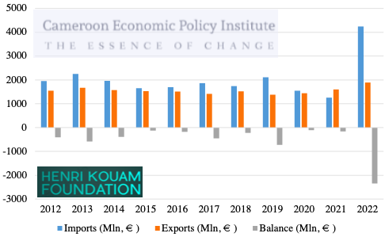

If we look closely at a country like Cameroon (the largest and most diversified economy in Central Africa), the majority of its exports to France include mineral Fuels, i.e., over 50%. This is followed by food and live animals, crude materials, and inedible and manufactured goods, which together contribute 4% of total exports (See chart below). This equally explains why Cameroon has a structural or persistent deficit with the European Union (See the Chart above). Cameroon exports products of very little value that are not transformed. This is not only driven by debt and post-colonial economic structures and inclinations, but also by other factors.
The business environment, the slow pace of digitalization, the lack of governance, and sluggish investment. However, a Western-centric world order (Now Changing) and post-colonial legacies are equally to blame for this slow pace of development. We should not forget that the manufacturing sector in Cameroon accounts for 13% of GDP, up from 17% in 1993 (World Bank, 2024),, while countries like South Korea and South Africa have stronger manufacturing bases, contributing X% and X% of GDP, respectively. Debt is one form of colonization while the

In Central Africa, colonialism took the form of a common currency backed by the French France after independence. This was driven by “La French Afrique”, the force behind the African Financial Community (CFA) franc monetary zone, which was fundamentally born of exploitative practices and dependence. This zone includes 12 countries and maintains their founding principles from the post-independence system, where 50% of their foreign currency reserves are held in the French treasury, with an additional 20% of reserves for financial liabilities. As a result, countries in the CFA monetary zone only maintain 30% of their reserves within their borders. Over the long run, this has caused direct economic consequences, including diminished per capita growth and reduced the capacity of these counties to implement policies that prioritise fighting poverty. The CFA franc causes huge outflows of capital due to the fixed exchange rate regime that forces capital to Europe, especially France. The cost of conducting financial transactions has not been well documented, but could easily equal 0.5% of countries budget over a ten-year period.

IMPACT
Among most black-governed countries, there is significant heterogeneity in their debt burden but the impact on their communities and citizens has similar patterns of vulnerability. High debt servicing costs, lack of debt structuring driven by unsustainable debt levels, have a profound impact on the human rights of African people. It significantly reduces countries' ability to raise and mobilise the resources required to realise higher standards of living, especially economic, social, and cultural rights.

The IMF has consistently imposed neoliberal policy reforms and structural adjustment programs during periods of debt crisis, driven by global inequalities and colonial legacies, as well as by inadequate and inefficient government institutions (although this is slowly changing). The structural reforms that were suggested to African countries during debt crises weakened labour standards and social protections through austerity measures that exacerbated poverty. These measures, suggested by multinational organizations, dispossessed many, entrenched inequality especially for women who bear the brunt of care work and are heavily represented in precarious informal work along with other communities. Unemployment, destitute and homelessness as well as malnutrition and starvation rose as a result of the debt burden. The youth became disenchanted due to the lack of opportunity and more attractive conditions abroad. Many of these youths continue to get exploited by traffickers and end up illegally crossing the border in Europe.

- Key historical events that shaped Africa’s financial landscape.

The slave trades
Sub-Saharan Africa’s engagement with Europe began with the slave trade. During the transatlantic slave trade, it is estimated that 12 million Africans were shipped to America in the most brutal human tragedies, while over 8 million were enslaved widely as a result of the East Africa, the Red Sea and Transatlantic slave trade.

Nunn (2008) merged shipment data on slaves’ ethnic affiliation with an anthropological map compiled by George Peter Murdock that delineated African boundaries and then examined the economic well-being and slave trade intensity. It is not surprising that there is strong negative correlation between slave trade intensity and GDP per capita. This reveals that enslavement of black people and others have lasting negative consequences. Given that African governments ae highly indebted, it is not surprising that lower GDP per capital levels prevents them from investing in vital infrastructure. Africa’s population was impacted in more ways than simply economic ones. However, the slave trade had a negative impact on social life, trust, underinvestment in education and financial development (Nunn, 2017).

The Scramble for Africa
Another aspect of colonization were the imprecise and absurd borders that carved out the continent in the late 19th century by our European fiends. For a largely unexploited continent, it was the British Prime Minister, Lord Salisbury who said “We have been engaged in drawing lines upon maps where no white man’s feet have ever trod; we have been giving away mountains and rivers and lakes to each other, only hindered by the small impediment that we never knew exactly where the mountains and rivers and lakes were”.
With a very few exceptions, these colonial borders in Africa have persisted to this day as African leaders and departing European did not want to engage with the issue since 1950’s. Economic underdevelopment was impacted by the division of states into parts, splitting ethnic groups and creating artificial borders that have slowed regional development and trade. War, repression and violence against Africans happened across these borders where ethnic groups that had similar cultures engaged in the most brutal civil wars. These were worse as they had an explicit ethnic angle.

Colonialism
Although the colonial era was short-lived, it had devastating effects on African countries following their independence. The old debate about the effects of colonization means that Africa is again in the spotlight as demonstrated by attacks against the statute of Belgian King Leopold who ruthlessly ruled Congo in the late 19th century to Cecil Rhodes – who was an epitome of imperialism. So let us summarize some important facts about this period;

- Colonial extraction, oppression and violence; Examples can be found in Congo with King Leopold’s rule int he 19th century (Lowes and Montero 2020) and the French repression in Madagascar (Garcia-Ponce and Wantchekon 2018).
- Indirect rule shaped both political and economic thinking and had lasting consequences as chiefs maintained their influence post-independence (Acemoglu et al. 2014), when the virtuous cycle of conflict-poverty-autocracy began.
- While the construction of colonial roads and railways (Jedwab et al. 2015) were beneficial, they were designed to transport cash crops to port, without accounting for country-wide connectivity o emerging economic poles (Huillery 2009). Their primary objective was the transportation of agricultural products.
- Christian missions also came and promoted religion, education and human capital (Wantchekon et al. 2014). Their influence is lasting and shaped African literacy, moral and gender roles (Nunn 2012). They equally formed the basis of social capital and interpersonal trust (Okoye 2020).

Through all this, European nations benefited and became very wealthy though exploited labor and resources. This enabled them to develop a range of technologies and skills that allowed them to rapidly grow and industrialized their economies. Meanwhile, they released vast quantities of greenhouse gasses into the atmosphere and caused the climate crisis that is having devastating consequences in Africa. In “How Europe UnderDeveloped Africa”, Even Walter Rodney, author of the Famous “How Europe Underdeveloped Africa” he argued and showed that development in the global north can be directly linked back to the resources of colonizing counties extracted during this period.

Cold war: During the cold war, Western and soviet countries provided support for black-governed countries through loans. Both authorities provided loans to African countries knowing well that some autocratic resources will plunder these resources for their personal gain, oppressing their citizens with impunity and without consequences. While many governments had to pay back loans that were given to, sometimes, corrupt leaders, African counties had to repay this debt. For example, in Congo, when Mbutu was made president forcing the anti-colonial Patrice Lumumba out of power, the French and the United States provided financial and military support. Mbutu was openly hostile towards communism and at the early years of his presidency openly supported the Western powers, who happily provided loans to quell any protest and allow a military leader to become president with no accountability towards his people.

Non-alignment: Indeed, there was some non-alignment. While most Western countries severed any relationship with Russia, African countries sought to do the opposite. Where Western powers could, they connived to replace such leaders as was the case in Congo where the United States and France helped Mbutu overthrow and allow the torture and killing of then president, Patrice Lumumba (a fervent anti-colonial president). Non-alignment went as far as Russia hosting an interparliamentary conference where Putin gave a speech that Russia-African ties have reached a new high. It was the sort of speech of “Friends with no limits” that President Xi Jinping gave regarding Moscow in recent years. Russia equally wrote off Africa’s debt accumulated during the soviet era – estimated at $20 billion.

So, it is evident that the debt burden of black governed countries resulted from the unjustified transfer of colonizers. Some countries inherited debt from the colonial era despite having no say about when, how and where this fund should be used. In some cases, such funds were used to oppress the people repaying them. Even so, these countries were hamstrung with debt obligations from departing colonialists. The erstwhile colonialists owe the Black governed countries a great deal of debt for the atrocities and exploitation they inflicted on our people. This debt remains unpaid and unrecognised. Conversely, it was the colonised that were coerced to indemnify the colonial master for their losses that they incurred when the enslaved gained their independence.

This essentially demonstrate that many newly independent countries were already lumbering in a detrimental inherited debt owed to the colonial powers, subverting their potentiality to develop while expediting European domination. Many Black governed countries began their independent status already with heavy debt burdens accrued by the former colonial powers. Democratic Republic of Congo is a case example how a brutal regime of King Leopold II and later the Belgian state accumulated astronomical amount of debts during their plundering of Congo’s enormous wealth. These debts included a 120 million loan from the world bank, which was primarily used to buy exported products from Belgium. When Congo gained independence in 1960 as Zaire, they had to inherit a debt accrued by Belgium paying for the cost of its own past exploitation. Crippling in debt, Congo had little fiscal space to provide robust vital services for citizens.

Things have changed. In fact in the last two decades, China has built the largest infrastructure projects in almost every country in Africa, within the backdrop of forging for a stronger comprehensive and cooperative strategic partnership. And also a shared history of anti-colonial struggle. This appealed so much to Africans, which has made Western critics unsettled, characterising it as debt-trap diplomacy. Chatham house debunked this claim that China is lending to poor countries intentionally, overwhelming them with unsustainable debts forcing them to surrender strategic assets- there could be a certain grain of truth in that. Chinese infrastructure projects have increased Chinese influence within the countries’ ruling elites. Again, debt is power, reason why every African country except Eritrea does not recognize Taiwan as an independent country. Debt can slowly create alliances that would have otherwise been absent.

The role of international financial institutions (IMF, World Bank) in African debt.

From the 1970s onwards, lending to counties in the global south boomed, especially from Western banks with loans to African and Latin Americans increasing fourfold between 1973-1979. But in the 1980’s the price of goods crashed and the increase in interest rates in the U.S. But the price of goods crashed in the 1980’s and an increase in interest rates means that many governments in the global south could no longer repay their loans. But in the 1980, the price of goods crashed and higher interest rates in the U.S. meant that global south governance could no longer repay their loans. Others had no choice but to default.

This posed a threat to the revenues and earnings of the global north – especially US and UK banks. The World Bank and IMF provided loans so that countries would not default and banks won’t get paid. We do not think it is cynical to think the IMF and World Bank were bailing out these banks in spite of their reckless lending that caused the crisis sin the first place. It is absurd that any African government's debt was not tied to the specific interest rate.

Naturally, these loans came with conditions. In order to get a loan, the borrowing nation had to implement a number of reforms that included cutting government spending, privatization and trade liberalization - with no consideration of local industry. These reforms were based on the idea that brutal economic reforms based on fee markets and the private sector was the best way to grow the economy.

While some us believe in free markets, some of us do not and think Africa should have been consulted and given the opportunity to develop in its own way. Africa was and is very communal, the Western countries blush about how wonderful and lovely the energy is here. Yet, when it comes economic negotiations, Africa’s culture and diversity is no acknowledged. It is incredibly presumptuous and intellectually pompous to assume that 54 countries with different cultures, ethnic tribes and groups will develop in the same manner. Capitalism in Sweden and Norway is different from that in the United States and Europe.

Who gave the West the Mandate to decide on Africa’s economic systems? Which other regions developed as a result of Western intervention rather than despite it?

Despite the promised benefits of said reforms, African economies stagnated, works right disappeared and inequality rose while health and educational outcomes fell off a cliff. A new era for Africa. The effects of these IMF reforms wee most felt in marginalized economies while elites and investors reaped massive rewards from such reforms. Some reforms forced African countries to digitize – which is good of4 the delivery of public services – but others caused the opposite. Asking Cameroon to move its manufacturing industry around the port of Douala was short sighted – it gave the government an excuse to develop roads slowly in rural areas and prevented manufacturing poles from developing in order parts of the county.

By mid-1980s, Jamaica’s healthcare sector was on the firing line due to high levels of debt. The IMF and World Bank imposed economic reforms with devastating effects for communities and society. In the health care sector, hospitals and clinics were shut and the cost of healthcare became expensive of the average citizen, undermining access of less fortunate communities. Global north counties seized the opportunities provided by the 1980 debt crisis to exert further control on the global south, reaping massive benefits without a regard for how people’s lives developed. After all, at 20 years old, there is no reason why these countries will already be saddled in debt. Secondly, we must never forget that Jamaica was still paying off their debt owed to French commercial banks. So, who are the IMF and the World Bank, anyway? Before we go any further, let us take a closer look at these “Bretton Woods” institutions.

Who are the World Bank and IMF?
The IMF and World Bank were created in 1944 to ensure a more stable global world order after World War II. Their primary objective was driven by the U.S. to establish a global financial and economy world order. Today, they are one of the most important financial institutions, even as regional institutions like the African Development Bank and the New Development Bank from the BRICS will be important players going forward.

Today, the IMF and the World Bank ae the most important global decision-making institutions and are still dominated by countries from the global north. For example, lower and middle-income countries make up 85% of the world’s population but have less than 50% of voting allocation in both institutions. The IMF and World Bank will remain pivotal in promoting global peace and stability, but their interest will be tilted towards the north and they will likely push brutal economic reforms in the global south.

Established in 1994 through the Bretton Woods Agreement, the International Monetary Fund (IMF) and the World Bank are central to global economic governance. While the United Nations (U.N.) has a clear charter, the

Despite being established within the United Nations and operating within its mandate, they are separate organisations with unique functions. With a goal of global monetary stability, the IMF provides member nations experiencing a balance of payments crisis with loans and policy recommendations. In contrast, the World Bank offers grants and loans to low- and middle-income countries for development initiatives to combat poverty.

Both organizations frequently carry out their projects in comparable ways, although having differing missions. The World Bank and IMF have worked closely with African nations to resolve debt issues since the 1970s, a time when interest rates and commodity prices rose sharply. However, as of 2024, the IMF owed $15.22 billion to African nations like Egypt, Kenya, and Angola.

Policies from Bretton Woods Institutions
The policies of the World Bank and the IMF are frequently set up to guarantee that loans or other forms of assistance generate profits. The Stabilization and Structural Adjustment Programs (SAPs), which were implemented in the early 1980s, were one such program that was intended to address the high commodity prices and interest rate surge in developing nations. SAPs were first introduced in Latin America, but they have since drawn a lot of criticism and concerns about their potential long-term effects. SAPs were designed to assist developing nations in obtaining loans with reduced interest rates. These loans did, however, have stringent requirements, requiring recipient nations to carry out particular economic changes. These included switching from food crops to cash crops in order to generate foreign exchange, lowering government expenditures on social programs, health care, and education, privatizing public businesses, and shrinking government workforces in order to save money.

These reforms have frequently had negative outcomes, especially in African nations. For example, when the government of Egypt eliminated subsidies on necessities in 1977—a requirement suggested by the IMF in order to obtain a loan—there were widespread demonstrations. This is but one illustration of how SAPs have caused social and economic upheavals, frequently making life worse for African inhabitants. There are questions regarding whether these programs actually serve the interests of developing countries because of the long-lasting detrimental effects of the pressure the World Bank and IMF put on governments to adopt these policies.

Interest Rates
High interest rates on loans are one of the main reasons African nations are still caught in a debt cycle with the IMF and the World Bank. For example, the World Bank charges rates as high as 6.59% for countries in Eastern and Southern Africa, while Jordan and Brazil have rates of 2.66% and 3.54%, respectively. Although a nation's economy and repayment history are taken into account when determining interest rates, African countries frequently face disproportionately higher rates. According to a report by Africa No Filter and Africa Practice, a "bias premium" costs African nations about $4.1 billion a year, underscoring structural injustices.

Despite the IMF's pledges to provide low-income countries with concessional, interest-free loans, these loans frequently have strict policy conditions attached. The International Bank for Reconstruction and Development (IBRD) and the International Development Association (IDA) are the two main organizations through which the World Bank offers loans. While the IDA serves more destitute countries, the IBRD concentrates on middle-income countries. African economies continue to bear the financial weight of these loans, which have variable interest rates determined on the state of the economy.
African nations are frequently caught in a debt cycle by these interest rates. Underdevelopment is sustained by the fact that many African countries take out emergency IMF loans to pay back commercial debts or World Bank loans. For example, the IMF-backed tax increases associated with a $3.6 billion loan recently sparked riots in Kenya. Comparatively, once the government reduced fuel subsidies, there was comparable upheaval in Nigeria. Furthermore, Nigeria's currency has lost value following a $2.25 billion loan from the World Bank. These organizations, according to critics, make economic misery worse; one analyst referred to the IMF as a "convenient scapegoat."

Poverty: Debt Cycle of African Countries
The financial burden that loans place on African nations is what links them to poverty. For instance, the World Bank is the biggest lender in Uganda, where foreign loans account for 61% of the country's total debt. Uganda borrowed $1.4 billion from the World Bank between 2018 and 2021. The public is greatly impacted by the debt load because the government is still required to repay the loans, even if the World Bank offered them at below-market rates.
By 2022, Uganda owed the World Bank $4.5 billion, which added to the country's $20 billion total public debt load, or $400 per person in the 48 million-person country. Debt repayments took up 47% of Uganda's GDP in 2023, which reduced funds for social programs, infrastructure, and healthcare, all of which have an impact on efforts to reduce poverty. Attempts to reduce poverty are further hampered by the austerity measures that the World Bank and IMF frequently "impose." A greater cost of living and higher inflation are often the results of policies like SAPs, which involve currency devaluation and reductions in subsidies. Low-income households are impacted since they spend the majority of their income on essentials like food and energy.

The "Fifty Years of Failure: the IMF, Debt and Austerity in Africa" report from ActionAid is based on compelling firsthand accounts from ten African nations as well as fresh research. It's scheduled to take place during the first IMF/World Bank Annual Meeting in Africa in fifty years. The study details how the IMF enforces austerity measures that jeopardize health, education, and general development throughout the continent. The IMF keeps enforcing cuts to public spending that disproportionately harm women and underprivileged groups, rather than looking for systemic answers to Africa's growing debt issue and considering clear alternatives like progressive tax changes.
Ghana, Kenya, Malawi, Nigeria, Senegal, Sierra Leone, Tanzania, Uganda, Zambia, and Zimbabwe are all included in this recent study. It reveals that eight out of ten nations have lately received advice to reduce or freeze wages in the public sector. The IMF did, in fact, successfully advise all ten nations to focus their public sector wage bill expenditure on frontline workers in the health, education, and other areas so that their spending would fall below the global average. This has led to wage freezes despite rising living expenses, the termination of frontline workers in certain countries, and recruitment freezes even in nations with severe shortages of teachers and healthcare professionals. Since they typically hold the most precarious employment contracts and comprise the bulk of frontline public sector employees, women have been disproportionately impacted.
Of the 35 low-income nations in Africa, 19 are in debt distress or at high danger of debt distress, despite decades of heeding the IMF's guidance. Due in large part to outside forces like COVID, the conflict in Ukraine, and rising interest rates worldwide, which they have little influence over, the majority of nations are currently dealing with a severe cost of living issue and mounting debt. African governments are frequently compelled to spend more on interest payments than on health or education. However, no significant attempt is being made to address the debt situation on a systemic level. Countries must bargain individually, as though they are solely to blame, and those who suffer the most are typically the ones who have the least.
A neo-colonial paradigm of economic development based on exploitation and extraction from the Global South has been imposed by the IMF and World Bank, leading to frequent debt and economic crises. In order to maintain dependency and deprive states of their ability through reductions in public spending, these crises have subsequently been utilized as justifications for imposing strict loan terms and coercive policy recommendations on African governments. Even though some of the language has altered recently, the IMF and World Bank continue to be associated with this austerity cult in practice, which hinders Africa's capacity to respond to and adapt to the climate problem and undermines advancements in public services like health and education. Giving loan after loan has turned into a tool for "the continued coloniality of the IMF," according to a recent statement made by Opa Kapijimpanga, founder of the African Forum and Network on Debt and Development. It is undoubtedly time to ensure the IMF learns from its mistakes after four decades of wasted progress in African development.
The hiring of teachers, nurses, midwives, and other public sector employees who are desperately required has been continuously hampered by IMF-imposed wage freezes and cuts, according to ActionAid's research. Women are the first to lose access to services, the first to lose possibilities for good employment, and the first to bear the increasing burden of unpaid caregiving and household chores, as we have observed.
Without access to low-cost financing, many African governments now find themselves facing a deeper debt crisis than ever before - with UNCTAD recently finding that the amount spent on interest payments is often higher than spending on either education or health. They observe that the current ‘inequal international financial architecture’ makes access to financing inadequate and expensive, meaning countries in Africa pay interest rates that are four times higher than the United States and eight times higher than Germany. Yet the IMF policy advice remains little changed, with countries forced to negotiate solutions one-by-one – denying the systemic causes of the debt crisis that clearly require a collective response.

Many African governments are currently dealing with a more severe debt issue than ever before due to a lack of affordable financing options; UNCTAD has discovered that interest payments frequently exceed spending on health and education. They note that access to funding is insufficient and costly due to the current "inequal international financial architecture," meaning that interest rates in African nations are eight times higher than those in Germany and four times higher than those in the United States. However, the IMF's policy recommendations haven't altered much, forcing nations to work out individual remedies while ignoring the systemic reasons for the debt problem that obviously call for a coordinated response. Beyond the common framework, we want a systemic approach to the debt crisis that radically changes the antiquated international financial system, especially by guaranteeing equitable participation for African nations.

There are Alternatives to Austerity
We are aware that there are alternatives to austerity; in fact, a significant IMF paper demonstrates that ambitious action to increase tax-to-GDP ratios is essential to financing the SDGs. However, in reality, the IMF does not advocate bold tax reform in Africa, instead favouring regressive taxes like VAT that shift the burden onto the poorest citizens. Instead, there are several progressive and gender-responsive tax options that can concentrate on obtaining funds for public services from the wealthiest people and businesses.
ActionAid released a policy brief earlier this year on the Vicious Cycle, which connects the debt and climate crises. The climatic catastrophe is accelerated by indebted nations' need to generate foreign exchange quickly, which they accomplish by investing in industrial agriculture and the extraction of fossil fuels. The IMF and World Bank currently exacerbate the situation by maintaining fossil fuel subsidies and by ignoring how debt is impeding climate adaption efforts. In the COP28 climate financing negotiations and other international forums, we urge our governments to acknowledge these links and prioritize debt cancellation and renegotiation. Grants and worldwide taxes, not loans, must be the foundation of climate finance, covering loss and damage. We must ensure that Banks in the global North fund African priorities while working with citizens to meet strict international standards that benefit our citizens over the long run.
Lastly, we urge African governments to acknowledge that the IMF and World Bank are essentially colonial in nature, having been established prior to the majority of African nations gaining their independence, as the leaders of these organizations gather once more on our continent. The IMF and World Bank's voting structures have essentially not altered since their founding, allowing the former colonizers to maintain a global system that disregards the voice, worth, and significance of the African continent. These organisations uphold colonial power structures, and their neoliberal philosophies are antiquated and unsuited to the demands of African nations or the twenty-first century. We urge African governments to forge a completely new course for the future, creating powerful, long-lasting nations that can provide high-quality public services and sustainable growth for everybody.
ActionAid demonstrates in Fifty Years of Failure that there are viable options for improving the public finances of African nations, particularly through bold and forward-thinking tax measures that target the richest people and businesses. According to an IMF staff analysis, countries should raise their tax-to-GDP ratios by 5 percentage points to finance the Sustainable Development Goals. But in reality, the IMF never gives this counsel at the national level; instead, it recommends austerity measures that reduce public spending rather than increase revenue. When the IMF does provide tax advice, it typically suggests regressive levies that harm the most vulnerable.
The fact that African nations still have very little influence over decisions at the World Bank and the IMF—they hold less than 10% of the vote on the IMF board—and that there are only two executive directors representing the 46 nations that make up sub-Saharan Africa exacerbates the situation. In fact, the IMF's basic voting system predates the independence of most African nations.
This study builds on a series of earlier studies, including The Pandemic and the Public Sector (2020), Who Cares for the Future (2020), The Public Versus Austerity (2021), and The Care Contradiction: The IMF, Gender, and Austerity (2022). As the IMF meets on African soil for the first time in fifty years, each of them presented strong evidence that the IMF and African countries need to take a different approach.

Solutions
In addition to providing financial assistance during crises like high inflation, rising expenses, and delayed development, the IMF and World Bank have a major impact on African economic policies. Many nations depend on these loans, despite their favourable terms. For example, after the 2011 revolution in Egypt and lower-than-expected income from the Suez Canal, Egypt was granted a $12 billion IMF loan in 2016. Ghana obtained a $3 billion loan in 2023 to deal with the issues that followed the COVID-19 pandemic. Ethiopia also received $3.4 billion following a commercial loan default. Even though these loans offer much-needed assistance, they frequently contribute to poverty and debt loads.

To lessen their dependence on foreign aid, African nations must advocate for policies such as open-border free trade, reduced loan terms, and lower interest rates. Such measures have the potential to transform loans into investments and boost the local economy. However, in contrast to Europe's open-border policy, which promotes smooth trade and cooperation, 46% of Africans still require a visa in order to travel within the continent as of 2023.

In Summary
Although the World Bank and IMF are vital in helping African countries in times of economic crisis, their loan programs and policies frequently feed a vicious cycle of debt and poverty. High borrowing rates and programs like SAPs have placed a heavy strain on African economies, causing social instability and delaying efforts to reduce poverty. Many nations are stuck in economic dependency as a result of these organizations' strict requirements, which frequently put financial stability ahead of long-term progress.

can chart a path toward financial independence and inclusive development.
African economies can attain sustainable prosperity by lowering their need on foreign loans and pursuing regional commerce through open-border policies. The continent can pave the way for equitable growth and financial independence by emphasising local solutions and bolstering intra-African collaboration.

“Plundering in the global south for profit in the global north”
In many ways, including debt, the global north forces continue to embezzle resources and income from the global south nations. Numerous studies have demonstrated that, rather than the other way around, the global south is really providing financial support to the global north. The governments of the worldwide south made enormous profits for lenders between 1970 and 2022 by paying an astounding $2.5 trillion in interest to creditors.

Strong lenders also have the authority to dictate how loans are used, frequently for their own gain. Many loans to Ecuador "were to be used exclusively for the purchase of materials from the lender nation, to be assembled in-country by workers from the lender nation, with advice provided by consultants from the lender country, to be transported to Ecuador via transportation companies registered in the lender country, with repayments to be made in the currency of the lender," according to Gail Hurley, a member of Ecuador's debt audit committee in 2005. We can see many examples of debt being used to line the pockets of wealthy lenders today:

Making money during a pandemic: Private lenders including banks, hedge funds, and oil traders—many of whom have their headquarters in the City of London—have been making an increasing number of loans over the past ten years. They offer high interest rates, so if they are repaid, they stand to gain a lot of money. Some people purchase debt at a discount when nations are having financial difficulties, and they benefit even more if the debt is eventually paid off in full. Private lenders declined to halt debt payments when COVID-19 struck, allowing the global south to free up funds to combat the pandemic. Zambia requested debt relief in 2020, but creditors turned down the proposal and demanded full repayment. If this happens, some lenders could make a 250% profit from their original loans.

Making nations pay for a catastrophe they didn't cause Countries in the global south are suffering the most severe effects of the climate disaster, despite the fact that governments and businesses in the global north bear the majority of the blame. The global north is unwilling to pay back the debt it has incurred for the harm it has created. As a result, in order to combat the climate problem, nations in the global south are being compelled to take on additional debt. Furthermore, assistance is primarily given in the form of loans, even in cases where governments in the global north claim to be helping countries in the global south combat climate change. Rather than pay any compensation for the damage caused to developing countries, rich countries ae using the climate crisis as another opportunity to saddle developing countries with debt and increase control of the global south – in line with expensive debt repayments.

Change is possible
Our global system is still dominated by global north powers. By taking advantage of and exploiting nations in the global south, they use loans and a variety of other instruments to uphold racist colonial power relations, keeping lower-income nations impoverished while enriching themselves. Rich lenders have rigged the system so they always win, while global south countries have been put up to fail and then blamed for their inability to repay loans.

“Debt took away control from impoverished people, keeping them trapped in subservience, all the time insisting that it is their own fault”, Kojo Koram.

It is possible to prevent the exploitation and extortion of debt. Debt cancellation to address the current crisis, systemic reforms to prevent reckless lending in the future, and broader efforts to transform the global system, including the creation of truly democratic decision-making processes and compensation from the global north to the south for the harm they have caused, are all part of the decades-long call by people in the global south and north to denounce debt as a colonial and neo-colonial tool. There are innumerable instances of hardships and triumphs that we can support and be inspired by.

Opposing the IMF The Bolivian city of Cochabamba's authorities were forced to sell the water system to a private business in 1999 as part of an IMF and World Bank loan, and they were unable to assist the populace when the water price unavoidably rose. Water costs had increased by up to 300% in a few short weeks. In response, Cochabamba residents organized the Coordinadora de Defensa del Agua y la Vida (Coalition for the Defence of Water and Life) and staged rallies, barricades, and strikes to close the city. The private water contract was terminated after months of protests that were violently suppressed by the Bolivian government.

Jubilee 2000 - debt cancellation as a stepping stone
Building on decades of debt justice activism in the global south, the Jubilee 2000 movement aimed to pressure governments and organizations in the global north to forgive debt for countries with overwhelming repayment obligations. Petitions and protests around the world mobilized millions of people. Because of this, 36 nations in the global south were able to pay off $130 billion in debt between 2000 and 2015, which allowed them to use the money for other vital services like health and education. Debt levels have once again reached perilous heights because, despite Jubilee 2000's pivotal role in achieving debt cancellation, decision-makers in the global north were not forced to confront the fundamental inequities that initially allowed debt to grow. The global debt movement is still pushing for a more equal financial and economic system because, while debt cancellation is an important first step toward achieving debt justice, it is insufficient on its own.

Climate reparations
A range of actions made to remedy past injustices and their contemporary manifestations are referred to as "reparations"46. Reparations for the impacts of slavery, colonialism, and neo-colonialism, as well as the consequences of the climate crisis, have long been demanded. These demands are growing in popularity as more and more organisations throughout the world urge wealthy polluting countries to provide climate reparations for the harm they have caused. This includes, but is not limited to, providing financial compensation to the countries and communities most affected by the climate crisis. As northern countries continue to refuse to make amends for the damage and expense they have inflicted, pressure is growing.

The demand for reparations is making its way into official climate decision-making platforms through global initiatives. At last year's COP26, the governments of Scotland and Wallonia were the first to pledge financial assistance for loss and damage in the global south.
• We insist that the IMF abandon the destructive neoliberal economic model and stop imposing restrictions on public sector wage bills and austerity measures. Instead, the IMF must support debt cancellation and bold, progressive tax measures both at home and abroad.
• We encourage nations in Africa to cooperate to address debt issues by drastic debt cancellation or renegotiation, particularly by bringing up this topic during climate negotiations. In order to create long-lasting and completely autonomous states, African nations must now investigate alternate economic paths that place a higher priority on social and economic justice as well as excellent public services.

Conclusion
The greater political and economic growth of Africa, which is firmly rooted in centuries of colonial dominance, exploitation, and the struggle for independence, is closely related to the continent's debt history. This chapter has shown that understanding Africa's current debt crisis requires more than just concentrating on recent financial mismanagement or governance failures. Instead, it is the result of a long and complex history in which extortion and control have been achieved through the use of debt by powerful nations and institutions.
External factors have influenced Africa's economic development ever since the continent's first contacts with Europeans during the slave trade. The transatlantic and other slave trades not only deprived the continent of millions of people but also seriously harmed its social and economic fabric. Underfunding of education, continuing wars, and weakened institutions were among the long-term effects of population decrease and the erosion of community confidence. These early upheavals paved the way for subsequent waves of colonisation, during which European powers created artificial nations and divided Africa without regard for local realities.

Systematic exploitation and extraction characterised colonialism itself. African economies were reshaped by European rulers to suit their own needs, with an emphasis on the export of raw goods such as oil, grains, and minerals. Roads and railroads were constructed to transport resources swiftly to ports for export to Europe, not to foster local development or link African communities. Rarely did the riches generated by Africa's resources benefit the local populace; rather, they supported European industrial expansion and affluence while keeping African communities impoverished and reliant.

During and after colonisation, debt evolved as yet another tool of control. A compelling example is the case of Haiti, which took more than a century to pay back the enormous amount it owed France for the "loss" of property, including enslaved people, after winning independence. Similarly, Zimbabwe's ability to invest in its people and economy was hindered by the $700 million in debt it inherited from the colonial Rhodesian government upon gaining independence. To sustain its repressive system, South Africa's apartheid government borrowed billions of dollars. At the same time, neighbouring nations were compelled to incur debt to protect themselves from its aggression.

These "odious debts," which were accrued by authoritarian and colonial governments, were frequently transferred to succeeding administrations, thus sustaining cycles of underdevelopment and dependency. Independence was not the end of colonialism's legacy. Rich countries continued to benefit from the post-World War II global economic structure. Global north-dominated organisations such as the IMF and World Bank enforced policies that frequently put debt repayment and macroeconomic stability ahead of social investment and development. African nations were forced to sell state assets, reduce public spending, and open their markets to international competition as part of structural adjustment programs in the 1980s and 1990s. Even though the goal of these policies was to spur growth, they frequently led to job losses, less access to healthcare and education, and a rise in inequality and poverty.

One notable illustration of the persistence of colonial-era financial systems is the CFA franc monetary zone. The requirement that member nations maintain a significant portion of their foreign reserves in the French treasury limits their capacity to respond to crises and maintain economic independence. This structure, which was created to help France, nevertheless depletes Africa's resources and limits its members' ability to make policy decisions. The human cost of debt is also highlighted in this chapter. Ordinary citizens suffer the most when governments are compelled to spend more on debt repayment than on necessary services. Austerity measures disproportionately affect women, children, and the impoverished, who experience hunger, increased unemployment, and limited access to essential services.

Disillusioned by the lack of prospects, young people are frequently motivated to travel overseas in search of better opportunities, occasionally becoming victims of human trafficking and hazardous migration routes.

In conclusion, Chapter 1 clarifies that recent errors or inadequate governance are not the only causes of Africa's debt crisis. It is the result of many years of external control, exploitation, and extraction. African nations' economies have been shaped by debt, which has also limited their capacity to make investments in their own growth. More than financial engineering or technical solutions are needed to address this dilemma; a fundamental examination of colonialism's legacy and a dedication to creating a more just and equitable global economic system are also necessary. The only way for Africa to escape the bonds of debt and build a future that genuinely benefits its people is to acknowledge and address this history.
Chapter 2: Understanding Debt: Types and Implications
The African continent is at a crossroads of potential and challenges, due to its abundance of natural resources, its fastest-growing economies, and its youngest population in the world. African nations must invest heavily in their human and physical resources, including infrastructure, health care, education, and—above all—energy, if they are to realise their full potential. Fundraising is necessary for this investment to ensure that Africa's development objectives are met without jeopardising its future. The African Development Bank (AfDB), for instance, estimates that infrastructure investment in Africa alone requires between USD 130 billion and USD 170 billion per year, with a USD 108 billion financing deficit (see African Economic Outlook 2018).

African nations must mobilise their own funds and attract significant external funding to raise this sum. The majority of these resources, both foreign and domestic, will be in the form of debt. Numerous African nations have benefited from debt in various forms, including private, external, internal, and official, since it has helped them reach their development goals and boost their overall economies. The rising debt levels, however, raise concerns, such as the high cost of debt servicing at the expense of funding other development initiatives. Effective macroeconomic policies, solid debt management procedures, and robust institutions are necessary to reduce such risks and enable debt to support economic growth in a positive growth cycle.

Revisiting the Past
Historical Context: It is crucial to understand the historical background of Africa's debt. To prevent making the same mistakes again, we must all learn from the past. Persistent structural flaws—including inadequate domestic revenue mobilisation, weak spending controls, weak growth, terms-of-trade shocks, susceptibility to climate and other exogenous shocks, and governance issues — have contributed to debt accumulation and difficulties in several African nations. Debt relief does not address the root causes of unmanageable debt accumulation. Many African nations' experiences after debt reduction programs like the Heavily Indebted Poor Countries (HIPC) Initiative were completed provide a stark reminder of opportunities lost. Over the past 50 years, the history of sovereign debt in Africa may be divided into discrete stages, each marked by notable advancements in how African nations have handled and responded to their debt loads.

1970s ― OIL PRICE SHOCKS, EASY CREDIT AND HEAVY BORROWING: Many African nations, particularly some that had just gained independence, took out large loans from commercial banks, the World Bank, the International Monetary Fund (IMF), and official bilateral creditors in the 1970s. Their goal was to provide funding for industrialisation and development initiatives. Many African nations were able to borrow large sums of money and drastically boost their public spending at this time due to the easy access to credit made possible by the international banking system's recycling of the massive surpluses of oil-exporting nations. The lenders themselves frequently promoted these loans as a way to boost economic expansion and advance the Continent. However, the 1973 and 1979 increases in oil prices negatively impacted African nations that import oil by raising energy expenses. These, along with fluctuating commodity prices, led to long-lasting imbalances of payments. The majority of African nations relied on external borrowing to cover financing shortfalls, although several implemented policy measures to address this issue.

1980s ― GLOBAL RECESSION AND A SHARP DECLINE IN NON-OIL COMMODITY PRICES
African nations, many of which had taken out large loans at variable interest rates, saw a dramatic rise in the cost of debt servicing during the early 1980s global crisis, which was characterised by high interest rates in industrialised nations. The ongoing drop in the price of non-oil commodities was another significant external shock to the African economy. Due to their reliance on the sale of a small number of primary commodities, many African nations experienced a decline in revenue while the costs of servicing their debt increased. The situation was made worse by external forces, as well as by economic mismanagement and unsuitable internal policies (such as excessively expansionary fiscal and monetary policies) implemented by certain African nations. Economic development stagnated, and many nations were unable to repay their loans, leading to arrears and further borrowing. In addition, several parts of Africa had a severe drought. Many countries defaulted on or restructured their obligations as a result of the convergence of these circumstances, which triggered severe debt crises across the Continent. With support from the IMF and the World Bank, numerous nations launched Structural Adjustment Programs (SAPs) in response to the escalating debt crisis, with the goal of stabilising economies and reviving growth through economic reforms. These initiatives, however, had societal consequences and varied in their success in restoring debt sustainability. Africa's "lost decade" of development prospects has been dubbed this decade.

1990s AND 2000s ― LAUNCH OF DEBT RELIEF INITIATIVES
The HIPC Initiative was started in 1996 by the IMF and World Bank to offer a comprehensive government sector debt relief framework in recognition of the unmanageable debt load on the world's poorest nations. Africa is home to thirty-three of the 39 qualifying nations. Countries had to fulfill specific requirements and pledge to carry out specific measures in order to be eligible for debt relief in order to take part in the HIPC Initiative. The Multilateral Debt Relief Initiative (MDRI) was established in 2005 to offer 100% debt relief on qualified loans, supplementing the HIPC Initiative to further reduce the debt of eligible countries. Except for Sudan and Eritrea, all eligible African nations had finished HIPC and obtained complete debt reduction as of March 2024.

The Current Context
Africa's sovereign debt has since increased to heights not seen in many years. As you can see from Figures 1 and 2, the average debt to GDP ratio in sub-Saharan Africa has nearly quadrupled, from 30% at the end of 2013 to nearly 60% by the end of 2022. The cost of repaying this debt has also gone up, and since the early 2010s, the ratio of interest payments to revenue has more than doubled, raising concerns about debt sustainability. Seven African nations were already in debt trouble as of November 2023, and 13 more were at high risk of becoming so, according to the IMF/World Bank.

Fig: Sovereign Debt (% of GDP), 2010-2024
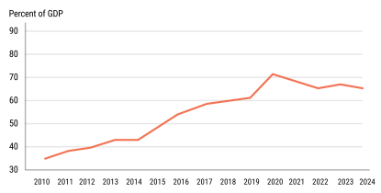
Source: AfDB Staff Calculations

Composition of Sovereign Debt Service, 2000-2023
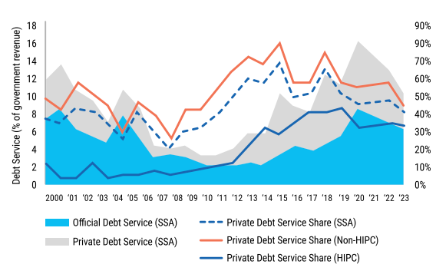
Source: World Bank

A SERIES OF GLOBAL SHOCKS
African nations have recently had to cope with the fallout from a number of international shocks, such as the COVID-19 epidemic, the Russian invasion of Ukraine, and the escalating crises linked to climate change. Global financing conditions have tightened, inflationary pressures have increased, and commodity prices have sharply increased as a result of these shocks. As a result, financial stress has increased and governments' budgetary circumstances have deteriorated, which has increased borrowing for national debt.

UNCERTAINTY ABOUT THE SOURCES OF NEW FINANCING
Beyond this, African nations are finding it more and more difficult to secure additional financing. Advanced economies' aid spending have decreased. China, one of Africa's biggest creditors, also seems to be cutting back on net payments to the continent. There are political and technical obstacles to reforms aimed at increasing the balance sheet and lending capacity of Multilateral Development Banks (MDBs), which have historically been big lenders to African nations. A higher interest rate environment than in the previous ten years has made it harder for many African nations to join financial markets. African nations' capacity to meet their current and future financial needs for growth, particularly those related to the Sustainable Development Goals (SDGs) of the United Nations (UN), is under jeopardy due to these issues.

International Response to Current Challenges
The international community has designed policies and initiatives to address these challenges. Let’s look at what is being done.

G20 DEBT SERVICE SUSPENSION INITIATIVE (DSSI)
The Debt Service Suspension Initiative (DSSI) was established in May 2020 by the G20 in response to the COVID-19 epidemic, at the behest of many of its leaders, the World Bank, the IMF, and civil society organisations. In order to focus their resources on combating the pandemic and protecting the lives and livelihoods of the most vulnerable, the DSSI gave IDA-eligible nations the choice to halt payments to official bilateral creditors between May 2020 and December 2021. The 30 African nations that took part in this program were given the choice to pay back any postponed debt service payments over a period of three years, with a one-year grace period following December 2021.

COMMON FRAMEWORK FOR DEBT TREATMENT BEYOND DSSI
In order to address the liquidity and debt sustainability issues that IDA-eligible nations confront, the G20 established the Common Framework for Debt Treatment Beyond the DSSI (Common Framework) in November 2020, building on the DSSI. Under this arrangement, qualified nations might request in a single forum to have their debt restructured under an IMF-backed scheme. As of March 2024, four African nations—Chad, Ethiopia, Ghana, and Zambia—had submitted applications to the Common Framework. In 2023, officials from the public and commercial sectors as well as debtor nations formed the Global Sovereign Debt Roundtable (GSDR) as a venue to debate how to improve stakeholder consensus and expedite the process of restructuring sovereign debt.

Who Lends to Africa? Types of Creditors

Multilateral Creditors

Multilateral creditors are official organisations with global or regional memberships that leverage funds contributed by their members to promote economic growth and stability through loan financing. Multilateral creditors are governed by their relevant legal and policy frameworks and may provide funding on both concessional and non-concessional terms. This chapter provides a brief overview of the most prominent (and most active) multilateral creditors in the African market.

The International Monetary Fund

The IMF, which was founded in 1944, works to keep the global financial and monetary system stable. As part of its mandate, the 190-member IMF conducts surveillance of its member states' economy, offers financial help to nations facing balance-of-payments issues, and offers technical assistance to promote prudent macroeconomic policy. Additionally, the IMF supports global monetary cooperation and financial stability. It serves to lower global poverty, encourages employment and sustainable economic growth, and enables international trade. In order to fulfill this mandate, the IMF may offer member nations financial support in accordance with two conditions set forth in its Articles of Agreement: Two Multilateral Debtors The goal of financial aid is to assist a member in resolving their balance-of-payments issue; it cannot be utilized for any other reason. Furthermore, the IMF offers crisis-affected member nations financial assistance to provide them breathing room while they put policies in place that bring back economic development and stability. Finally, in order to help avert crises, the IMF also offers precautionary finance. 1. As stated in table 1. IMF Financing Facilities and Instruments, the borrowing member nation is required to reimburse the IMF for the financial aid that was provided.

Members must carry out a program of economic, financial, and structural reform intended to resolve the underlying balance-of-payments or structural issue in order for the IMF to offer finance, including as a "lender of last resort." Following a request from a member nation, an IMF staff team meets with the authorities to determine the financial and economic reasons for any structural or balance-of-pay issues as well as the amount of funding required to fix them. After that, the IMF and the member government decide on a set of structural and economic policy changes. The IMF Executive Board is provided with this reform proposal to approve a supportive arrangement.

After approval by the Executive Board, if the member satisfies the "conditionality" of the reform program, it can subsequently obtain financing from the IMF. Through reviews, the Executive Board monitors how the reform initiative is being implemented. The IMF offers funding from several sources, including emergency aid.

GENERAL RESOURCES ACCOUNT (GRA)
A pool of currencies and reserve assets that represent the paid subscriptions of member countries' quotas make up the IMF's principal account. The IMF finances its normal loan activities from the GRA account.

POVERTY REDUCTION AND GROWTH TRUST (PRGT)
The PRGT is the primary means by which the IMF offers qualified low-income countries (LICs) concessional credit, currently at zero interest rates.

RESILIENCE AND SUSTAINABILITY TRUST (RST)
The IMF's Resilience and Sustainability Trust (RST), which has been in operation since October 2022, offers longer-term, reasonably priced financing to assist low-income and vulnerable mid-income nations in strengthening their ability to withstand external shocks that present macroeconomic risks like pandemic preparedness and climate change. Policy changes that the RST supports lower macro-critical risks related to climate change and disaster preparedness. Table 1 summarises the main terms and conditions of the IMF financing instruments. Facilities and Tools for IMF Financing in the "Multilateral Financing" Chapter.

The World Bank Group
Founded in 1944, the World Bank Group is an international development organisation with 189 member nations that consists of five institutions collaborating to find sustainable solutions. By providing loans to the governments of its less wealthy members to fund development initiatives, it seeks to alleviate poverty. The International Development Association (IDA) and the International Bank for Reconstruction and Development (IBRD) are the two main World Bank Group lenders to sovereigns.

THE INTERNATIONAL BANK FOR RECONSTRUCTION AND DEVELOPMENT (IBRD)
In addition to providing financial products (loans, guarantees, and risk management products) and knowledge and advisory services (including on a reimbursable basis) to governments at the national and subnational levels, the IBRD was founded in 1944 and provides creative financial solutions to middle-income and creditworthy poorer countries. It provides technical support and experience at every step of a project and finances investments in various areas. IBRD's resources facilitate international knowledge transfer and technical support while providing borrowing nations with the necessary funding.

The World Bank's IDA owns most of Africa’s external public debt held by multilateral creditors
The percentage of Africa's external governmental debt held by multilateral creditors decreased from 36.8% in 2009 to 34.1% in 2022. The International Bank for Reconstruction and Development (at 15.3%) and IDA (at 40.3%) of the World Bank Group held more than half.
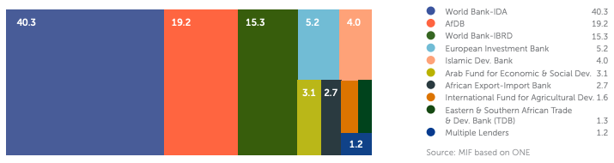

AfDB, African Export-Import Bank, Eastern & Southern African Trade & Development Bank, West African Development Bank, Economic Community of West African States (ECOWAS), Development Bank of the Central African States, and Central Bank of West African States were among the African multilateral institutions that held a quarter of Africa's external public debt held by multilateral creditors.

THE INTERNATIONAL DEVELOPMENT ASSOCIATION (IDA)
Established in September 1960, the IDA is tasked with providing assistance to the world's poorest nations. The IDA, which is supervised by 173 shareholder countries, provides grants for economic development initiatives and zero- to low-interest loans, or "credits," with the goal of reducing poverty.

THE MULTILATERAL INVESTMENT GUARANTEE AGENCY (MIGA)
MIGA was established in April 1988 to encourage international investment in developing nations by offering lenders and investors assurances (credit enhancement and political risk insurance).

THE INTERNATIONAL FINANCE CORPORATION (IFC)
The World Bank Group's private sector branch, the IFC, was established in July 1956 with the same goal of eradicating world poverty. It provides solutions through firm-level interventions, including derivatives, structured finance, blended finance, trade and commodities finance, equity investments, and investment services, including loans.

THE INTERNATIONAL CENTRE FOR SETTLEMENT OF INVESTMENT DISPUTES (ICSID)
ICSID is an arbitration organisation founded in October 1966 to resolve international investment-related disputes and facilitate conciliation between nations and foreign investors. See Table 2. IDA Lending Facilities and Instruments in the Chapter "Multilateral and Bilateral Financing" for additional details on the terms offered by these organisations.

The African Development Bank Group
The AfDB, the African Development Fund (ADF), and the Nigerian Trust Fund (NTF) comprise the African Development Bank Group (AfDB Group).

THE AFRICAN DEVELOPMENT BANK
The AfDB is an MDB established in 1963 to enhance economic conditions and reduce poverty in Africa. The bank was originally open only to African nations, but since 1982 non-African nations have also been able to join. The African Development Bank (AfDB) pursues its objective by lending to private businesses and African governments that invest in the bank's Regional Member Countries (RMCs) for projects and programs expected to support the continent's social and economic advancement.

THE AFRICAN DEVELOPMENT FUND
The ADF began activities in 1974 after being founded in 1972. In the 38 least developed African nations, the ADF fosters social and economic advancement. The ADF offers project and program finance on a concessional basis, unlike the AfDB.

THE NIGERIAN TRUST FUND
AfDB's low-income RMCs receive concessional financing from the NTF, a self-sustaining revolving fund established in 1976 by an agreement between the Nigerian government and the AfDB Group to support their development initiatives.

Official Bilateral Creditors
Bilateral official creditors are sovereigns or sovereign entities that lend to other sovereigns. Such loans are typically approved as part of the broader government-to-government relationship, which also involves greater political collaboration, trade, official development assistance, and foreign direct investment. Therefore, when evaluating the conditions of official bilateral loans, debt managers must take these different factors into account. A wide range of government institutions, including presidents, ministries of finance, foreign affairs, development, cooperation, and/or commerce, central banks, national development banks, export credit agencies, export-import banks, policy banks, and sovereign wealth funds, are involved in the granting of bilateral official loans. These government organisations have distinct goals, strategies, and incentives, which result in various loan terms that are covered in more detail in the "Types of Financing" section.

Given the complexities of governmental approval for each official bilateral creditor, it is imperative to understand the decision-making process for such financings. Last but not least, it's critical to recognise that, particularly about policy banks that may be state-owned but behave commercially, the distinction between official and commercial creditors has become more hazy in recent years. It is occasionally possible to distinguish between the various lending activities of an organisation that may perform some of its operations commercially while extending some of its loans on behalf of a government, such as through direct budget subsidies for concessional loans.

AFRICA'S PUBLIC DEBT: THE MAIN CHALLENGE, 53 NOT PROPERLY ADDRESSED
External public debt stock: tripled since 2009. Recent unanticipated and exogenous crises, such as the COVID-19 pandemic and the hostilities between Israel and Gaza, Russia and Ukraine, have compelled governments to raise public spending. Yet, economic activity has decreased, and access to markets has been severely restricted. As a result, the weight of debt and its repayment has significantly increased, particularly in low-income African nations. At this point, the sheer magnitude of the debt—and more crucially, the expenses of servicing it—as well as its structure, have made it extremely difficult for Africa to close the financial gaps required to achieve its development objectives. Since 2009, Africa's total external state debt has nearly tripled, from $220 billion in 2009 to $655 billion in 2022. Over the last decade, this is the highest level of public debt seen in Africa.

Fig X: Africa: total public and publicly guaranteed external debt (2009-2022)
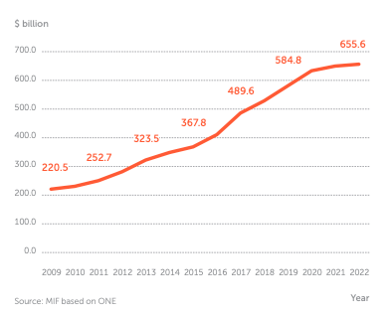

The majority of African nations are currently facing several issues that have a significant impact on their fiscal sustainability and capacity to make substantial investments, including increased debt vulnerabilities, poor mobilisation of private and domestic resources, higher borrowing costs, and a "big funding squeeze."

Africa is at risk of a debt crisis due to debt servicing costs and structure.
To properly depict Africa's debt trajectory, we will make every effort to keep it as visually appealing as possible. Because we borrowed too much, Africa is not in danger of a debt catastrophe. The reality of "interest payments" that Africans are required to make is overlooked in that oversimplified narrative. The IMF estimates that Africa's average debt-to-GDP ratio will be 68.6% in 2024. According to that figure, the continent still lags much behind several developed economies, such as the US (123.3%) and Japan (254.6%). Only two of the 52 nations for whom IMF data is available—Sudan and Eritrea, with 280.3% and 207%, respectively—are listed in the top 10 worldwide. However, a country's level of debt distress is not determined by its overall debt stock or debt-to-GDP ratio. According to a research by Debt Justice, which takes into account factors including debt structure and debt payments in proportion to revenue and exports, 28 African nations were "in debt crisis" as of 2022.

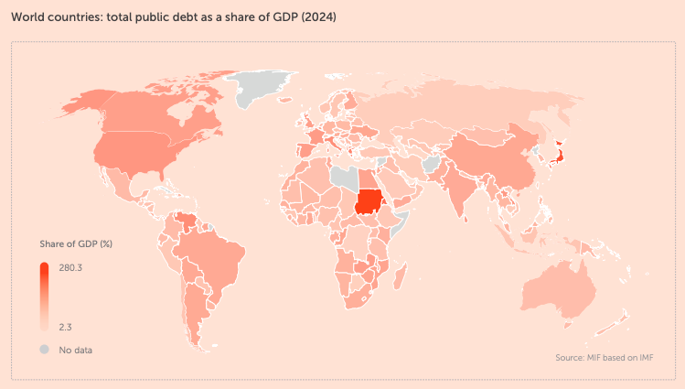

With a debt-to-GDP ratio of 280.3%, Sudan is the most indebted nation in the world; in contrast, 50 of the 52 African nations for which data is available have debt-to-GDP ratios below that of the US. As we talked about the dynamics of debt, I was worried about governance, efficiency, and the reliance on aid that has hampered infrastructure and health spending. But the perception of debt in industrialized nations differs from that of debt in Africa. Consider Japan, the world's second-most indebted nation that consistently maintains investor confidence. Japan's total debt is 2.5 times the size of its economy, making it the country with the second-highest debt-to-GDP ratio in the world at 254.6%. However, a number of strategies, such as borrowing at extremely low interest rates and making investments in high-risk, high-return assets, allow Japan's economy to maintain this high ratio, and investor confidence is also at an all-time high. One way to describe what the IMF refers to as the "Africa risk premium" is as outright, if not deliberate, ignorance. It's crucial to remember that different definitions, reports, and stories about debt tell different tales.

Debt crisis: multiple definitions give different accounts of the debt story
With five statuses—"No risk identified," "Risk of public debt crisis," "Risk of private debt crisis," "Both," and "In debt crisis"—Debt Justice offers a distinctive approach to determining a nation's financial situation. Debt Justice focuses on situations in which debt payments jeopardise a nation's economy or the government's capacity to defend the fundamental economic and social rights of its citizens, whereas the IMF focuses on whether a nation can pay its debt. Of the 28 African countries categorized to be "In a debt crisis" back in 2022, the IMF acknowledged that only eight of them were actually at risk of debt distress. This included countries like Congo Republic, Ghana, Malawi, São Tomé and Príncipe, Somalia, Sudan, Zambia and Zimbabwe. Remember that In 2022, only 9 out of 54 African countries were in no risk of debt crisis (See IMF Graphic below).
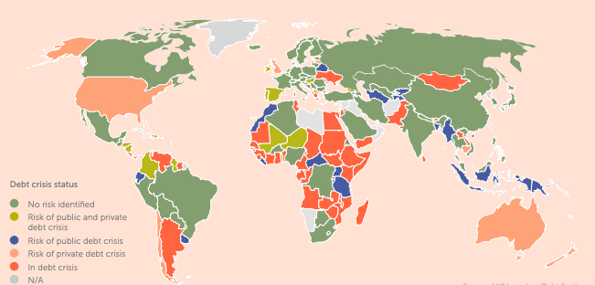

Debt Justice criteria for debt crisis status
Debt crisis | A significant financial imbalance with the rest of the world, such as a current account deficit that averages more than 3% annually for three years or a net foreign investment position of -30% of GDP or worse. | Significant external debt payments: nearly 15% of total government revenue is spent on foreign debt.
Risk of private sector debt |  | A high amount of private external debt is defined as more than 40% of GDP or 150% of exports.
Risk of public debt crisis |  | With a single economic shock, the IMF projects that external government debt payments will exceed 15% of government income (over several years); 40% of GDP or 150% of exports; or 10% of revenue.

Debt and sovereignty: the "original sin
National budgets are being subject to more stringent restrictions as a result of Africa's growing public debt and the ensuing increase in interest rates. As a result, states and individuals may believe that they have lost control, that they are not to blame for the decline in public finances, and that reductions in public investment and spending are negatively impacting them. If the sale of state-owned assets to the private sector is motivated by the state's pressing need for funding, it may be considered a surrender of sovereignty by the government. There are equally as many examples from the perspective of the citizens. Consider health care. In 2021, only 7.4% of the average African state budget was allocated to health care, despite increased spending driven by the COVID-19 pandemic. This is less than half of the goal set by the African Union's member nations in the Abuja Declaration 20 years ago.

The weight of debt repayment expenditure is one of the reasons for these insufficient amounts dedicated to health. Education is no exception. Admittedly, few African nations were meeting spending targets even before the COVID-19 pandemic. According to UNICEF, only 12 of the 52 countries for which data are available met at least one of the Incheon Declaration spending targets during the 2017–19 period, whether in terms of budgetary spending (15% of total expenditure), economic size (4% of GDP), or spending per capita. However, during the pandemic in 2020, education spending per capita decreased (by an average of 8% across the continent) and did not increase again.

The problem of debt-induced loss of sovereignty existed long before 2020. Debt, by definition, always entails a loss of sovereignty because it necessitates reliance on one's creditors. For instance, in 1850, the British navy blockaded the Greek port of Piraeus and captured it a few years later, in part due to an unpaid debt. The loss of sovereignty is genuine but less evident in many other situations. The United States forewarned Japan about the dangers of foreign currency debt as early as the second half of the 1800s.

Since then, the significance of a nation's capacity to issue debt in its own currency has been underlined repeatedly, to the point that this early challenge faced by growing economies has been dubbed the "original sin." When they take on debt, companies must therefore assume exchange rate risk, which exacerbates volatility and currency depreciation.

This risk is demonstrated by the fact that many African nations with flexible exchange rate regimes were unable to issue government bonds on global markets in 2022 and 2023. Before this, the "original sin" was brought to light by the crises in Asia in 1997 and in Latin America in the 1980s and 1990s. Following the latter, South Korea, China, Japan, and the ASEAN nations decided to accelerate the growth of local currency bond markets. Due to the involvement of a wide range of domestic and international investors, both private and public, many of these nations today have robust and liquid local bond markets. This is how many African countries will move forward.

Tackling African countries' 500% debt premium
Net financial flows to supposedly "developing countries" went negative in 2023. Now, debt service payments surpass aid and new debt issuances in terms of total amount paid. And that's before accounting for the effects of illicit financial flows. In 2022, more than one in five developing and emerging markets paid more to service their debt than they received from external sources. By 2025, this might increase to over one in three. Private investment in Africa has also fallen from $41 billion in 2021 to $22 billion in 2022, due to China's faltering economy and traditional donors spending more of their aid domestically on in-country refugee costs. This is taking place at a time when the African continent has substantial needs and opportunities.

Africa's population is booming as other regions struggle with ageing populations. Africa holds 60% of the world's solar potential and significant deposits of critical minerals essential for the clean energy transition. That youth boom is fuelling a cultural renaissance. From the Afrobeats artists that now fill stadiums in Europe and North America to the high culture of the Venice Biennale. So how do we channel investment towards harnessing these significant opportunities? The widespread perception that African countries have too much debt is incorrect. The truth is, they have debt that is far too expensive.

According to research by The ONE Campaign, African nations typically pay 500% more for Eurobonds than they would if they borrowed money from the World Bank. Three innovations in policymaking should be given priority by policymakers to cut costs. First and foremost, it is crucial to increase the multilateral development banks' balance sheets and lending rates. While the African Development Bank is experimenting with a hybrid capital model that leverages IMF Special Drawing Rights as collateral to secure low-cost financing on capital markets, efforts are already underway to better leverage current balance sheets. The G20 nations should immediately pledge to expedite these recommendations.

Second, we need to give priority to providing low-income countries with concessional financing through the World Bank's IDA Low-Income Country Fund. When IDA's shareholders gather in Korea in December, African leaders have demanded a $120 billion replenishment. Third, we require improvements in how credit ratings are handled across nations, and in the way prudential rules implemented in the wake of the financial crisis to safeguard the banking sector are impeding sensible investments in environmentally friendly technologies throughout Africa. These inventions are inexpensive, low-risk, and have the potential to pay off handsomely in the long run. All policymakers need to do is have the vision to put them into effect.
At a time when the need for social safety nets is growing, the increase in debt servicing payments has put a strain on Africa's state finances. The cost of financing Africa's external public debt is a startlingly high percentage of total government spending, total revenue, total expenditures, and total exports.

Africa: external public debt servicing cost as a share of government spending (2009-2024)
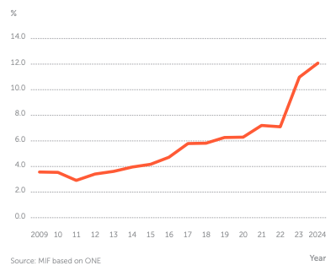

Since 2009, the share of financing Africa's foreign public debt in government spending has more than tripled. Countries have resorted to shift development funds to debt payments in order to reduce vital public spending. The continent's potential for prosperity could be jeopardized, its resilience to future shocks diminished, and the convergence of per capita incomes in many nations slowed in the face of high population expansion. The capacity to invest in climate change is diminished by debt servicing costs. In the next five years, 47 nations with a combined population of over 1.1 billion people may face bankruptcy as they seek to increase investment to meet development and climate targets, according to the Debt Relief for a Green and Inclusive Recovery Project. African nations account for 15 of the 20 nations with the highest debt servicing costs relative to total revenue worldwide.

Africa’s borrowing costs are too high
High borrowing prices, harsh terms and fees, and partner defaults are some of the main obstacles. African nations are spending four times as much in interest on loans as the United States and eight times as much as Germany, their European counterpart, according to UNCTAD. In comparison to global financial institutions like the World Bank, African nations are also paying foreign bondholders and other lenders, such as China, significantly higher interest rates. Twenty-five African nations spent more on debt payments than on health care between 2019 and 2021. Seven paid more for interest than for schooling.

IMF conditionalities and surcharges further restrict African budgets
Conditionalities associated with IMF loans usually include policy packages that promote deregulation, privatization, liberalization, and austerity. Thirty-three of the 39 IMF programs that were assessed had fiscal consolidation measures. Measures to control or lower public wages were implemented in thirteen African nations. While the majority of public spending cuts are intended to increase efficiency and transparency, human rights organisations have criticised some of these policies for harming low-income nations. The IMF levies surcharges, which are extra interest payments, on highly indebted borrowing nations based on the amount and length of their loans.

Long criticized for charging 2% or 3% interest on loans, the IMF takes limited funds away from other essential spending at a time when nations are already struggling with a lack of liquidity. They pertain to loans acquired through the General Resource Account (GRA) of the IMF, which manages the majority of lending activities in high- and middle-income nations. There have been increasing requests for the IMF to either completely stop surcharge payments or suspend them for a number of years, according to the Centre for Economic and Policy Research (CEPR). Africa accounts for 10 of the 23 nations that are expected to face a high or moderate risk of paying surcharges in the near future. These charges also discriminate against countries that are most in need of IMF financing.

Through 2025, the IMF will impose levies totalling more than $2 billion per year. Surcharges account for an average of 36% of all charges and interest payments to the IMF for countries that pay them, and 40.2% on average for the five most indebted nations. Interest rates on private external bonds are typically 6.2%. UNSG Antonio Guterres demanded a comprehensive overhaul of the world financial system in April 2024:
1. Increase the representation of developing nations in the global financial system;
2. Offer more affordable, long-term financing, primarily through MDBs;
3. Improve debt transparency, expand lending in local currencies, and create new debt instruments for more equitable and expedited restructuring procedures;
4. Temporarily halt IMF surcharges

"This vision and mission will test the sincerity of our ambition – it sets us on a journey that will require reimagined partnerships, a new way of working and thinking, an innovative plan to scale and replicate, additional resources, and optimism for what could be possible." Ajay Banga, President, World Bank Group

Top 20 countries: external public debt servicing cost as a share of total revenue (2024)

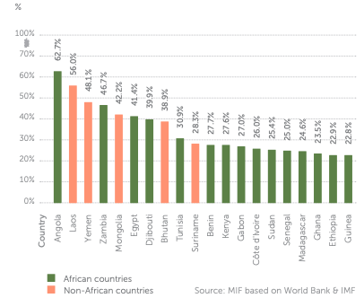

In terms of overall revenue, Africa has the highest external public debt payment costs worldwide. Africa spent 18.6% of its total revenue in 2024 on servicing its external public debt, which is over twice Europe's and more than twice Oceania's. Africa's external governmental debt as a percentage of exports increased from 74.5% to 140% between 2010 and 2022. As a result, the continent's debt service expenses have increased faster than the rate at which it acquires the foreign currency needed to pay down its external public debt. Due to significant foreign public debt service obligations over the coming years, Africa is in a difficult situation.
The expense of servicing foreign public debt accounts for between 5 and 20% of total expenditures in more than half of African nations. Only three countries—Algora, Botswana, and Zimbabwe—are below 5%. Africa's annual governmental debt servicing costs in 2021 were five times higher than those in Asia and accounted for nearly 15% of the continent's overall revenue. 25 African nations spent more money on debt service payback net interest than on health care between 2019 and 2021. At 72.1% of its total public spending, Angola has the highest external public debt servicing costs.

World regions: external public debt servicing cost as a share of total revenue (2024)
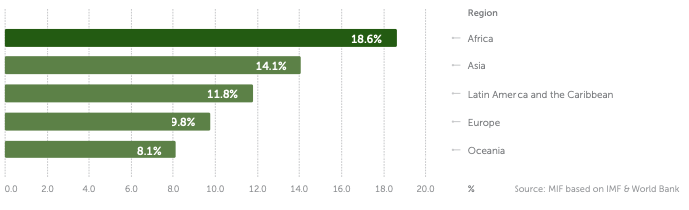

Conclusion
This chapter explores the intricate connection between Africa's debt and its colonial past, contending that debt is a potent instrument that continues to shape the continent's political and economic landscape rather than merely a financial burden. The chapter traces the origins of Africa's debt issue to centuries of exploitation, structural inequality, and the continued influence of former colonial powers and international financial institutions, challenging the prevalent narrative that attributes it to contemporary corruption or poor management.

The chapter begins by noting that debt is frequently presented in the media and in policy debates as a managerial or technical issue, or as the outcome of subpar governance in African nations. But this perspective is not comprehensive. According to the chapter, debt is essentially about power—who controls the resources, who makes the decisions, and who gains from the international economic system. The chapter shows how debt has been used to extract wealth from Africa and keep wealthy nations and businesses in power, examining the structural and historical factors at work.

The Colonial Blueprint: Exploitation and Economic Restructuring
The chapter examines how European powers methodically reorganised African economies to suit their own interests throughout the colonial era, when Africa's debt crisis first began. Diverse, self-sufficient cultures were turned into economies centred on the export of raw goods —such as grain, minerals, and oil —by colonial rulers to support the expansion of European industry. Roads and railroads were constructed to transport commodities swiftly to ports for export, not to link African communities.
African nations were reliant on a small number of exports and exposed to fluctuations in world prices as a result of this extractive paradigm. Additionally, it hindered the growth of regional industries and diverse economies. Since newly independent nations inherited economies built for extraction rather than self-sufficiency, these trends continued even after independence.

The chapter offers striking illustrations of the imposition and upkeep of colonial debts. One of the most notable is Haiti, which was compelled to pay a staggering $150 million to French enslavers to make up for their "losses" after gaining independence from France. Haiti's economy was hamstrung for generations by this debt, which took more than a century to pay off. The colonial Rhodesian government also left Zimbabwe with a $700 million debt, which hindered its progress from the moment it gained independence. To sustain its repressive system, South Africa's apartheid government borrowed billions of dollars, and surrounding nations were compelled to incur debt to protect themselves from its aggression. As a result, the region now owes £28 billion.

The CFA Franc Zone: Modern Colonialism in Disguise
The CFA franc monetary zone, which still ties 12 former French colonies to the French treasury, is one of the chapter's most illuminating examples. Member nations have only a small portion of their own resources under this structure, since they must maintain up to 70% of their foreign exchange reserves in France. Created to guarantee French dominance over African economies, this system continues to deplete the continent's resources and restrict member states' capacity to invest in growth or respond to emergencies. The chapter argues that the CFA Franc Zone is an obvious example of how colonial-era financial systems persist and threaten Africa's economic autonomy.

The Slave Trades and the Scramble for Africa
In addition, the chapter examines the historical causes of Africa's economic problems, emphasising the destructive effects of the slave trade and the arbitrary borders established during the Scramble for Africa. Millions of Africans were forcibly transported to the Americas, the Middle East, and other places between the 16th and 19th centuries. In addition to reducing the continent's population, this enormous migration damaged societal structures, undermined confidence, and prevented funding for development and education.

According to the research presented in the chapter, today's economic well-being is strongly correlated with the areas most affected by the slave trade. Underdevelopment, weakened institutions, and ongoing warfare are some of the long-term effects of population decline and the trauma caused by the slave trade. European powers divided the continent during the late 19th-century Scramble for Africa, paying little attention to local conditions. They frequently drew borders that divided ethnic groups and established fictitious governments, laying the groundwork for future instability and conflict. These borders, which still exist in considerable part today, play a significant role in Africa's continuous conflicts over economic fragmentation, repression, and war.

Independence and the False Promise of Freedom
The chapter argues that, although there was hope and optimism following the end of colonial rule, achieving economic freedom remained difficult. Along with colonial borders and economies reliant on exports, the new African governments also inherited the debts and responsibilities of their previous overlords. The international community, represented by organisations like the IMF and World Bank, has frequently maintained its control over economic policy, giving debt repayment and macroeconomic stability precedence over social investment and growth.

The chapter talks about how Africa's financial situation became even more complex during the Cold War. Both Western and Soviet nations provided African states with funds and assistance, frequently endorsing authoritarian administrations that prioritised allegiance over sound governance. With little regard for the money's intended use or potential benefits to the populace, many of these loans were purposefully made to dishonest officials. New governments were left to pick up the pieces when these regimes fell because their debts remained.

Structural Adjustment and the Human Cost of Debt
The chapter's primary focus is on the effects of the World Bank and IMF's structural adjustment initiatives from the 1980s and 1990s. These initiatives forced African governments to expose their economies to international competition, privatise state-owned enterprises, and reduce spending. Although promoting prosperity and restoring economic stability were the declared objectives, the reality was frequently disastrous for ordinary people.

The chapter details how austerity measures led to job losses, reduced access to health and education, and increased poverty and inequality. Social protections were weakened, labour rights eroded, and entire communities were left without support. Women and young people were particularly hard hit, facing rising unemployment and limited opportunities. The chapter argues that these policies failed to address the root causes of Africa’s debt crisis and instead deepened the continent’s dependency on foreign aid and loans.

Debt, Human Rights, and Social Justice

The significant effects of debt on social justice and human rights in Africa are highlighted in the chapter's conclusion. The most vulnerable—women, children, and the impoverished—suffer the most when governments are compelled to spend more on debt repayment than on necessary services. Social discontent, hunger, and unemployment have all increased as a result of austerity measures. Disillusioned by the lack of prospects, many young people are motivated to travel overseas in search of better opportunities, frequently running the risk of being used and hurt. The chapter makes it abundantly evident that debt is a problem of justice, human rights, and dignity rather than only an economic one.

Governments' capacity to invest in and defend their citizens' rights is weakened by unmanageable debt levels. Africa's ability to fairly participate in the global economy is restricted, and dependency is maintained by the continuous use of debt as an extraction weapon.
In conclusion, Chapter 2 of Debt Chains offers a powerful critique of prevailing theories of Africa's debt problem. It demonstrates how the continent's colonial past and the current systems of global inequality are intricately linked to debt. The chapter urges a reconsideration of debt as a matter of power, justice, and solidarity rather than as a management or technological one.

The chapter argues that Africa requires more than debt relief or new loans to escape the bonds of debt. It necessitates a comprehensive overhaul of the world economy, one that puts the welfare of people and the environment first and acknowledges the problem' historical causes. The chapter concludes with a call to action: to help African nations fight for economic justice, to oppose the influence of former colonial powers and international financial institutions, and to create a more fair and just world for everybody.

Chapter 3: AFRICA AND THE SUSTAINBALE DEVELOPMENT GOALS

Current relief options are hampered by the complexity of Africa's foreign public debt problem, which is not solely a function of its volume. In 2022, private creditors held the majority of Africa's external public debt, whereas in 2009, bilateral creditors held the majority. In fact, from 2009 to 2022, the amount of debt held by private creditors more than quadrupled. Private creditors held 43.1% of Africa's foreign state debt in 2022, compared to 24.8% in 2009.

Africa: total external public debt owed by creditor type (2009-2022)
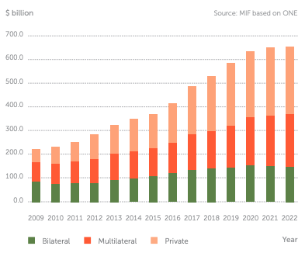

Debtor-creditor relationship imbalance
Since 2012, the majority of Africa's debt has been held by private creditors. Bondholders possess a significant amount of this debt; in particular, they own 28.5% of all foreign public debt in Africa. The makeup of creditors is crucial in discussions since many African nations would need to restructure their debt in the upcoming months and years. The voluntary involvement of bondholders in restructuring leaves debtor nations at their mercy. It has been argued that this debtor-creditor arrangement favors bondholders and their obligations to their parties, while rarely acknowledging the debtor's obligations to the public.

African Eurobonds: foreign currency and credit rating risks
Africa’s debt structure has changed rapidly as borrowing from private creditors has increased, mostly in the form of Eurobonds. While Eurobonds provide much needed liquidity, they are issued in foreign currencies, exposing debtor countries to exchange rate risks that exacerbate existing vulnerabilities. In contrast to domestic debt, external debt cannot be inflated away,, and in the case of local currency depreciation, it becomes more expensive to service.

Africa: top 10 private creditors by ownership share of external public debt (2022)
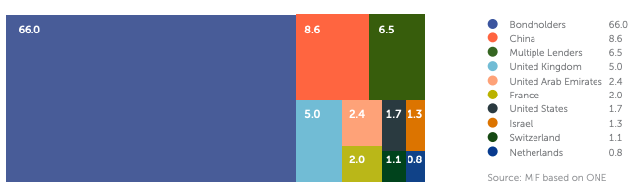
African nations began issuing more Eurobonds with 10-year maturities in 2013, resulting in a mountain of sovereign debt repayments due in 2024–2025. This has put additional pressure on budgets and the ability to make payments. Respecting maturing debt is essential for future access to foreign funding since it shows the market how committed a nation is to managing its own debt. However, favourable conditions and respectable credit ratings are necessary for a triumphant return to the market and the issue of Eurobonds. In 2021, there were $136.2 billion worth of outstanding African Eurobonds, with just four nations—Nigeria, South Africa, Egypt, and Morocco—holding 57% of the total. Two thirds of Africa's foreign state debt, which is held by private creditors, is owned by bondholders.

China owns most of Africa's public debt held by bilateral creditors
Bilateral creditors held 22.7% of Africa's external public debt in 2022, a nearly 16% decrease from 2009 (when they held 38.4%). With 42.2% of Africa's foreign state debt held by bilateral creditors, China held the highest share, followed by Saudi Arabia (8.0%) and France (10.0%).

Africa: top 10 bilateral creditors by ownership share of external public debt (2022)
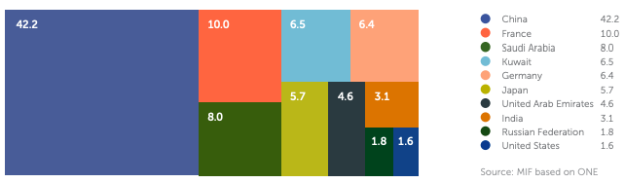

Debt restructuring, debt forgiveness, debt swaps
Since all alternatives rely on a voluntary agreement between debtor governments and their creditors, there is currently no widely accepted process for debt restructuring.
Private creditors must be included in the Debt Service Suspension Initiative (DSSI): The DSSI, developed in response to COVID-19, covered 32 of the 48 African nations and ran until December 2021. Only one private creditor joined the scheme, despite the G20's demand for private creditors to participate on similar terms. Future endeavours must include more private creditors, as a significant portion of Africa's external debt is privately held.

The G20's Common Framework: slow process, no common ground among multiple creditors:
The Common Framework, which was introduced in 2020 in reaction to African nations going into default, was swiftly criticized for moving slowly. The "compatibility of treatment" criterion, which stipulates that no creditor should be given preferential treatment over others, is one significant barrier. Finding common ground is particularly challenging because of the diversity of Africa's creditors, which include France and China. Although Zambia has reached an agreement with bondholders as of March 2024, several African nations, including Ghana and Ethiopia, have few viable options due to the years-long wait for the debt restructuring agreement.

Multilateral Development Banks: the need for more concessional loans:
If they improve their capabilities, multilateral development banks (MDBs) may be able to play a bigger part in easing the debt problem. In fact, the concessional loans that the poorest nations received from MDBs in 2022 were less than the debt service that these nations were making. African leaders demanded sustained concessional financing for Africa (now projected at $60 billion during IDA20 until June 2025) and a strong IDA21 replenishment, which is sure to be ratified in December 2024, at the second IDA21 replenishment meeting in Nairobi in April 2024.

Disagreements delay debt restructuring: Paris Club vs China.
Disagreements between creditors, particularly the Paris Club and China, have led to debt restructuring failures in recent years. China wants to restructure on its own terms as the main bilateral creditor, despite the Paris Club accusing it of failing to adhere to customary collective debt relief. Conflicts will postpone much-needed debt restructuring; thus, it is in Africa's best interest for creditors to work together. China's position is significant for Africa because it is the continent's most significant bilateral creditor and holds 8.6% of its external governmental debt owed to private creditors.

The Finance for Development Labs proposal: delayed debt repayment for greater fiscal space
The goal of the nonpartisan, nonprofit Finance for Development Lab (FDL) is to "build a fairer architecture for international finance." The plan's main goal is to address the gap between short-term debt issues and long-term investment needs. Countries could reschedule their payments with the cooperation of debtors, creditors, and MDBs. The required financial room for investment, funded by MDBs, would subsequently be created by the postponement of debt repayment.

Debt-for-nature swaps: a fast-growing sustainable debt market?
Debt-for-nature swaps are agreements whereby lenders reduce debt for developing nations that pledge to protect the environment. Thomas Lovejoy of the World Wildlife Fund first proposed this idea in the 1980s, targeting heavily indebted nations that frequently reduced government expenditures on environmental preservation and protection. Seychelles completed a debt-for-nature deal worth US$21.6 million in 2015. In 2023, Gabon became the first country in continental Africa to introduce a debt-for-nature swap, with plans to purchase up to $450 million in government debt in return for environmentally friendly blue bonds.

Debt-for-nature exchanges could provide governments with much-needed budgetary resources to enhance climate resilience, as the majority of climate-vulnerable nations are in Africa. To transfer revenues from debt repayment to investment initiatives addressing climate change, the African Leaders Nairobi Declaration (6 September 2023) proposed granting African nations 10-year grace periods on interest payments.

SOMALIA: Somalia's debt: one of a kind
Creditors of the Paris Club declared in March 2024 that 99% of Somalia's debt had been cancelled. A portion of the debt will be voluntarily and bilaterally waived by each of the individual creditor nations, with the remainder falling under the IMF and World Bank's Heavily Indebted Poor Countries Initiative (HIPC). The identity of creditors significantly affects African nations' capacity to negotiate debt relief or restructuring. The majority of Somalia's public debt—85.5%—is owned by public bilateral creditors, with the United States holding 50% of the nation's foreign public debt due to bilateral creditors. Six of the top ten bilateral creditors are members of the Paris Club. This stands in stark contrast to the African average. Inter-creditor conflicts may make it difficult for other nations with more diverse creditors, such as Paris Club and non-Paris Club nations, to come to a comparable agreement.

Foreign Direct Investment to the Rescue?
FOREIGN DIRECT AND PORTFOLIO 67 INVESTMENTS IN AFRICA: A COMBINED WORTH OF OVER $200 BILLION.
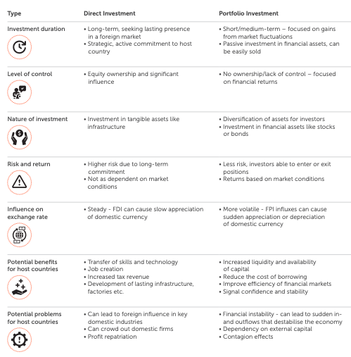

Foreign Direct Investment (FDI) vs Foreign Portfolio Investment (FPI)
An investor from one nation establishing a direct business stake in another is known as foreign direct investment (FDI). This usually means launching a new business or purchasing a sizable stake in an existing one, typically defined as holding at least 10% of the business's ownership. Since FDI involves active participation in management, joint ventures, and technology and experience transfers, it offers a long-term commitment to the host nation. FPI is the practice of non-residents investing in foreign equities and bonds. FPI does not grant the investor direct control over the companies it invests in, unlike FDI.

Getting a speedy return on investment from changes in asset values is the main goal of FPI. Because they may be sold very rapidly, FPIs are frequently more liquid and pose less risk than FDIs. They are often short-term investments, and investors trade assets regularly in response to their evaluations of market conditions. Only 3.3% of global FDI goes to Africa. With just 3.3% of global FDI, Africa receives the least of any emerging nation. Only 3.3% of all foreign direct investment went to Africa in 2022.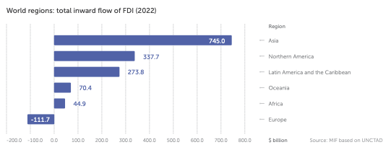

Only five nations in Africa receive 64% of all foreign direct investment: Egypt, Ethiopia, Morocco, Senegal, and South Africa.

Top 10 African countries: recipients of FDI (2022)
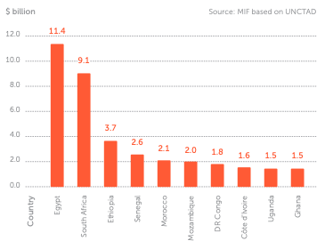

FDI to Africa declined by 44% between 2021 and 2022
After peaking at $80 billion in 2021, foreign direct investment inflows into Africa fell to $45 billion in 2022. The global polycrisis, which includes the COVID-19 pandemic, the conflict between Russia and Ukraine, the high cost of food and energy, and mounting debt, is largely to blame for the slowdown. Rising interest rates, more stringent financing requirements, and volatile financial markets had a particularly negative impact on international project funding and cross-border mergers. In 2023, Africa's foreign direct investment (FDI) flows stayed relatively stable at an anticipated $48 billion. Announcements of greenfield projects increased throughout the area, especially in Morocco, Kenya, and Nigeria. Concerns over the continent's infrastructure financing prospects are raised by the notable one-third decline in project finance deals, which is higher than the global average. In 2023, FDI flows to developing nations decreased by 9% to $841 billion.

African regions: FDI received (2021-2022)
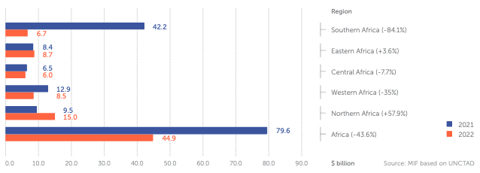

Between 2021 and 2022:
• With an 84.1% decrease, Southern Africa saw the biggest drop.
• Due to cross-border merger and acquisition (M&A) sales, foreign direct investment (FDI) in Egypt more than doubled to $11 billion.
• As a result of equity divestitures, FDI flows in Nigeria went negative to -£187 million.
• FDI dropped 39% to $1.5 billion in Ghana.
• Ethiopia remained Africa's second-largest beneficiary of foreign direct investment (FDI), a 14% decline to $3.7 billion.

Africa has some of the highest rates of return on investment globally
The UN claims that foreign direct investment in Africa in 2023 was paradoxical. Africa currently draws the least amount of foreign direct investment (FDI) of any region, even though it offered some of the best rates of return on investment between 2006 and 2011 (11.4%, compared to 9.1% in Asia and 8.9% in Latin America & the Caribbean). The rate of return on all inward foreign direct investment (FDI) in emerging African nations in 2019 was 6.5%, higher than the 6% return in industrialised economies and the 6.2% rate in Latin America and the Caribbean. The Lucas paradox states that even though weaker economies have higher marginal returns, global capital does not move from wealthy to poor nations.
Selected country groupings: rates of return on FDI inflows & oil prices (2011-2020)
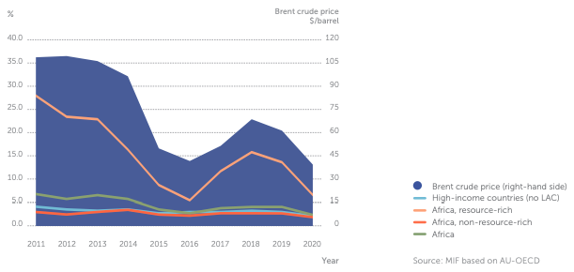
Nevertheless, several issues discourage investment:
• Low human capital (lack of a trained, educated, and healthy labour force) • Low public capital (poor infrastructure)
• Inadequate institutional capital (poor legal and security systems) • Inadequate property rights
Compared to FDI in high-income nations, returns on investment in Africa have decreased:
• A significant factor in the decreasing proportions of FDI inflows to developing nations has been the narrowing of FDI return gaps between advanced and developing economies.
• In Africa, the decline in FDI returns has been mostly driven by resource-rich economies due to a downward trend in oil prices from 2011 until prices rebounded in 2021.
• In contrast, FDI inflows to non-resource exporters (such as Ethiopia, Kenya, Madagascar and Mauritius) have been relatively more resilient.

The rate of return on total inward foreign direct investment (FDI) in Africa was 6.5% in 2019, which was higher than the 6% return in developed economies.

African FDI remains mainly concentrated in the extractives and energy industries
The extractives industry has historically accounted for the majority of foreign direct investment inflows into Africa. Over half of the estimated $236 billion in greenfield foreign direct investment (FDI) projects announced in Africa between 2006 and 2010 were related to resource extraction, petroleum, and coal processing. Following the 2010 discovery of the deposit, three enormous LNG plants are planned in Mozambique, with a total investment of $55 billion (other estimates have the total investment as high as $100 billion).

With a 2024 GDP of $24.0 billion, the Mozambican economy is far less than these investments. Because of their vital role in the shift to green energy, extractives continue to draw foreign direct investment. Given that 30% of the world's mineral reserves are found in Africa, as noted in MIF's Africa on the Road to COP28 report, the region is expected to see a significant increase in foreign direct investment (FDI) in the mining industry as a result of the global energy transition. However, between 2003 and 2020, FDI expanded to other industries.

With an average of five jobs created for every $1 million spent, greenfield FDI to Africa's manufacturing sectors accounted for 20.6% of all foreign investment on the continent and had the highest ratio of any other sector. Approximately 75% of all renewable energy foreign direct investments (FDIs) in Africa since 2010 have been in South Africa, Morocco, Egypt, and Kenya, totaling $46 billion.

FPI in Africa: approximately $185 billion from G7 countries and China
The US presently owns more foreign portfolio investment (FPI) in Africa than any other country, with over $130 billion, followed by the UK and Germany, with a combined investment of over $25.7 billion, according to the IMF's Coordinated Portfolio Investment Survey (CPIS).

G7 countries & China: total FPI in Africa (as of June 2023)
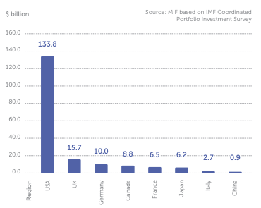
Together, South Africa, Mauritius, and Liberia accounted for 79.3% of the G7 and Chinese FPI in Africa in 2022.

Top 10 African countries: FPI received from G7 countries & China (as of June 2023)
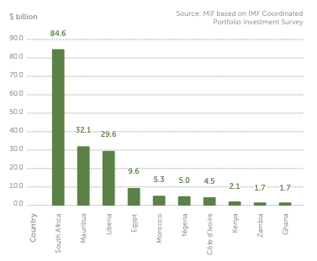
All estimates of the 'cost' of the SDGs are greatly outweighed by the global investment community. The SDGs and the environmental targets are only partially aligned with financial capital today. Article 2.1.c of the Paris Agreement, the Addis Ababa Action Agenda, and the Montreal-Kunming Framework all make it plain that we require a global financial architecture capable of reorienting the whole financial system.

CASE STUDY: Investment in Africa: the growing prominence of Gulf investors
According to the most recent data from fDi Intelligence, businesses in the Gulf Cooperation Council (GCC), which includes the United Arab Emirates, Saudi Arabia, Kuwait, Qatar, Bahrain, and Oman, announced 73 foreign direct investment (FDI) projects in Africa in 2023 valued at over $53 billion. The oil-rich Gulf governments' attempts to diversify away from hydrocarbons and invest in cutting-edge technologies are reflected in this notable upturn. Although complete implementation of green hydrogen is still years away, it will be essential for decarbonizing hard-to-abate sectors like steel and shipping.

Africa: investments from Gulf countries by type of project (2022-2023)

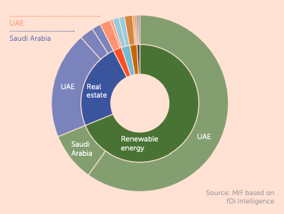
In 2022 and 2023, the Gulf invested mostly in renewable energy projects in Africa. Other emerging world economies are investing in Africa at the same time that Gulf investors are growing there. An all-time high of $38.5 billion in foreign direct investment (FDI) was made by Hong Kong and China-based businesses on the continent in 2023, matching the $38 billion invested by Western European businesses. According to early fDi Intelligence data, greenfield foreign direct investment (FDI) from the United States into Africa totalled less than $10 billion in 2023, the highest since 2018. However, this amount was still less than that of the Middle East and other regions.

AFRICAN RISK ASSESSMENT AND CREDIT RATINGS: THE PROBLEM CHILD
When figuring out how much countries can borrow on global financial markets, credit rating agencies (CRAs) play a crucial role. Fundamentally, sovereign credit ratings evaluate a nation's capacity and willingness to repay its debts. Usually, the nation issuing the bond or other financial instrument requests that they be done. The issuer pays for this rating, and the CRA of their choosing will receive the pertinent data. S&P, Moody's, and Fitch are the three CRAs that currently hold 95% of the global market. In 1994, Fitch assigned South Africa a sovereign rating, making it the first African nation to receive one.

33 African nations, or 14.2% of the continent's GDP, have a sovereign rating from at least one of the three agencies as of 2023, while 21 nations remain unrated. The 'big three' evaluate only 33 countries. Twenty-one African nations have never been rated as sovereignly risky. Since 1994, at least one of the three major rating agencies has assigned ratings to just 33 African countries.

African countries: credit rating status (2023)
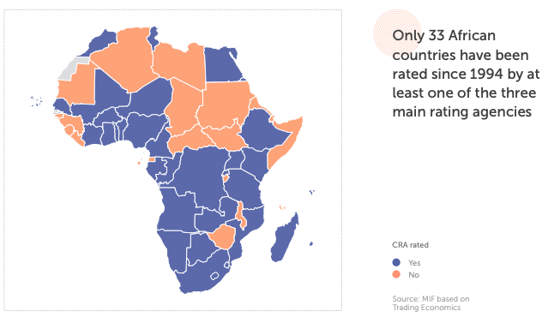

International financial institutions have long held damaging prejudices about Africa as an unsafe travel destination, which are reinforced by media coverage and "objective" evaluations from credit rating agencies (CRAs). Investor sentiment and risk perception are significantly influenced by media coverage, especially when domestic data is scarce. The interest rate at which nations can borrow money from institutional or private lenders rises with a higher risk perception. Negative media representations might cost Africa up to $4.2 billion a year in "overpaying" for interest, according to Africa No Filter in 2023.

Would extra FDI result from coverage of the remaining 21 countries? FDI inflows and credit ratings for African nations are strongly positively correlated.
• nations have received FDI inflows totalling about $40 billion with at least one credit rating.
• A total of $5.6 billion in foreign direct investment has been received by nations that have not been given a credit grade.
The 33 credit-rated nations collectively received over $40 billion in foreign direct investment in 2022. Only $5.6 billion in foreign direct investment entered the 21 African nations without ratings.

Top 10 African Countries: FDI inflows (2022) & credit rating from S&P, Moody's and Fitch (2024)
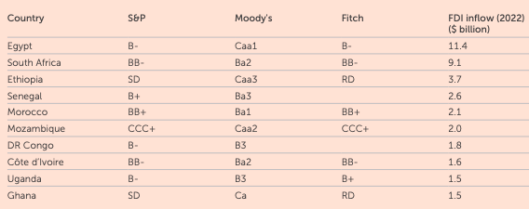

Only two African countries are classified as "investment grade"
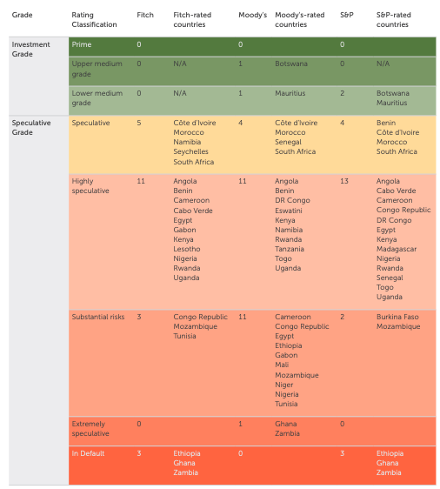

How to improve ratings: Moody's viewpoint
A few Sub-Saharan African nations have made significant strides in recent years toward changes that, if maintained, might improve Moody's evaluation of their overall creditworthiness and governance. For example, Tanzania, Angola, and Côte d'Ivoire are increasing revenue by introducing new taxes or boosting tax collection through digitisation. The fiscal stabilization rules that Angola and eSwatini have put in place will gradually increase the efficacy, credibility, and efficiency of governmental spending. The promotion of price stability and access to foreign exchange through monetary reforms in Tanzania, Angola, and Nigeria is increasing investor, consumer, and corporate confidence. Additionally, the changes might eventually create a domestic capital pool for government borrowing and investment by promoting savings. In the event of a worldwide crisis, floating exchange rates may also serve as automatic economic stabilisers. To reduce financial strain and barriers to competition, Tanzania and Angola have simplified the governance of their state-owned businesses. Together with Côte d'Ivoire, both nations have made some strides in combating corruption. Maintaining these initiatives will strengthen institutions and prepare these nations to manage better the financial, social, and economic challenges that all Sub-Saharan African sovereigns face. Ratings must, however, demonstrate that institutions can withstand external shocks and have a solid track record of implementing changes to advance up Moody's scale. To maintain creditworthiness, for instance, investment-grade sovereigns can respond to domestic and global social and political shocks by making the required fiscal, political, and economic adjustments.

In comparison, Nigeria continues to face widespread institutional problems. It is yet unknown how resilient eSwatini is to internal political unrest or outside shocks. Angola's reform initiatives could be hampered by social risks resulting from exchange rate or inflationary pressures. Policy stability across Tanzanian administrations is dubious in the absence of major institutional reforms. Furthermore, Côte d'Ivoire still faces political and societal challenges in spite of its strong track record of implementing reforms.

Africa has more "speculative" rather than "investment grade" rated countries

Only two African nations are classified as "investment grade": Botswana and Mauritius. Moody's and S&P have both recognized the investment grades of Mauritius and Botswana. No African nation is considered "investment grade" by Fitch. The majority of the other African nations with ratings fall into the "speculative" (noninvestment) category. Compared to other regions, this is a significantly larger percentage of countries. North American nations are all classified as "investment grade," but Europe, Central and East Asia, and the Pacific have more than twice as many "investment grade" as "speculative" ratings.

World regions: share of investment and non-investment ratings by S&P (2023)
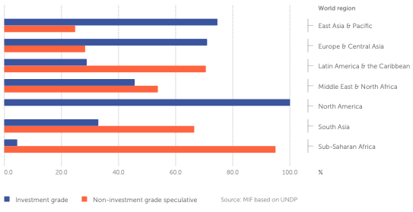

Is there a Perception Premium?
62% of African nations have had their ratings lowered since their initial evaluation, which is twice as high as the global average (31%). Concerns have been raised by the high frequency of negative ratings in Africa. Although the AfDB predicted economic recovery in the first half of 2023, five African economies were downgraded. At least seven African nations have bond yields (cost of borrowing) exceeding 10% as of October 2023: South Africa (10.8%), Namibia (11.0%), Nigeria (15.0%), Uganda (15.9%), Kenya (16.7%), Egypt (25.6%), and Zambia (26.6%). No European nation pays more than 10%.

Due to the agencies' lack of contextual knowledge, Nigeria and Kenya have both contested downgrades in 2023, which were ascribed by CRAs to unfavorable foreign exchange trajectories, an increase in debt payments, and high yields on Eurobonds.
African nations, in contrast to other sovereigns, have historically been the target of unsolicited ratings, in which governments are not sufficiently engaged. As a result, ratings are based on analysts' opinions and desktop research from outside the continent rather than official and contextual data.

One of the primary causes of Africa's estimated $200 billion trade and investment imbalance is risk perception. At least seven African nations—South Africa, Namibia, Nigeria, Uganda, Kenya, Egypt, and Zambia—have bond yields more than 10%. Additionally, a nation's ability to fulfill its responsibilities is directly impacted by the ratings provided by CRAs. Thirty-one of the 33 nations that at least one of the "big three" graded are classified as "junk." Bond rates from nations classified as "junk" are more susceptible to downgrades, according to research. A downgrade essentially transforms a liquidity crisis into a solvency crisis by forcing countries to increase the amount of revenue allocated to debt servicing, which raises the likelihood of default.

Furthermore, it typically takes a developing nation seven years to return to its prior ranking. According to a number of African nations, organizations like the African Union, international partners like the United Nations Development Program, and independent experts, there is a "perception premium" applied to Africa. These assessments are allegedly subjective and result in lower ratings than those for nations with comparable political or economic circumstances. Indeed, the UN found that the African premium on international loan markets was 2.9 percentage points greater than that of other non-African nations with comparable macroeconomic circumstances. According to the UNDP, the total cost of these credit rating quirks in Africa is $74.5 billion in lost revenue and excess interest, which is equal to 80% of the continent's yearly infrastructure investment requirements.

CRAs have repeatedly declined to raise Afreximbank's BBB-class rating to A-class, citing a "high-risk business environment," despite the bank's continuous good profile. Fairer credit ratings may save Africa $74.5 billion, or 80% of the continent's yearly infrastructure investment needs, according to the UNDP.

Quis custodiet ipsos custodes?
Rating methodologies have often been compared to a "black box", citing lack of transparency, deficiency in their robustness and opacity as to the respective weight of objective and subjective indicators. According to CRAs’ own methodologies, ratings are based on:

The comparison of rating techniques to a "black box" is frequently made due to its opaqueness, lack of transparency, and opacity about the relative weights of objective and subjective variables. Ratings are based on the following, per CRAs' own methodologies:

• An "objective" step, in which countries are rated based on national statistics provided by the issuer upon rating request, as well as governance, economic, and fiscal indicators from projects like the World Bank World Development Indicators and the IMF World Economic Outlook and Currency Composition of Official Foreign Exchange Reserve databases.

• A "subjective" stage that frequently follows the same structure as the first, but is based on the analysts' assessments of CRAs, which will raise or lower the "objective" grade according to a set of preset standards. The ratings of African nations are frequently lowered from their "objective" assessment as a result of this second stage. The fact that the indicators used penalize African economies based on economic metrics that are common across several African countries—such as a sizable informal sector, high percentages of debt denominated in foreign currencies, and the use of debt rescheduling or restructuring mechanisms to improve economic sustainability—is a common criticism of CRA methodologies. Furthermore, it is difficult to find reliable and accessible data for Africa in the areas that credit rating techniques address. Accurate assessments are significantly hampered by research demonstrating that the data coverage of Africa by different international organizations is frequently fragmented, either not covering all nations or not covering enough data years throughout a time span.

It is necessary to update rating methodology to account for the difference between perceived and actual risk associated with investments in EMDEs. EMDEs frequently discuss credit rating agencies and their procedures. Enhancing the process's transparency will enable nations to concentrate on strengthening their weak points and raise their rankings as a result (Songwe et al, 2024). This problem is addressed in part in the most recent Fitch 2023 report.

• By adding independent review and involvement into rating determinations, as well as by strengthening regulatory and public disclosure requirements, CRAs should increase transparency.
• By utilizing specialized data, modeling, and analysis from current platforms, CRAs should incorporate climate and nature risks and acknowledge the benefits of funding tied to sustainability.
• Governments should promote innovation in credit rating methods, procedures, and business models while lowering entry barriers for new CRAs through regulatory harmonization and simplification.
• CRAs should provide explicit, stand-alone criteria for rating uplift from credit enhancement, define distressed debt exchange more precisely, and reveal the models and assumptions that underlie the counterfactuals.

African stakeholders are challenging CRAs more and more because they lack pertinent data and contextual expertise about Africa. Because they are primarily situated in London or Hong Kong, analysts do not have the requisite exposure to African nations to provide appropriate ratings and perceptions of risk. Instead, their assessments are typically based on desk research or online debates, which frequently result in negative conclusions. Concerning governance flaws within grading procedures and the absence of African agency and ownership appear to be major underlying issues. To guarantee accountability and transparency of rating processes, a number of experts have emphasized the necessity for improved consultative procedures and the creation of regulatory frameworks by African nations. It has been proposed that CRAs' operations be governed by accountability mechanisms, like penalties for failing to use due diligence while determining credit ratings. Regulatory agencies like the European Securities and Markets Authority and the Securities & Exchange Commission's Office of Credit Ratings have been established in both the US and the EU. However, the African continent does not have such a body. Better frameworks for government consultations and the prevention of market shocks may be made possible by publishing rating calendars and making sure ratings are announced on Fridays following market closing. In order to lessen the impressions of ambiguity, the UN also emphasizes how important it is that African governments address the accuracy and dependability of the data they use. Only two of the "big three" rating agencies, S&P and Moody's, have operations throughout the continent, and both are located in South Africa. According to Fitch's research, "intangible" elements are the reason why they believe "advanced economies" can withstand a far greater debt load.
Data on the status of debt-financed projects and their subsequent repayments could be gathered by the AU. The agencies may be held accountable if credit ratings don't accurately represent the work being done on the ground. In order to create an African Credit Rating Agency (ACRA) that would offer the continent complementing alternative rating opinions, the AU is collaborating with the African Peer Review Mechanism (APRM). A technical committee convened by the APRM in Nairobi in July 2023 approved the creation of an ACRA led by the private sector that is self-sustaining and self-funding. Additionally, the organization will offer ratings for foreign direct investment as well as rankings for governance, social issues, and the environment.

The APRM, in partnership with UNECA and with assistance from Open Society Foundations (OSF), held a meeting on the operationalization of the ACRA in Lusaka in March 2024 after consulting with potential shareholders and transaction advisers. With an annual operating capital of $837,000, the ACRA was set to debut on December 31, 2024. The AU is looking to shareholders, rather than governments, for finance through equity capital from African financial institutions, rating agencies, and private investors in order to avoid political conflicts of interest. Japan Credit Rating Agency and Dagong Global Credit Rating Company are alternative rating agencies in China and Japan.

Capital ultimately comes from the market, where capital providers would only offer it the proper security and return in proportion to the risks they take, regardless of whether it comes from the public or private sectors. The public sector (i.e., multilateral organizations) has provided the majority of development funding for Africa under concessionary conditions, which are accomplished by shifting some of the risk to the donors. Public sector funding is crucial, but it is constrained by the amount of money that donors may contribute. We need to figure out how to reduce these risks if we want to draw in large amounts of private sector funding.

A more fundamental approach would be to lower the investment risks at the project level, for which sound governance and robust institutions are crucial, even though there are many market instruments of risk transfer that might be useful.

Barriers to further investments
Compared to other parts of the world, Africa receives the least amount of capital from institutional investors, despite its potential. Although the amount of global assets under management increased from $48 trillion in 2010 to over $112 trillion in 2021, Africa's contribution of global investment capital has remained small (less than 1%). Several important variables are regarded as major risks to investing in Africa, per a 2022 AUC/OECD investor survey. Portfolio investments provide investors who are worried about political and macroeconomic risk with short-term, highly liquid assets that don't require active management. The flow of finance to Africa is further impacted by the dangers that investors have detected and that major credit rating agencies are evaluating.

"Which of the following risks have been most important for your investments in African countries?" AUC/OECD investor survey, 2022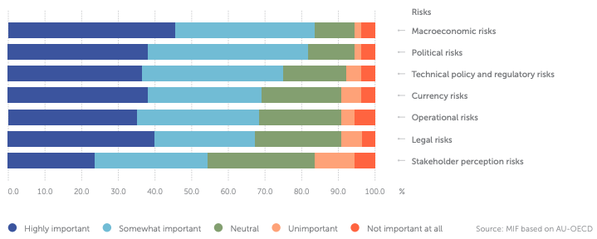

The particular burden of "dollarization" Since the US economy is the biggest in the world, decisions on its monetary policy have a big effect on international financial markets. Many goods around the world are valued in dollars, and the dollar is the main reserve currency of the world. Above all, since shifts in US interest rates have an effect on international financial circumstances, borrowing costs are dictated by the US Federal Reserve rate. Borrowing costs would probably increase if interest rates in the Global North rose, even if the macroeconomic and political conditions of an African nation were improving. The Global North's central banks have raised interest rates once more, which has contributed significantly to the increase in borrowing costs and interest rates since the outbreak. Therefore, the goal of the BRICS is to establish a multipolar global financial system that is less susceptible to dollar swings. In conclusion, here is what we discovered:

• In the first half of 2024, 23 African currencies saw their lowest valuations ever recorded in relation to the US dollar.
• The Naira has lost more than 200% of its value in relation to the dollar since May 2023.
• The Tunisian Dinar lost 72% of its value in relation to the Euro between 2011 and 2022.
• Since 2019, the official value of the Ethiopian Birr has dropped by half.

SPOTLIGHT: "Building bigger and better financial institutions: really?"

IMF quotas affect the distribution of voting shares and Special Drawing Rights (SDRs).
IMF quotas, which are expressed in SDRs, represent the relative positions of nations in the global economy. GDP is the most important element (50%) in the calculation for quotas, which also includes Openness, Variability, Reserves, and GDP. These quotas dictate each nation's portion of SDR allocation, loan availability, voting power in IMF decisions, and financial contribution to the IMF. Richer nations typically have more sway over decisions, even while voting share distribution takes smaller nations' rights into account.

Nearly one-third of the vote is in Europe alone, with Asia (apart from China and Japan) coming in second with 16.8% and the US with 16.5%. Despite making up over 18% of the world's population, Africa only has 6.5% of the IMF's voting rights, which is just slightly higher than China and Japan, respectively. The COVID-19 epidemic brought to light the SDR system's shortcomings in aiding developing nations. Compared to poorer nations that were less vulnerable to global shocks, IMF members with big quotas had access to substantially more SDR reserves and were already better prepared to manage expensive public health emergencies.

High-income nations benefited from over 70% of the $650 billion SDRs that were allotted in 2021. Germany, which has a population of only 83 million, received more SDRs than Africa, which has a population of over 1.4 billion.

Selected world regions & countries: share of IMF voting rights (2024)
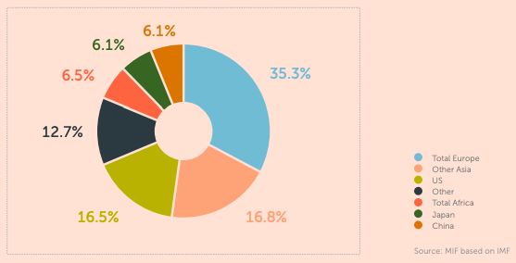
The COVID-19 epidemic brought to light the SDR system's shortcomings in aiding developing nations. Compared to poorer nations that were less vulnerable to global shocks, IMF members with big quotas had access to substantially more SDR reserves and were already better prepared to manage expensive public health emergencies. High-income nations benefited from over 70% of the $650 billion SDRs that were allotted in 2021. Germany, which has a population of only 83 million, received more SDRs than Africa, which has a population of over 1.4 billion.

The World Bank’s new “playbook”
At the 2023 Annual Meetings in Marrakech, the World Bank Group began an evolution process under the direction of its newly appointed president, Ajay Banga. This "playbook" calls for expanding the financial capabilities of the International Development Association (IDA) and the International Bank for Reconstruction and Development (IBRD), launching a new Crisis Preparedness and Response Toolkit, improving data transparency on investment risks in developing nations, and establishing cooperative co-financing platforms with other development banks. In order to unlock $40 billion yearly by 2025, of which an extra $9 billion is generated annually, the World Bank set ambitious goals at COP28, including reaching 100 million Africans with renewable energy by 2030 and raising climate finance to 45%. In order to eliminate bureaucracy, the Group is actively trying to expedite approval procedures and implement the One World Bank concept in pilot nations.

IDA21 replenishment: the need to triple concessional finance to Africa
Mo Ibrahim and other prominent members of advocacy and philanthropic organizations urged G20 leaders to restructure the Bretton Woods institutions in an open letter dated April 2024. By increasing IDA contributions and changing tax laws, they emphasized that polluters and the wealthiest should pay their fair part. They also pushed for the cancellation of heavy debt so that impacted nations could invest in resilience, health care, and education. Following the summit of African heads of state and government, the Nairobi IDA Communique of April 2024 expressed similar demands. The statement called for steady and predictable increases in concessional financing to the continent for IDA 21, which will be refilled in December 2024, and restated the anticipated $60 billion allotment to Africa for IDA 20 (July 2022–June 2025).

Progress still slow for about 60% of MDB reform agenda items
For 60% of the MDB reform agenda items, progress is still slow. In five categories—capital efficiency, adding capital, mandates, country engagement, and private finance mobilization—the Center for Global Development (CDG) monitors MDB reforms of the World Bank Group, the Asian Development Bank (ADB), the Asian Infrastructure Investment Bank (AIIB), the European Bank for Reconstruction and Development (EBRD), the European Investment Bank (EIB) Global, the Inter-American Development Bank (IDBG), and the African Development Bank (AfDB). Approximately 60% of the 28 agenda items continue to make slow progress on average. The two areas where all banks have made the most headway are mobilizing private money, particularly through donor guarantees, and extending their objectives to include global concerns.

Selected MDBs: progress across reform categories (2024)
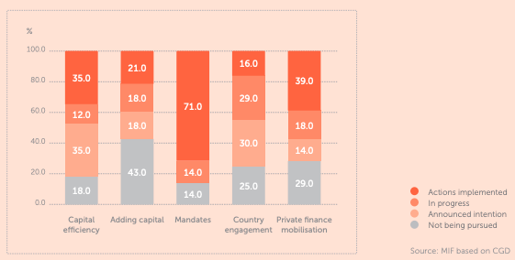
With the exception of the AfDB, all MDBs have achieved their goals in terms of their mandates; however, ADB and IDBG are the best at maximizing capital efficiency and raising private capital. AfDB is leading the transformation of country engagement, while EBRD is leading the addition of capital. The World Bank Group's performance is mediocre, but it particularly lags behind in terms of capital addition, and none of its planned reforms have been fully implemented as of yet.

Conclusion
Debt Chains: Breaking Free from Africa's Financial Struggles, Chapter 3, examines the profound and enduring impacts of colonialism on the continent's economy, society, and current debt crises. The chapter makes the case that Africa's present financial problems have their roots in a lengthy history of exploitation, extraction, and outside control rather than being the product of recent poor management or corruption. The chapter charts the development of Africa's economic history, demonstrating how colonialism, the slave trade, and the establishment of artificial borders created the conditions for ongoing underdevelopment and debt susceptibility.

The chapter starts out by refuting the widely held beliefs that attribute Africa's debt crisis to incapacity or bad governance alone. Although these elements are important, the chapter maintains that they cannot be comprehended in isolation from colonialism and the international structures that still harm African nations. The chapter makes the case that debt is really a question of power—who controls the resources, establishes the regulations, and reaps the rewards of the world economy. Powerful countries and organizations have utilized debt as a means of obtaining wealth from Africa and preserving their domination throughout history.

The way colonialism reorganized African economies to suit European interests is one of the chapter's main themes. In order to support Europe's industrial development, colonial rulers converted varied communities into economies centered on exporting raw commodities, such as grain, minerals, and oil. Roads and railroads were not constructed to connect African communities or promote local development, but rather mainly to transport commodities to ports for export. African nations were left reliant on a limited number of exports and exposed to fluctuations in global market prices as a result of this extractive paradigm, a trend that continues to this day.

The chapter also emphasizes how African nations were burdened by colonial debt. For instance, in exchange for its independence, Haiti had to pay France a hefty debt that ruined its economy and took more than a century to pay back. South Africa and its neighbors were left with £28 billion in debts associated with apartheid and regional instability, while Zimbabwe inherited a $700 million debt from the colonial Rhodesian government. Authoritarian and colonial governments incurred these "odious debts," which were transferred to succeeding administrations, thereby sustaining cycles of underdevelopment and dependency.

The CFA franc monetary zone, which links 12 former French colonies to the French treasury, is another potent example covered in the chapter. The need that member states maintain a significant amount of their foreign exchange reserves in France restricts their capacity to invest in development and maintain economic independence. The chapter makes the case that this system is an obvious illustration of how colonial-era financial systems still exist and threaten African sovereignty.

The destructive effects of the slave trade and the arbitrary borders established during the Scramble for Africa are then the focus of the chapter. Millions of Africans were forcibly removed via the transatlantic and other slave trades, upsetting societies, undermining confidence, and impeding investments in development and education. According to research, the areas most impacted by the slave trade continue to rank among the poorest in the world, with crippled institutions and ongoing hostilities. European powers frequently divided ethnic groups and established fictitious governments along their borders, which resulted in continuous instability and violence.

African nations faced the difficulty of establishing new countries on the borders and economies of former colonies after gaining their freedom. The reality of the global economy and the burden of debt swiftly dampened the euphoria of the independence era. The Cold War made things even more difficult because both Western and Soviet nations gave loans and assistance to African governments, frequently endorsing authoritarian administrations that left their nations in debt.

The chapter also looks at the effects of the World Bank and IMF's structural adjustment plans from the 1980s and 1990s. These initiatives forced African governments to expose their economies to international competition, privatize state-owned enterprises, and reduce spending. Despite their stated goal of fostering stability and progress, these policies frequently resulted in the loss of jobs, decreased access to healthcare and education, and a rise in poverty and inequality. Whole communities were left without assistance, and social safeguards were undermined. Due to restricted prospects and increased unemployment, women and young people were disproportionately affected.

The chapter concludes by highlighting the human cost of debt. The most vulnerable—women, children, and the impoverished—suffer the most when governments are compelled to spend more on debt repayment than on necessary services. Social discontent, hunger, and unemployment have all increased as a result of austerity measures. Disillusioned by the lack of prospects, many young people are motivated to travel overseas in search of better opportunities, frequently running the risk of being used and hurt.
Chapter 3 concludes by making the case that Africa's debt dilemma is a matter of justice, dignity, and human rights in addition to being an economic one. Ordinary people are most affected by the problem, which has its roots in centuries of exploitation and outside domination. More than just technological solutions are needed to address Africa's debt problem; a deeper understanding of colonialism's legacy and a dedication to creating a more fair and just global economic order are also necessary.

CHAPTER 4: ASSESSING THE NEEDS: SDGs?
According to recent development experience, nations must achieve and maintain an investment rate of 30% of GDP for at least 20 years in order to achieve economic takeoff. Africa's national savings rate is 20%, and its investment rate is 22%. When applied to Africa's $3 trillion GDP, the 30% investment criterion compared to the 20% saving rate results in a financing shortfall of 10 t of GDP, or $300 billion annually. Although there is still much uncertainty, estimates of climate financing appear to agree on a need of $250 billion to $300 billion year, or an additional 8 to 10% of GDP. In energy, for instance, there will inevitably be some overlap; the two investment requirements are not additive. However, even with these broad brush boundaries, there is still a financial need of almost 15% of GDP, or $450 billion annually.

This is not a significant sum of money in terms of global capital available. Of the $120 trillion in assets under management (AUM) held by international institutional investors, it represents only around 0.4%. Seven years of the baseline investment need is equal to a GDP proportionate share, or $3.2 trillion. African nations have issued more than $160 billion in sovereign bonds since they first entered the markets in 2007. In what may have been the most challenging market conditions since Africa's introduction into the bond markets, three nations—Cote d'Ivoire, Kenya, and Benin—raised $4.85 billion.

Clearly, the issue is not one of money. What is it? Macroeconomic stability and the ability of the public debt to be carried are two factors. Both refer to a constraint on solvency. The macroeconomics comes first.

The gap between savings and investments is far too wide. The savings-investment gap is equivalent to the current account balance in economic accounting. It is just not financially feasible to maintain a current account deficit of 15% of GDP over time. The amount of the investment gap that may be sustainably financed externally is limited by macroeconomic stability and debt sustainability, possibly not exceeding 5% of GDP. This implies that at least half of the financing shortfall must come from domestic savings. In both theory and reality, the question of what public policy may do to increase domestic saving is not simple. Approaching the topic by breaking it down into three parts—household, business, and public savings—is beneficial.

The main structural factors that affect household saving are income and demographic changes, both of which change gradually. Nevertheless, one area where public policy can assist in mobilizing household savings is the establishment of pension plans. With just 10% of the population covered by pensions, Africa has an extremely low pension coverage rate, which is mostly due to the country's informal sector on the one hand and its payroll deduction-based pension plan structure on the other. In the face of rising urbanization and the resulting deterioration of traditional kinship-based systems of old age security, it is imperative to develop a pension plan model that is effective for Africa's largely non-payrolled workforce in order to both mobilize savings and avert widespread old age poverty.

The amount of investment that is funded by retained earnings is referred to as corporate saving. Profitability comes first, followed by the rate of return on possible investments, or, more generally, the business climate and economic fundamentals. It is challenging to distinguish particular policy initiatives from broader economic policy in order to increase it.

Public savings remain after this. The surplus of government revenues and ongoing spending, or "consumption" if you will, is referred to as public saving. In other words, it is the amount of public investment that is funded by government revenues and surpluses of state-owned businesses. In actuality, it is the aspect of saving that is most responsive to public policy. In fact, the initial phase of the Asian Tigers' economic development was greatly aided by public savings. Throughout the 1970s and 1980s, the East Asian Tigers were able to keep public saving rates above 6% of national GDP, which is twice the average of 3% for developing nations overall. This made it possible for East Asian governments to finance the majority of their public capital from income, which reduced their foreign debt and forced the private sector out of their home markets.

Let’s turn to debt carrying capacity.
Because infrastructure and human capital investments are vital and still substantial, and because they are required to attract private capital, the public debt carrying capacity is important. Africa's public debt is 60% of GDP, while the average for OECD nations is around 120%. Notably, the four African nations that have defaulted on their debts—Chad (41%, Ethiopia 47%, Ghana 79%, and Zambia 92%)—had debt loads that are between a third and three times higher than the OECD average.

The cost of borrowing money and the government's revenue base are the two main criteria that determine debt carrying capacity. The average revenue of the OECD nations is 34% of GDP. 3.2% of revenue is used for debt servicing, which corresponds to a 1.2% annual interest rate. The debt service would take up 7.5% of the OECD countries' earnings if they had 15% of GDP from African sources but were still paying interest at 1.2%. The debt service would be using up 21% of sales if they paid 8% interest on the same revenue base. Debt service now accounts for 48% of revenue due to a combination of low revenue and high borrowing costs.

The obvious implication of this is that it is crucial to close "the great financial divide," which explains why poor nations pay five to eight times as much for credit on global markets as wealthy ones. More concessional financing and innovative climate finance tools have their uses, but they are limited. Making markets function is the first and greatest solution.

DEVELOPMENT: TRILLIONS NEEDED BY 2030
Africa's two main development frameworks, the African Union's (AU) Agenda 2063 and the United Nations' Agenda 2030 Sustainable Development Goals (SDGs), are not being met with much speed. The cumulative effects of climate change, the aftermath of the COVID-19 epidemic, and the ongoing Israel-Gaza and Russia-Ukraine hostilities make it more difficult to achieve these goals. Only two of the 17 Sustainable Development Goals (SDGs)—SDG 12 Responsible Consumption and Production and SDG 13 Climate Action—show notable development in Africa, according to the 2023 UN Sustainable Development Report, which is almost two-thirds of the way to the 2030 deadline. Both goals are tied to climate change. Despite their critical relevance for Africa's development, the three worst-performing goals—SDG 1 No Poverty, SDG 2 Zero Hunger, and SDG 3 Good Health and Well-Being—are encountering significant challenges.

The SDGs that perform the worst in Africa are SDG 1: No Poverty, SDG 2: Zero Hunger, and SDG 3: Good Health and Wellbeing. The annual financing need for SGDs in Africa is estimated to be between $194 billion to $470 billion. Likewise, Africa's progress toward the AU's Agenda 2063 has been uneventful. Nearing the conclusion of the First Ten-Year execution Plan (FTYIP), the New Partnership for Africa's Development (NEPAD) in 2022 reported that the average level of execution for all 20 targets was 55%. The objectives that perform the worst among these pertain to crucial areas of priority for the advancement of the continent: The lowest-performing aim is aim 4: Transformed Economies. Goal 1: High Standard of Living comes next, followed by Goal 12: Capable Institutions and Transformative Leadership.

Africa: estimated financial needs and gaps from various sources ($ billion) (2020-2040)
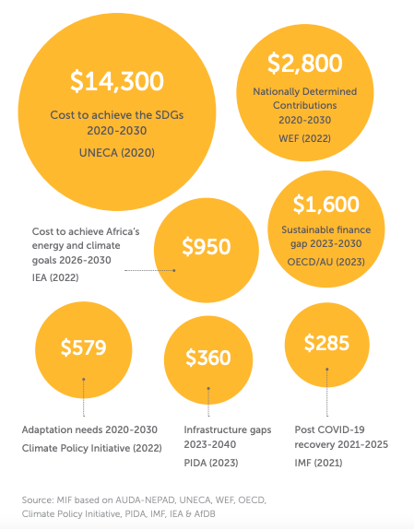

Although Agendas 2030 and 2063 are distinct frameworks with distinct deadlines and entities, their goals are very similar. The United Nations Economic Commission for Africa (UNECA) reports that there is 100.0% goal-level convergence, 69.8% target-level convergence, and 67.2% indicator-level convergence between the SDGs and Agenda 2063's objectives. Africa still has a long way to go in achieving its sustainable development goals, which include raising living standards, preparing for climate change, transforming the economy, and strengthening the capacities of governments and financial institutions.

Though highly variable, all figures point to substantial financial needs

In 2020, UNECA estimated that $1.3 trillion would be needed in gross financial needs for Africa to achieve the SDGs by 2030. The Organization for Economic Co-operation and Development (OECD) and the African Union (AU) predicted in 2023 that the gross funding needs for attaining the SDGs by 2030 would be close to $870 billion annually. Estimates of the resources available to meet these gross needs, which range from $870 billion to $1.3 trillion year, likewise differ. Africa's funding sources are $673 billion a year, according to AUOECD data. These come to $829.7 billion for 2022, based on MIF's own figures.

Consequently, using the UNECA's estimate of $1.3 trillion in gross needs and MIF's computation of $829.7 billion in accessible sources of finance, the net financing gaps to meet Africa's demands range from roughly $194 billion (as reported by the AU-OECD) to roughly $470 billion. About 15.7% of Africa's GDP is lost each year as a result of the continent's inability to meet the SDGs on schedule.

Africa: annual GDP & SDG gross financial needs and net gaps ($ billion) (latest year available)
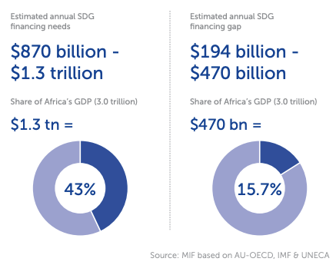

Africa: estimated financial needs by SDG (latest data year)
Goal 1: No Poverty: Goal 1: No Poverty: The United Nations Development Programme (UNDP) estimates that it will cost about $14 billion in 2023 to elevate 165 million people out of poverty globally who live on less than $3.65 per day. The estimates to end extreme poverty are even higher, with $175 billion required annually to end extreme poverty worldwide.

Goal 2: Zero Hunger: In 2019, Africa Improved Foods (AIF) estimated that it will cost about $5 billion to end hunger in Africa. In 2023, the World Meteorological Organization (WMO) predicted that by 2025, food imports from African nations will have increased by around three times, from $35 billion to $110 billion. In 2022, there will be a $74.5 billion funding need for agricultural small and medium-sized businesses (SMEs) in sub-Saharan Africa, according to the Commercial Agriculture for Smallholders and Agribusiness.

Goal 3: Good Health and Well-being: Africa faces a $66 billion annual funding shortfall to fulfill its expanding healthcare financing needs and rising healthcare demands, according to UNECA in 2019. The IMF stated in 2021 that in order to increase the spending response in the wake of the COVID-19 pandemic, an additional $285 billion in funding was required for all African nations between 2021 and 2025.

Goal 4: Quality Education: In 2023, the United Nations Educational, Scientific, and Cultural Organization (UNESCO) anticipated that the average yearly financial deficit for education across all low- and lower-middle-income countries would be $97 billion between 2023 and 2030. On average, African nations provide $70 billion annually.

Goal 5: Gender Equality: In 2016, the UNDP estimated that gender inequality costs Africa over $95 billion annually. The African Development Bank (AfDB) estimates that $42 billion would be needed to close the gender financing gap for women-led businesses.

Goal 6: Clean Water and Sanitation: In 2023, the AU estimated that by 2030, water security in Africa would require about $50 billion annually.

Goal 7: Affordable and Clean Energy: throughout 2021, the International Institute for Sustainable Development (IISD) estimated that an average of $73 billion more annually is required to provide affordable and sustainable electricity throughout Africa. The International Energy Agency (IEA) estimated in 2023 that it would cost $950 billion between 2026 and 2030 for African nations to meet all of their development objectives related to energy, including universal access to energy.

Goal 8: Decent Work and Economic Growth: In 2014, the OECD estimated that $13.5 billion would be required to end modern slavery globally.

Goal 9: Industry, Innovation and Infrastructure: The AfDB estimated in 2022 that the continent will require $170 billion year in infrastructure investment through 2030. $200 billion will be needed over ten years to clear Africa's housing backlog. Africa requires between $4–7 billion a year in ICT support, according to UNECA in 2020.

Goal 10: Reduced Inequality: The UN estimated in 2023 that it would cost around 1.6% of GDP, or $49.6 billion, to increase social safety programs and extend old-age pensions throughout all low-income nations.

Goal 11: Sustainable Cities and Communities: Each small city may need $20–50 million year, each medium-sized city $140 million to over $500 million, and each large developing city $600 million to over $5 billion annually, according to UN Habitat in 2020.

Goal 12: Responsible Consumption and Production: Africa would require $6–$42 billion in the near future and up to $125 billion by 2040 to implement extensive recycling and recovery technology in order to cut trash, according to the United Nations Environment Programme (UNEP) in 2022.

Goal 13: Climate Action: Africa may require up to $1.7 trillion for climate adaptation between 2023 and 2035, according to the AU and Climate Policy Initiative (CPI) in 2023. In 2020, UNECA estimated that, with approximately $1 trillion in investments and projects ready to be financed, between $18 billion and $30 billion will be required yearly over the following 20 years to mitigate and adapt to climate change in Africa.

Goal 14: Life Below Water: UNCTAD stated in 2019 that in order to accomplish SDG 14 by 2030, $175 billion annually is required globally.

Goal 15: Life on Land: The World Economic Forum (WEF) 2023 estimates that the global needs for biodiversity are worth about $300 billion. SDGs 13, 14, and 15 would be served in this way.

Goal 16: Peace, Justice and Strong Institutions : In 2020, the IISD and the OECD estimated that the annual financing need for data capacity associated with strong institutions is around $200 million. Interpeace and the new Finance for Peace Initiative predict that peacebuilding projects will cost between $1.6 and $2 million over the course of 18 months.

Goal 17: Partnerships to achieve the Goal: The UN anticipated in 2023 that $10 billion would be needed in funding over the next six to ten years to ensure the African Continental Free Trade Area (AfCFTA) is implemented continuously.

Infrastructure development in Africa: $360 billion needed by 2040 under the Programme for Infrastructure Development in Africa (PIDA)
The African Union Commission (AUC), the African Development Bank (AfDB), and the New Partnership for Africa's Development Planning and Coordination Agency (NPCA) collaborated to design and approve PIDA in 2012. PIDA is essential for greater regional commerce, integration, and the realization of Africa's long-term goals as stated in Agenda 2063 and the AfCFTA. Its goal is to accelerate significant infrastructure projects in Africa. Implementing all of the PIDA-identified projects to meet anticipated infrastructure demands by 2040 is expected to cost $360 billion in total. Projects in its Second Priority Action Plan (PIDA PAP 2) concentrate on telecommunications networks and transnational transportation corridors in order to enhance regional integration.

The UN's SDGs: where do we stand two-thirds through to 2030?
Building on the Millennium Development Goals (MDGs), the United Nations established Agenda 2030 in 2015 and outlined a 15-year implementation roadmap based on 17 Sustainable Development Goals (SDGs).

World countries: SDG Index overall score (2023)
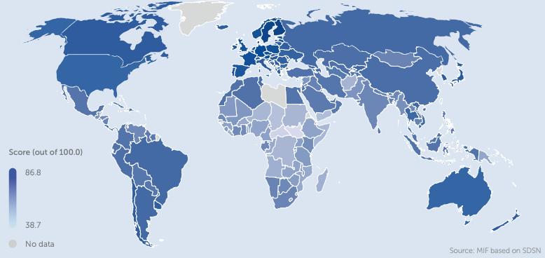
Africa needs to make greater progress to meet the SDG deadline, which is two thirds of the way to 2030. The 2023 Sustainable Development Report states that at least one African nation has achieved only six of the 17 SDGs. Of these six, SDG 13 Climate Action and SDG 12 Responsible Consumption and Production are the two that are performing the best; 34 and 30 out of 54 nations, respectively, have already achieved them.

• 34 nations met SDG 13 Climate Action.
• 30 nations met SDG 12: Responsible Consumption and Production. At least one nation has already achieved the remaining four SDGs:
• Algeria, Mauritius, and Tunisia: SDG 1: No Poverty
• Seychelles: SDG 4: Quality Education
• Gender Equality SDG 5: Namibia
• SDG 10: Algeria's Reduced Inequalities
On average, 18 sub-Saharan African nations are less than halfway to achieving the desired results for each of the SDGs. We predict that, if current trends continue, 600 million people will remain in extreme poverty after 2030. The core of the issue is money.

However, none of the countries have achieved the important SDGs relating to development, and the majority are experiencing significant obstacles. Every one of the 54 African nations is categorized as having major or severe obstacles to reaching the SDGs.
SDG 2: No Hunger & SDG 3: Well-being and Health
• 50 out of 54 nations are categorized as "facing major challenges," and the remaining 4 are categorized as "facing significant challenges" for SDGs 2 and 3 (no hunger and good health and well-being).
• Few nations outside of Africa are doing any better in spite of this. Not only are African nations falling short of SDG 2, but the US and the UK are also categorized as "facing major challenges."
• In addition, the data poses intriguing problems because the SDG approach does not take intersectionality into account. For instance, while achieving SDG 1 No Poverty, nations like Algeria continue to face significant obstacles in achieving SDG 2 No Hunger.

Is progress towards development-related SDGs ruling out progress in climate-related SDGs?
The intricate connection between development and climate goals on the continent is highlighted by the table on the overleaf that displays each African nation's performance across the 17 SDGs. Economically less developed nations emit fewer emissions, which helps them achieve the SDGs related to climate change. However, performance on climate-related metrics declines as nations advance in their socioeconomic development, suggesting that climate and development objectives need to be better aligned. This illustrates how challenging it is for any nation to accomplish all of the SDGs at once.

In fact, compared to other global regions, the largest percentage of African nations have already attained SDG 13 Climate Action. These nations concurrently confront significant obstacles in terms of socioeconomic or human development metrics.

However, the only African nations having difficulties with climate-related indicators are those that have made progress in human or socioeconomic development metrics. For example, the only African nations to have achieved SDG 1 No Poverty are Algeria, Tunisia, and Mauritius. But according to SDGs 12 and 13, they are all categorized as facing problems. This pattern is also seen in other parts of the world: although the majority of African nations have accomplished SDG 13 Climate Action, neither the US nor Canada nor the EU have. Nearly 90% of North American and EU nations are having significant difficulties reaching SDG 13, and none are on course to do so. At the same time, these regions are rating among the highest when it comes to socio-economic development metrics.

The AU's Agenda 2063: assessing the first decade of progress (2014-2023)
The strategic plan for Africa's transformation between 2013 and 2063 is known as AU Agenda 2063. It is structured around 20 aims and seven aspirations. There are five Ten-Year Implementation Plans for Agenda 2063. 2014–2023 was covered by the First Ten Year Implementation Plan (FTYIP). The first evaluation of the FTYIP was created by NEPAD and presented to the AU Summit in February 2024.

AU Agenda 2063 – 20 Goals
The African Union's strategy plan for changing the continent between 2013 and 2063 is called Agenda 2063. It is centered on 20 objectives and seven ambitions. Five Ten-Year Implementation Plans comprise Agenda 2063. The period covered by the First Ten Year Implementation Plan (FTYIP) was 2014–2023. NEPAD created the initial evaluation of the FTYIP in 2022, which was presented at the AU Summit in February 2024.

AU Agenda 2063 – 20 Goals
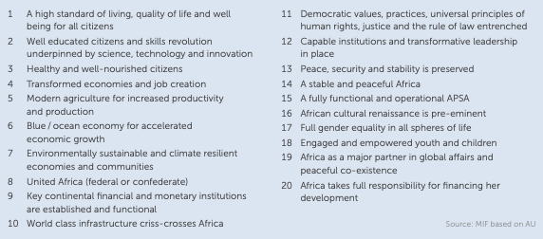

Selected African countries: Agenda 2063 FTYIP implementation progress (2022)
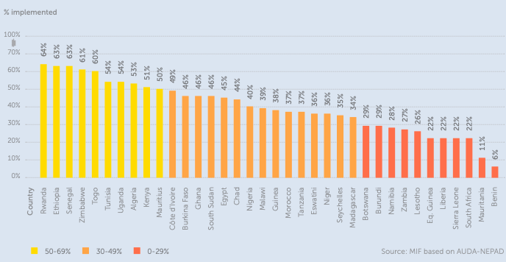

Only ten nations, which together accounted for 23.8% of Africa's population in 2022, had achieved at least 50% of their targets by the end of the FTYIP: Rwanda (64%), Ethiopia (63%), Senegal (63%), Zimbabwe (61%), Togo (60%), Tunisia (54%), Uganda (54%), Algeria (53%), Kenya (51%), and Mauritius (50%). Conversely, 11 nations—which together will account for 9.4% of Africa's population in 2022—have an implementation rate of 30% or less. These nations are Burundi (29%), Namibia (28%), Zambia (27%), Lesotho (26%), Equatorial Guinea (22%), Liberia (22%), Sierra Leone (22%), South Africa (22%), Mauritania (11%) and Benin (6%).

Just five of the twenty goals are evaluated as having more than 70% of their implementation completed at the goal level: Objective 3: Healthy and nourished citizens Objective 8: United Africa (federal or confederate); Objective 10: Africa is crisscrossed by world-class infrastructure; Objective 13: Peace, security, and stability are maintained; and Objective 17: Complete gender equality in all areas of life. Importantly, Goal 4—Transformed economies and job creation—is the least implemented of the 20 goals, with only 17% of them being achieved. This is crucial given the main areas of this goal measure focus points for the economic development of the continent: manufacturing, industrialization, value addition, and STI-driven economic diversification and resilience; hospitality and tourism; and sustainable and inclusive economic growth.
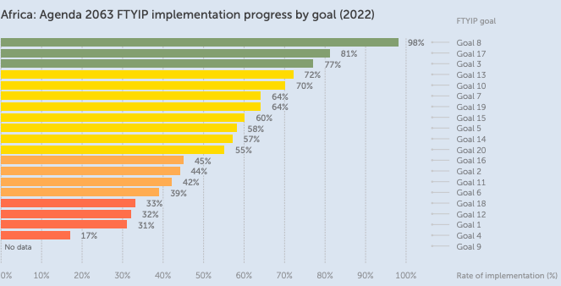

Goal 8: United Africa (federal or confederate), Goal 17: Complete gender equality in all areas of life, and Goal 3: Healthy and well-nourished citizens are the three Agenda 2063 goals that are performing the best. Goal 4: Transformed economies; Goal 1: A high standard of living, quality of life, and well-being for all citizens; and Goal 12: Capable institutions with transformative leadership in place are the three Agenda 2063 goals that are performing the worst. Less than one-third of Agenda 2063's first decade goals (FTYIP) have been met by 11 nations, including South Africa.

The Second Ten-Year Implementation Plan (STYIP)
The Second Ten-Year Implementation Plan (STYIP), which was introduced by the AU at its Summit in February 2024, consists of seven "moonshot" goals that must be accomplished in the upcoming ten years, from 2024 to 2033 (the "Decade of Acceleration"). Motivated by Agenda 2063's goals, the objectives are as follows:
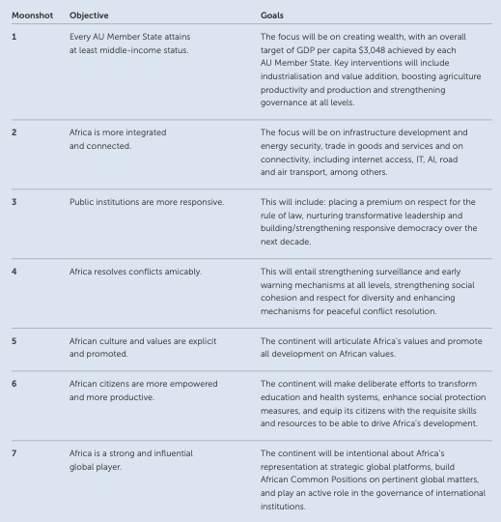

CLIMATE: A COMPLEX FRAMEWORK, SEVERELY 23 UNDERFUNDED
Africa's particular climate situation. Despite being the most impacted, Africa bears the least responsibility for climate change. Africa accounted for only 2.8% of global fossil fuel emissions between 1850 and 2021, while the OECD nations, Russia, and China together are responsible for more than 75% of historical fossil fuel emissions. African countries are less resilient to climate change due to their limited economic growth. Seven of the ten most climate-vulnerable countries in the world are in Africa, according to a 2021 assessment by the Notre Dame Global Adaptation Initiative (ND-GAIN), which considers both country-specific geographic vulnerabilities and climate vulnerability in terms of economic development. Because of its limited economic development, Africa will continue to emit very low emissions in the near future. But everywhere, the process of developing industrial economies with robust food and energy systems, jobs, infrastructure, safe housing, and overall human progress may be fraught with emissions. Africa has seven of the world's ten most climate-vulnerable nations.

First, a loss of continental GDP, up to $50 billion annually by 2030
The AfDB (2022) estimates that climate change costs Africa $7–$15 billion a year, and by 2030, that amount is predicted to increase to almost $50 billion. By 2050, the cumulative macroeconomic impacts of climate change may reduce the continent's GDP by up to 3%, according to the OECD (2023). According to UNEP projections, the annual decline in GDP per capita growth might reach 15%. Additionally, the WMO projects that by 2025, the annual food imports of African nations will have increased thrice, from $35 billion to $110 billion, partly as a result of the deteriorating consequences of climate change. Food and water shortages, population displacement, droughts, floods, damage to crops and infrastructure, loss of harvest and agricultural revenue, and natural disasters are the main causes of Africa's GDP decline brought on by climate change.

Selected figures for climate-related costs
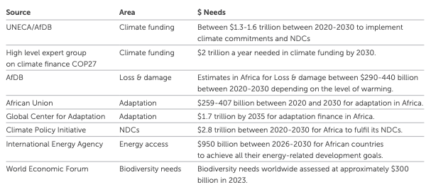

Between 2020 and 2030, to fulfil its NDCs, Africa needs $2.8 trillion
At COP21 in 2015, the Paris Agreement was established as a legally enforceable international framework. According to the accord, emissions must be reduced by 50% by 2030 to reach net-zero emissions by 2050. It will regularly evaluate progress on climate change. All 54 African nations signed it, committing them to submit Intended Nationally Determined Contributions (INDCs) every five years that detail the actions and financial requirements to achieve the objectives of the Paris Agreement. Alignment with the Paris Agreement is the AU's goal. According to estimates made in 2022 by the World Economic Forum (WEF) and the Climate Policy Initiative (CPI), Africa will require $2.8 trillion between 2020 and 2030 to meet its NDCs under the Paris Agreement ($277 billion annually for the decade between 2020 and 2030). All African nations have approved their NDCs as of 2024, except Libya.

• All African nations, except Libya, have filed their first NDC, detailing their strategies for reducing emissions and preparing for the effects of climate change.
• Forty-six of them have updated their initial NDC.
• A second NDC has already been filed for registration by South Sudan, Madagascar, Gabon, and Gambia.

African nations: as of February 20, 2024, NDCs are listed in the United Nations Framework Convention on Climate Change (UNFCCC) registry. The Paris Agreement relies on a gradual escalation of both collective and individual ambition, acknowledging that the long-term objectives outlined in its Articles 2 and 4.1 will be achieved over time. The UNFCCC secretariat receives NDCs every five years. To reflect the utmost aspiration, subsequent NDCs are anticipated to offer progress over the previous NDC.

Between 2020 and 2030, Africa would require $2.8 trillion to meet its NDCs. African nations: as of February 20, 2024, NDCs are listed in the United Nations Framework Convention on Climate Change (UNFCCC) registry.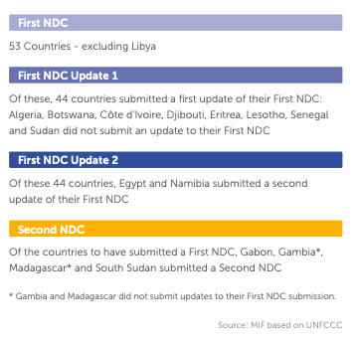

Adaptation vs mitigation: In Africa, adaptation should get the lion’s share of climate finance
The low level of economic growth in African nations, coupled with problems of energy and food security,, as well as housing and infrastructure shortages, makes people less resilient to the effects of the climate crisis. This creates a vicious cycle whereby adaptation and resilience capacities are further weakened while the impact of climate change and extreme weather events are felt more keenly because of already poor resilience. Though these are not a short-term priority in the particular context of Africa, NDCs typically focus more on mitigation because the Paris Agreement targets centre on lowering emissions internationally.
CPI estimates that, at $1.6 trillion, or 66% of all climate financing needs, mitigation will account for the greatest portion of reported needs in 2020–2030. Transportation accounts for 58% of mitigation needs, followed by energy (24%), industry (7%), and agricultural, forestry, and other land use (AFOLU) (9%). With the exception of South Africa, which has the majority of the transportation needs, the breakdown of mitigation needs by sector is as follows: industry (20%), transportation (10%), AFOLU (27%), and energy (39%). Sub-Saharan Africa's adaptation needs were assessed by CPI in 2022 to be $579.2 billion between 2020 and 2030, which is greater than any other region's needs and only accounts for 24% of all identified climate finance needs. Building climate-resilient infrastructure and cities, safeguarding water supplies, increasing agricultural output, and preserving coastlines are examples of common adaptation strategies. Policies to reduce carbon emissions, such as carbon taxes and cap-and-trade schemes, are common mitigation strategies. Africa does not prioritise mitigation efforts, which are often the emphasis of NDCs.

Africa: reported climate finance needs by type (2020-2030)
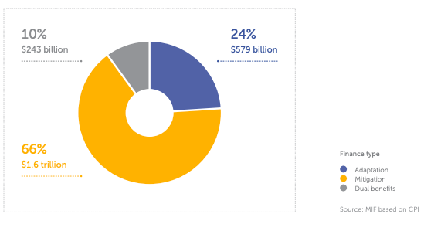
The Global Centre on Adaptation (GCA) and Africa's NDCs estimate that the continent needs $52.7 billion annually for adaptation. However, according to the GCA, only half of the NDCs (28) account for adaptation costs; therefore, this is probably a significant understatement. In fact, another evaluation of the NDCs by CPI in 2022 and by Brookings in 2024 both concur that the continent needs between $53 and $ 57 billion annually in adaptation finance. These numbers, based on Africa's NDCs, are likely greatly underestimated, according to Brookings and CPI, because there is insufficient data and technological know-how to determine the actual adaptation needs. Based on their initial estimate of $53 billion, Brookings contends that the annual cost of adaptation needs could be 100% higher, reaching as much as $106 billion. Furthermore, by 2035, Africa would mobilise only $195 billion at current financing levels of about $30 billion annually. At the highest estimate, the annual adaptation funding projections might reach $106 billion, which would not even cover adaptation costs for two years.

But in 2023, the Institute for Global Environmental Strategies (IGES) projects an even higher figure based on NDCs, which distinguishes Africa's significant demands from those of other regions. IGES estimates that Africa will require $3.5 trillion to address its climate, of which $2.1 trillion would go toward mitigation, $986.6 billion toward adaptation, and $364.7 billion toward unidentified requirements. Africa accounts for 55.3% of the world's total climatic demands.

Africa is responsible for 69.3% of mitigation needs and 71.0% of adaptation needs. The lack of mitigation financing numbers from big emitters in their separate NDCs is one factor contributing to Africa's shockingly high proportion of mitigation demands. The actual climate financing needs for Africa are diverse and far greater than existing flows, and likely far greater than the predicted needs stated in the NDCs, as shown by data from Brookings, CPI, and IGES.

Due to data inadequacies and the NDC's emphasis on mitigation, Africa's overall climate demands and its priority share of adaptation climate funds are understated. Africa's adaptation needs could cost up to $106 billion a year, 100% more than previously estimated. By 2030, Africa's total climate-related demand will be about $3.5 trillion.

World regions: mitigation and adaptation financial needs as expressed in NDCs (2022)
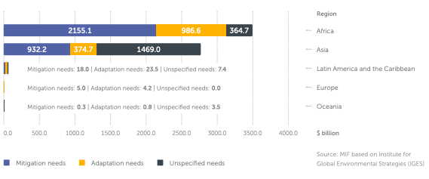
Financing climate goals cannot come at the expense of development goals
There is considerable fear in Africa that a greater emphasis on climate finance may displace funds meant for development. For Africa, balancing growth and climate is essential. A crucial first step in this direction is enough adaptation funding, which should be kept apart from mitigation funding. Furthermore, increasing climate financing pledges shouldn't come at the expense of existing development finance. At the 2009 Copenhagen COP15, wealthy nations pledged to provide scaled-up, new, and additional funding to developing nations for climate change adaptation and mitigation efforts, with a target of $100 billion per year between 2020 and 2025. When wealthy nations contributed around $116 billion in climate funding in 2022, this target was finally achieved.

The UN General Assembly decided in 2015 that climate change funding should be "new and additional," meaning it shouldn't come at the expense of other SDGs. Climate finance should not take precedence over non-climate development finance in new funding since this would make communities more susceptible to climate shocks. Climate money should neither replace existing development finance nor merely reclassify it; instead, it should complement it. Foreign aid fell by over 5% in 2022, the year the $100 billion target was met, according to ONE, raising serious concerns about the "new and additional" criterion. It has been discovered that just 7% of the climate financing provided between 2011 and 2020 was "new and additional" to the ODA commitments already made by high-income nations.

World: development & climate finance (2009 & 2020)
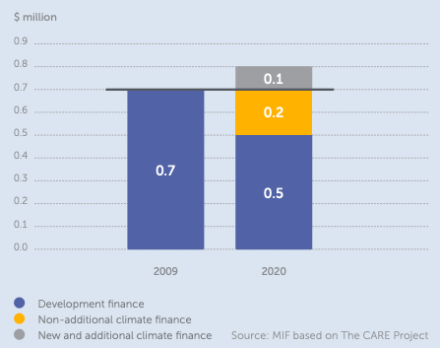

However, according to CARE, the total amount of "additional" climate financing given since 2009 is just about $141 billion. This is still far less than the $53–$106 billion that CPI and Brookings predict the continent will require for adaptation alone. As a result, resource-constrained developing nations are compelled to choose between investing in other development goals, mitigating the effects of climate change, or reducing their own already low emissions. The 20 most climate-vulnerable nations in the world received only $1.7 billion in climate finance disbursements in 2021, which is just 6.5% of the annual climate financing they require to combat climate change, according to the ONE Project. Furthermore, it was reported that less than half (49%) of the climate money committed by bilateral donors between 2013 and 2021 had been disbursed or had a significant climate connection.
According to the ONE Project, to meet their own goals, climate finance funders are typically free to define what constitutes climate-related funding as they see fit. This allows providers to claim additional climate financing without increasing their pledges or budget. In October 2023, for instance, the UK broadened the definition of climate money, allowing cash designated for unrelated projects to be reclassified as climate finance, indicating that no new funding was received. Some nations, including the US, Italy, Japan, and the EU, used "creative counting" to eventually meet the $100 billion target in 2022 due to the absence of standardised reporting guidelines. For instance, they included counterterrorism initiatives and coal-fired and natural gas-fired power facilities in the $116 billion in climate money.

Moreover, over two-thirds were provided as loans rather than grants, further increasing the financial strain in nations affected by climate change. Only $1 out of every $5 in "climate finance" promises in the OECD's public dataset between 2013 and 2021—worth $115 billion—are actually related to climate change due to this complicated financial framework and high-income countries' lack of commitment to pledges and international accords. Some affluent nations counted non-climate-related expenses to meet the $100 billion annual climate funding target. The debt crisis in developing nations was exacerbated by the fact that loans accounted for two-thirds of the $116 billion in climate funding offered by rich nations in 2022.

Major emitter countries provide no financial figures to implement their NDCs
The latest NDC filings in the UNFCCC's NDC registry show that several major economies have failed to provide the funding needed to implement their adaptation and mitigation plans. Giving the biggest emitters comprehensive plans and funding is essential, given the Net Zero Coalition's 2050 worldwide timeframe for achieving net zero. However, the goals, targets, and costs for emission-reduction objectives are not explicitly stated in the NDCs submitted by nations such as the US and China. A significant portion of the worldwide mitigation financial needs are probably unaccounted for since the veracity of global mitigation and adaptation estimates is compromised by the absence of these figures for the biggest emitting nations.

The majority of African nations have provided specific numbers for their mitigation and adaptation needs. Even though Africa has a greater share of adaptation needs than mitigation needs worldwide, data is skewed by the absence of data from the biggest emitters, which means Africa accounts for a sizable share of mitigation needs worldwide (69.3%, according to the IGES). "N/A" appears next to several adaptation and mitigation sections in the United States' most recent NDC, which was released in 2021. In its introduction, the NDC notes that "the United States is the second-largest producer and consumer of energy in the world." Significant opportunities are thus created to reduce greenhouse gas emissions through energy efficiency, electrification of end-uses that currently burn fossil fuels, and a carbon-free energy supply. However, the NDC is written in ambiguous terms and lacks any supporting figures.

Similarly, in China’s most recent NDC, while it states that “the central government budget has scaled up investments in climate change mitigation and adaptation and technological support” it does not provide the figures to prove this or to understand the scale of these commitments.

In the US' NDC, the following key sections are marked with "N/A":
Information on adaptation plans that also yield mitigation co-benefits, including specific projects, measures, and activities to be implemented to contribute to mitigation co-benefits that may cover, but are not limited to, key sectors like energy, resources, water resources, coastal resources, human settlements and urban planning, agriculture, and forestry; and economic diversification actions that may cover, but are not limited to, sectors like manufacturing and industry, energy and mining, transportation and communication, construction, tourism, real estate, agriculture, and fisheries.

Confronting Incoherence in Development Financing Discussions
The one noteworthy truth, without getting bogged down in the specifics, is that the majority of requirements estimates are orders of magnitude greater than the financing that is currently available and larger than realistic projections for the financing that is probably going to become available in the next five years. Although there is a great deal of opportunity to raise money by rerouting illegal financial flows out of Africa or by taking advantage of Africa's inherent ability to supply carbon markets, it will take many years to realize this potential.

As a result, the total amount of money required to reach the SDGs and fulfill the climate agenda is hundreds of billions or possibly trillions of dollars more than the existing domestic and international financing flows for African development. The growing demand for humanitarian aid and refugees, along with the reallocation of money to address the aftermath of the conflict in Ukraine (and, eventually, Gaza), are putting strain on concessional finance or ODA flows. A significant and long-term rise in private funding for development and climate projects is anticipated, assuming a departure from historical patterns and long-standing customs among official development finance institutions and private investors, both of which are anticipated to act as catalysts for this expansion. Furthermore, even though the origins and destinations of illegal financial flows are now widely known, it is still difficult to overcome the financial and political opposition to cracking down on them.

This discrepancy between financial projections based on potential or demands and financing availability influenced by political, policy, or budgetary restraints is not specific to Africa. However, ignoring it is especially detrimental when developing a plan for funding the continent's future growth. An open discussion on priorities and tradeoffs is hampered by the time and money invested in creating intricate national and continental investment plans that are unlikely to be implemented due to a lack of financing. In the context of cross-border flows, the discrepancy between promises and delivery further erodes confidence, harming international debates and making it more difficult to reach consensus on common issues.

The inherent incoherence in the numbers presented in the various chapters necessitates this examination. Confronting that incoherence and advocating for greater realism and genuine ambition are the challenges facing analysts and politicians. Real ambition concentrates on the resources required to push the boundaries of what is feasible rather than on lofty goals devoid of realistic resources. Ultimately, we can only truly improve the lives of Africa's expanding population and satisfy the demands of its impatient young by pushing limits.

Conclusion
A comprehensive and depressing analysis of how Africa's economic present is inextricably linked to its colonial past may be found in Chapter 4 of Debt Chains: Breaking Free from Africa's Financial Struggles. The main takeaway from this chapter is that Africa's debt crisis is not just a financial or technological problem, nor is it exclusively the result of recent corruption or poor management. Instead, it is the outcome of a centuries-long process where colonialism, global power disparities, and predatory financial systems have methodically weakened the growth and autonomy of the continent.

The chapter's challenge to the prevailing narratives that attribute Africa's debt to the alleged shortcomings of African governments is among its most significant contributions. Although corruption and bad administration have occasionally been factors, these justifications are insufficient and frequently mask the more profound structural and historical factors at play. Debt has always been about power, the chapter shows, about who controls resources, who makes the rules, and who gains from the world economy. African societies have been bound to the interests of foreign powers and institutions through the use of debt as a tool of domination and extraction since the early days of European colonial expansion. Millions of Africans were taken from their homes and transported across the Atlantic and other routes during the slave trade, which is when the chapter examines the origins of Africa's debt crisis. In addition to causing havoc among populations, this massive displacement damaged social structures, undermined trust, and slowed economic growth. The slave trade's long-term effects are still visible today, as the areas most impacted by slavery have greater rates of poverty, less robust institutions, and ongoing warfare.

Economic restructuring and systemic exploitation were features of colonialism itself. European powers converted African economies into export-driven structures intended to further the interests of the metropolis. Roads and railroads were constructed to transport resources swiftly to ports for sale, not to link African communities or promote local development. Rarely did the riches created by Africa's resources serve the local populace; rather, it supported European industrialization while keeping African nations impoverished and reliant. The chapter demonstrates how the legacy of these extractive economies persists, with many African nations still relying on a small number of exports and remaining susceptible to fluctuations in global prices.

The examples of colonial and post-colonial loans imposed on African nations provide perhaps the most compelling proof of debt as an instrument of control. The Haitian example is particularly potent since, after gaining independence, Haiti was compelled to reimburse France for the "loss" of property, including slaves. This debt destroyed Haiti's economy and took over a century to pay back. South Africa and its neighbors were left with £28 billion in debts associated with apartheid and regional instability, while Zimbabwe inherited a $700 million debt from the colonial Rhodesian government. In addition to being unfair, these debts severely burdened newly elected administrations, preventing them from making investments in growth and bettering the lives of their constituents.

The chapter also looks at how colonial-era financial systems, such the CFA franc monetary zone, continue to have an impact. This structure continues to deplete Africa's resources and limit its members' economic autonomy by requiring them to maintain a sizable amount of their foreign reserves in the French treasury. Even decades after formal independence, colonial links have been maintained and modified to suit the interests of former colonial powers, as seen by the CFA franc zone.

Much of the chapter is devoted to the ways that international organizations, particularly the World Bank and IMF, have used neoliberal policy reforms and structural adjustment programs to prolong Africa's debt problem. African governments have been forced to reduce public spending, privatize state assets, and open their economies to global competition as a result of these policies, which are frequently enforced as prerequisites for fresh loans or debt relief. Although the claimed objective was to foster stability and growth, the reality was frequently disastrous for common people. Whole communities were left without assistance, worker rights were undermined, and social protections were reduced. Due to increased unemployment, hunger, and limited access to essential services, women, children, and the impoverished were disproportionately affected by austerity measures. The chapter makes it abundantly evident that these policies increased Africa's reliance on loans and aid from outside sources rather than addressing the underlying reasons of the continent's debt issues.

The significant human cost of unmanageable debt is also highlighted in the chapter. Ordinary citizens suffer the most when governments are compelled to spend more on debt repayment than on necessary services. Human rights are violated as cycles of poverty and inequality are sustained by underfunding infrastructure, health care, and education. Disillusioned by the lack of prospects, young people are frequently motivated to travel overseas in search of better opportunities, sometimes putting themselves in danger and being exploited.

The chapter addresses the effects of artificial borders established during the Scramble for Africa in addition to these structural and historical issues. Conflict and instability have been greatly exacerbated by these borders, which divided ethnic groups and established fictitious states. According to studies reviewed in the chapter, ethnic group division and state artificiality are powerful indicators of repression, conflict, and economic underdevelopment. Africa's political and economic environment is still shaped by the effects of colonial aggression, exploitation, and indirect domination.

Although the chapter paints a grim image, it also highlights instances of resistance and optimism. A surge of hope and a vision of Pan-African solidarity were introduced by the independence movements of the mid-20th century, which were led by figures such as Kwame Nkrumah and Julius Nyerere. However, the demands of the Cold War, the legacy of debt, and the reality of the global economy soon dampened the optimism of the post-independence era. Despite its occasional good intentions, foreign aid frequently did not advance real development and, in certain situations, worsened the situation by escalating conflict and corruption. The chapter ends by making the case that financial engineering and technical solutions alone are insufficient to alleviate Africa's debt dilemma. It calls for a commitment to creating a more just and equitable global economic system as well as a fundamental reckoning with the history of colonialism. This entails opposing the influence of former colonial powers and international financial institutions, standing up for African nations in their fight for economic justice, and prioritising the welfare of people and the environment over the interests of creditors and businesses.

In conclusion, Chapter 4 offers a convincing and sophisticated examination of the ways in which a lengthy history of exploitation, structural inequality, and outside control are the foundations of Africa's debt issue. The chapter urges a fresh strategy that acknowledges the crisis's historical causes, prioritizes the interests and voices of Africans, and unites in the pursuit of a more equitable and sustainable future. Africa can only expect to escape the shackles that have kept it back for so long by facing the lingering effects of colonialism and debt.

CHAPTER 5: UNLOCKING DOMESTIC RESOURCES IN AFRICA

"The time has come to examine the different factors that are impeding the mobilisation of development finance in Africa in a practical manner without complacency."
Despite numerous pledges to alleviate this burden, all of our Member States have been ensnared in a vicious cycle of ever-increasing debt, which keeps them under the control of creditors with oppressive demands.

Although a number of endogenous causes can account for this excessive reliance on debt, an external funding model that combines debt relief, development aid, the promises of green financing, and the allure of African nations for foreign direct investment is also to blame. Similar gatherings, like the one in Paris in June 2021, have since adopted this paradigm, which was outlined in the 2015 Addis Ababa Declaration on Financing for Development. Objective evidence has been used to establish this [external funding] model's limitations. Another injustice against Africa is that the external funding's contribution to the continent's development agenda has fallen well short of expectations.

In addition to the detrimental effects of financial crises, Africa is subject to high financing costs due to the administration of the global financial system, which is beyond its control. To propose and implement pertinent solutions for nations dealing with issues like sovereign rating, excessive debt, the effects of climate change, tax evasion and illicit flows, the need to strengthen multilateral banks, and so forth, it is imperative that a comprehensive reform of international governance be undertaken.
The process of developing shared African stances on the strategic concerns at the core of the global financial system reform should be successfully started by our institutions and our nations in the G20. Especially on the difficult issues of international taxation, climate change financing, debt management, and the Bretton Woods institutions, especially in light of the current events leading up to the adoption of a United Nations Framework Convention on International Cooperation in Tax Matters.

We must immediately implement our own monetary and financial reforms to prepare for a potential reconfiguration of the global financial system. There has been a a significant delay in establishing the African Union's long-standing financial institutions. The moment has come to develop a tangible plan to bring the African Central Bank, African Investment Bank, African Monetary Fund, and Pan-African Stock Exchange operational. I also demand that the African Development Fund's resources be aggressively restored. The concessional financing necessary to sustain our economies is provided by this instrument.

Where is the Money? Youths?
Africa's current economic situation is a patchwork of contradictions. Despite abundant resources and a growing number of young people and entrepreneurs, the continent still faces structural financial constraints that limit its potential. We must critically assess the current global financial paradigm, explore creative funding sources, and make a determined move toward achieving Agenda 2063's goals while we navigate these complexities. The youthful population of the continent, which is predicted to grow from about 1.3 billion to 2.2 billion by 2043, offers a unique opportunity for economic growth and development. From US$1,132.5 billion in 1990 to US$3,055.3 billion in 2019, Africa's GDP has increased significantly and is expected to reach US$8,724.4 billion by 2043. However, population growth—rather than productivity increases—is the main driver of this expansion. Even though the continent is home to 17% of the world's population, its economy still makes up a modest percentage of the global economy—just 3.1% in 2019.

This discrepancy emphasizes how structural change is required to attain sustainable growth. With its origins in Western economic theories, the global financial model has often failed to adapt to African realities. It mostly helps the "creditworthy" and the "stable," leaving behind countries that are in dire need of investment but do not fulfil these criteria. Furthermore, foreign loans and assistance often come with conditions that may not align with Africa's socioeconomic dynamics or developmental goals. In addition to limiting the budgetary room required for expansion, this strategy has sustained a dependence cycle. Achieving significant structural change and meeting the lofty objectives of Agenda 2063—which aims to create an integrated, affluent, and peaceful Africa led by its own people and a powerful player in the global arena—will require significant investment.

The Second Ten-Year Implementation Plan's seven Moonshots require US$8.9 trillion over the next ten years, with an estimated US$3.3 trillion gap. This disparity emphasises how urgently creative financial alternatives are needed. Conventional funding sources won't be enough on their own. It's critical to stop illegal financial flows, which cost the continent up to $60 billion a year. Global financial policies can better align with Africa's needs if international financial institutions are reformed to give African nations a greater say in decision-making. Improving financial infrastructure and creating risk-reducing financial products, such as as capital flight insurance and currency hedging tools, are crucial first steps. Growth can be accelerated by advancing inclusive and sustainable finance through fintech innovations, green bonds, and increasing access to financial services, especially in underserved areas.

We require cutting-edge financial instruments that leverage Africa's abundant resources. Green bonds, diaspora bonds, and thematic funds that focus on particular industries like infrastructure and renewable energy can mobilise domestic resources and capitalise on the savings of the African diaspora. A strategic alliance of African governments, business executives, and development partners dedicated to revolutionary initiatives throughout the continent is known as the "Africa Team." By working as a team, we can share risks, pool resources, and increase the returns on our investments. The Africa Team's effort is a perfect example of the kind of cooperation and coordination necessary to mobilise resources and carry out Agenda 2063. The Africa Team seeks to promote regional integration, economic cooperation, and sustainable development by utilising the advantages of member nations, regional economic communities (RECs), and international partners.

AUDA-NEPAD’s efforts in mobilizing resources through the Africa Resource Mobilization Campaign, developing infrastructure projects under PIDA PAP 2, and promoting innovation through digital transformation initiatives exemplify the collaborative approach needed to achieve Africa’s development goals. The money to finance Africa’s future is right here on the continent and within the global African diaspora. It lies in our natural resources, our people, and our innovations. It is within the grasp of new, tailored financial instruments that respect our unique contexts and tap into our vast potential.

Furthermore, it exists in international alliances founded on respect and interest rather than the outdated ideas of help. We must continue to push for a revised international financial system that takes into account the unique requirements and contributions of African nations. Through this approach, we can open up new avenues for sustainable development that address the questions of "Where is the money?" and "How can it be used to transform Africa?"

Financing Agenda 2063: at least 75% expected to come from domestic resources according to the AU
The AU states that, on average, domestic resource mobilization should cover 75–90% of Agenda 2063's funding per nation. The continent and the African diaspora around the world have the financial resources to support Africa's development. It is found in our people, our innovations, and our natural resources.
The strategic framework for Africa's transformation from 2013 to 2063 is the African Union's Agenda 2063. There are five 10-year implementation plans for Agenda 2063. As stated by the AU in 2013 and reaffirmed at the most recent AU Summit in February 2024, funding for Agenda 2063 comes from two sources: External Financing Mechanisms (EFM) and Domestic Resource Mobilization (DRM). On average, DRM is expected to provide 75–90% of Agenda 2063's funding each nation, specifically:
1. Increased mobilization of fiscal resources.
2. Optimizing the rents from natural resources, such as tourism, agriculture, and the sea.
3. Making use of African institutional savings, such as capital market growth, sovereign wealth funds, pension funds, and foreign exchange reserves held by the central bank.
4. Improved financial inclusion-based retail saving mobilization, specifically: a. The reduction of illicit financial flows (IFFs).
b. The decrease of financial leaks and wastes caused by inefficiency and governance/corruption. EFMs will finance the remaining 10–25% of Agenda 2063 funding, which includes: 1. Foreign Direct Investment (FDI).
2. Official Development Assistance (BRICS countries, Arab and Gulf partners, and other emerging development partners)
3. Financial cooperation.
4. Other types of investment collaborations, such as Public Private collaborations (PPPs).
5. Making use of savings and remittances from the diaspora.
6. Enhanced accessibility to global financial markets.

PREVENTING LEAKAGES THROUGH ILLICIT FINANCIAL FLOWS
Africa loses up to $100 billion each year to IFFs. Illicit Financial Flows (IFFs) refer to the movement of money across borders that is illegal in its source (e.g. corruption or smuggling), in its transfer (e.g. tax evasion), or in its use (e.g. terrorist financing). While not a purely African phenomenon, IFFs are particularly damaging in finance-scarce regions. They are relatively easy to define, but difficult to quantify, given their illicit nature. According to UNCTAD in 2020, estimates of IFFs leaving Africa on an annual average are almost $90 billion. The amount is higher than all FDI or ODA the continent is receiving. Estimates of IFFs leaving Africa annually amount to about $100 billion.

Africa: remittances, IFFs, ODA & FDI (latest data year 2020-2022)
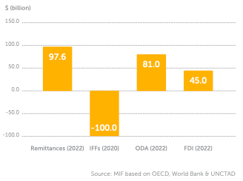

The Yaoundé Declaration (2017)
The Yaoundé Declaration is a call to action to address IFFs through international tax cooperation in the wake of the 2015 Mbeki Report. The statement calls on the AU to start high-level talks on IFFs, tax cooperation, and how they relate to mobilizing domestic resources. Although it is unclear how many have ratified the declaration, as of March 2022, 34 African nations and the AU Commission had signed it. The United Kingdom, France, and the OECD all formally support it.
Although they were published in 2015, the 15 main conclusions of the Mbeki Report on IFFs from Africa are still relevant and hardly used. Former President Thabo Mbeki served as the chair of the High-Level Panel on IFFs out of Africa, which was established by the UNECA in 2011.
The Mbeki Report, which was completed in 2015 and approved by the AU, offers a thorough set of suggestions categorized into five areas along with 15 important findings:
The commercial, criminal, and corrupt aspects of IFFs; additional strategic actions taken by African states; and further obligations of Africa's partners

Mbeki Report: 15 important conclusions
1. The number of IFFs from Africa is growing.
2. IFF termination is a political matter.
3. In every facet of IFFs, transparency is essential.
4. IFFs' commercial channels require more careful observation.
5. African nations are susceptible to IFFs due to their reliance on the exploitation of natural resources.
6. There are new and creative ways to create IFFs.
7. Cost-benefit analysis is typically not used to influence tax incentives.
8. The issue of corruption and misuse of authority is still present.
9. More work is required for repatriation and asset recovery.
10. The issue of money laundering still needs to be addressed.
11. Weak national and regional capacities hamper efforts to reduce IFFs.
12. The global infrastructure for addressing IFFs is incomplete.
13. Jurisdictions pertaining to financial secrecy need to be closely examined.
14. Development partners play a significant influence in reducing African IFFs.
15. All United Nations processes and frameworks should effectively integrate and coordinate IFF problems.

Although inconsistent, the Mbeki Report's execution is largely subpar. Since 2015, the number of IFFs from Africa has been constant, and there are very few historic IFFs returning to Africa from Europe. Although African nations have put in place a number of laws, rules, and organizations to regulate IFFs, their efficacy is still quite low. SDG 16 Peace, Justice, and Strong Institutions acknowledges that IFFs are still a major problem for all developing nations, and its fourth target calls for a considerable reduction in IFFs by 2030. SDG 16's fourth target, "significantly reducing IFFs by 2030," is focused on peace, justice, and strong institutions. Compared to Asia Pacific (19.8%) and Latin America and the Caribbean (21.7%), Africa has a substantially lower tax-to-GDP ratio (15.6%).

Better data and stronger capacities are needed to tackle IFFs
IFFs are made possible by a number of internal and external variables, including the relative lack of data and the institutional or tax system deficiencies among African nations. The continent's tax-to-GDP ratio is 15.6% lower than that of the Asia-Pacific region (19.8%), Latin America and the Caribbean (21.7%), and OECD nations (34.1%), according to the OECD.

Fighting Illicit Financial Flows: Tax Inspectors Without Borders, a concrete initiative
Since the 2008 global financial crisis, tax cooperation has advanced to levels previously unheard of. Bank secrecy was abolished, and tax authorities now regularly share data on both individuals and businesses. Large multinational corporations' tax evasion in Africa is still a significant problem with enormous financial stakes. As with conventional transfer pricing rules, part of the problem stems from the fact that tax laws are out of date. A global minimum tax of 15% is one way the international community has begun to address them, but more work has to be done. In addition to the policy challenge, developing nations frequently lack the capacity to implement existing regulations effectively. Limited audit capabilities, especially for foreign transactions, enhance the danger of illicit financial transfers.

A straightforward idea
In light of this, the effort Tax Inspectors Without Borders (TIWB), which was started ten years ago, should be viewed as a model of a workable and successful solution to directly assist African nations. The OECD and UNDP jointly manage this program, which has the straightforward idea of assigning qualified tax inspectors to help local teams conduct international tax audits. A nation chooses a business to audit but lacks the resources to do so and does not want its tax inspectors to engage in an unfair dialogue with hordes of highly qualified attorneys. The nation may request that TIWB provide an experienced tax inspector with expertise in the company's industry. At the time of the audit, a qualified tax inspector will be selected by the TIWB secretariat and sent to the nation. Since a local squad is required, there is no substitute. Instead, knowledge and skills are transferred through "learning in doing" experiences.

…with amazing results
Nearly US$ 4.5 billion in tax adjustments and over US$ 2.30 billion (US$ 1.82 billion in tax revenues in Africa) in increased tax revenues across 62 countries have been the outcomes of the program since 2015. The initiative's cheap cost (a volunteer tax inspector and a small secretariat) results in a $100 return on investment for every dollar invested. In addition to generating income, TIWB's work builds the long-term capabilities of developing nations. In addition to combating illicit financial flows, they have made a substantial contribution to the mobilization of domestic resources in poor nations, which is one of the Sustainable Development Goals (SDGs). Even certain tax crime-related deployments have been successful, as have South-South deployments, where tax inspectors from Kenya or India are stationed in certain nations. TIWB is a perfect example of how IFFs need to be addressed at both ends of the chain and are not a one-way street.

More to come?
Based on this experience, it could be worthwhile to investigate whether further "down-to-earth" efforts of this type could be developed and put into action to combat IFFs, a disease that undermines Africa's economic potential. In conclusion, the TIWB program is a crucial tool for answering the question of "Assessing and unlocking Africa's own financial resources." In their attempts to improve tax systems, raise money, and fight IFFs, developing nations—especially those in Africa—have found it to be a very useful instrument. The initiative's ability to continue helping recipient nations meet their development goals and efficiently mobilize their domestic resources is demonstrated by the results attained. This project serves as an example of creative and fruitful global collaboration.
African countries track tax and commercially related
IFFs World countries: tracking of crime-related IFFs & tax and commercial IFFs (2000-2022)
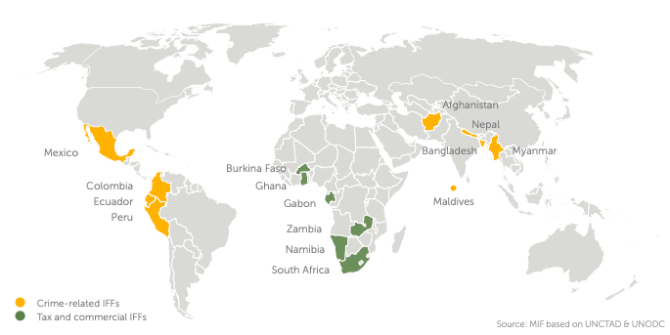
IFFs are not regularly monitored by nations, according to a UNCTAD/UNODC pilot program that tracked IFFs in Africa related to commercial and tax activities rather than crime-related activity in other regions. Only six African nations contributed data on inbound and outward IFFs through tax and commercial activities, despite the fact that eleven participated in the UNCTAD/UNODC pilot. Between 2010 and 2021, Gabon monitored the most tax and commercially linked IFFs, totalling $65 billion.

Selected African countries: inward and outward IFFs (2000-2021)
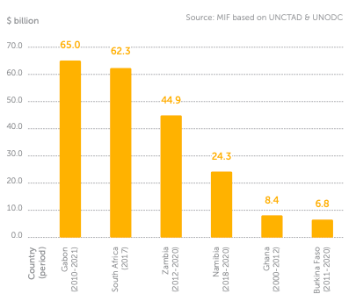
When resident funds are utilized to purchase goods and services from overseas (such as purchasing foreign financial or nonfinancial assets), outward IFFs occur. If nonresident illicit funds—such as those obtained from drug trafficking in another nation—are utilized in the country of interest, inward IFFs are produced. Lack of transparency, the institutional framework required to address IFFs, and the difficulties in acquiring information and data continue to be major barriers to effectively monitoring and combating IFFs in Africa, as seen by the low level of participation in the UNCTAD/UNODC initiative.

IFF enablers are mostly, but not all, outside the continent
To draw attention to the part intermediaries play in facilitating IFFs out of Africa, Transparency International (TI) conducted research. They found 87 professionals and companies that most likely enabled IFFs through criminal involvement, carelessness, or inability to address client risks in 78 incidents across 33 African nations. The role of international enablers is shown by the fact that in 88% of the cases, an enabler was involved in providing services to clients overseas. The British Virgin Islands, Switzerland, the United Arab Emirates, the United Kingdom, Nigeria, and Portugal are among the few nations that have a high number of IFFs associated with them. The importance of domestic enablers was also emphasized in the TI report. Sub-Saharan Africa is the destination for 10.3% of African IFFs, making Africa nearly as important as Europe as a destination for African IFFs. When compared to other African nations, Nigeria stands out for having a greater number of domestic enablers implicated in cases. Africa alone has the second-highest percentage of global IFF enablers, with Europe having the largest share.

World regions: number & location of enablers of IFFs from Africa (2023)
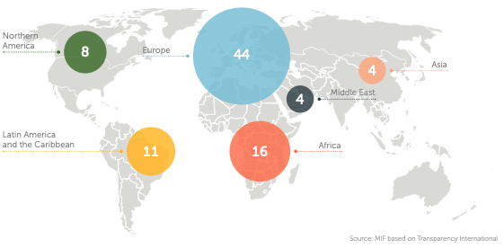

International cooperation is key to tackle IFFs
Africa's origin nations cannot fight IFFs by itself. It is the duty of destination nations to make sure that their own national and local laws do not encourage illegal migration. International initiatives like ratifying the UN Tax Convention frequently encounter opposition, especially in Europe, where the majority of the facilitators are located. Africa in the forefront of the worldwide UN Tax Convention Through the UN Tax Convention, Africa led the charge to introduce international tax cooperation to the UN. The November 2023 UN Resolution, which was supported by 125 nations and proposed by Nigeria, was rejected by the US, UK, Germany, and Japan, who said it was comparable to OECD-led initiatives.

World countries: stance on the UN Tax Convention (2023)
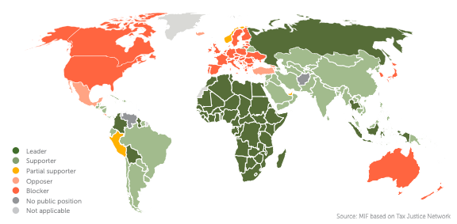

The AU on IFFs
Since the 2015 Mbeki Report on IFFs from Africa, the AU has been bringing up the subject of IFFs for more than ten years. In addition to highlighting the importance of regional institutions and international partners, it highlights the steps that AU members must take to address the commercial, criminal, and corruption aspects of IFFs. With 33 participating nations as of 2021, the Africa Initiative was started in 2014 and has trained over 2,000 African authorities, increased information requests by 26%, and helped nine African nations recover or identify $255 million. To enhance regional coordination in response to IFFs, the AfDB and the Coalition for Dialogue (CoDA) initiated a three-year, $5.9 million project in March 2023.

The Working Group on IFFs of the Africa-Europe Foundation A Strategic Working Group (SWG) on IFFs was established in 2023 by the Africa-Europe Foundation, which was co-founded by the Mo Ibrahim Foundation, in response to the 6th EU/AU Summit Final Declaration (February 2022), which notably addressed the need to address IFFs from Africa collectively. Co-chaired by Dr. Adeyemi Dipeolu, a former Economic Special Adviser to the President of Nigeria and former member of the Mbeki High-Level Panel, and Pascal Saint-Amans, Advisor, International Tax Task Force, and former Director, OECD Centre for Tax Policy and Administration, the SWG has already produced a thorough assessment of the 2015 Mbeki Report's implementation status as well as some preliminary recommendations, which the SWG is currently working on.The Africa-Europe SWG on IFFs highlighted four key areas to prioritise

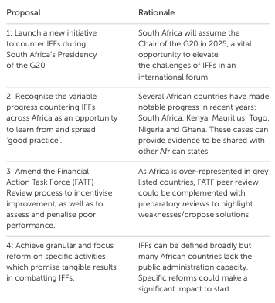

The EU on IFFs
The Brookings Institution and the Centre for Global Development (CGD) claim that the EU frequently applies milder versions of international standards. The EU Court of Justice ruled against beneficial ownership registries, a crucial weapon in the fight against IFFs, in November 2022. Nevertheless, some EU nations eliminated beneficial ownership public registers, hence impeding anti-IFF initiatives. Established in 2017, the worldwide anti-money laundering facility (AML) has a six-year budget of $22.0 million.
The European Central Bank (ECB), the European Banking Authority (EBA), and the EU's efforts were examined in a 2021 report by the European Court of Auditors, which discovered institutional fragmentation and inadequate coordination. The European Union's Emergency Trust Fund for Africa (EUTF) provided €5 million over three years to begin the Anti-money laundering and Financial Investigations Capacity in the Greater Horn of Africa (AML/THB) in 2020. Beginning with nine nations in the Greater Horn of Africa, the project seeks to enhance cross-border crime coordination and investigation. It now encompasses 16 nations.

Launched in 2019, the four-year Organised Crime West African Response to Money (OCWAR-M) project aims to support the implementation of international money laundering standards. It operates in 16 countries and has a €6.75 million budget. As of July 2023, 138 nations and jurisdictions are working together to create a more transparent tax environment as part of the G20/OECD BASE Erosion and Profit Shifting (BEPS) project, which was started in 2013 to combat tax avoidance. Launched in 2020 in response to the Mbeki Report, the Multi-Donor Action on Good Financial Governance in Africa is a €7 million joint AU/EU and GIZ initiative to improve anti-IFF policy coordination and fight IFFs in Africa.

The money is here 2:
We applaud the recent improvements in the financial architecture reform, including the support and testing of creative alternatives like callable and hybrid capitals, SDRs rechanneled through MDBs, etc. These are crucial tools that MDBs can use to raise significant and affordable funding for Africa. However, ODA to Africa has undoubtedly decreased as a result of the numerous crises and geopolitical tensions of the past several years, despite the fact that these resources are more urgently required than ever and should be expanded and better targeted to hasten the accomplishment of the SDGs. More concessional resources are generally required, which is why IDA and ADF's replenishments are being called for. In order to organize and attract additional resources for their own development, African nations are also putting solutions into practice. We must encourage this.

Improving domestic resources mobilization: Africa continues to have some of the lowest tax rates in the world. African nations can increase revenue by expanding the tax base, improving revenue collection governance, and assisting the shift to more formal economies without sacrificing competitiveness or leaving anyone behind.

Stronger governance and collaboration with partners are two ways to combat illicit capital flows, such as multinational corporations transferring their profits to low-tax jurisdictions. International tax cooperation is, in fact, essential to preventing revenue losses brought on by illegal financial activity. In this regard, the collaboration with OECD nations and the recently acquired AU seat in the G20 are very significant. The G20's present drive for a minimum corporation tax payment is a smart place to start. It must, however, benefit the continent, and we must make sure that the bare minimum of taxes are paid on the continent whenever value is created or taken from Africa.

Improving natural resource governance: Nations can produce greater financial resources by enhancing natural resource management's accountability, transparency, and governance. Signing balanced contracts for nations is crucial, but so is closely monitoring how these contracts are being carried out over time to make sure the nations are truly and successfully benefiting from them. In certain situations, technical support and capacity building are essential.

Luring private sector investment in collaboration with MDBs and partner nations by using creative financing techniques like blended finance, PPPs, and risk mitigation techniques. By facilitating the transfer of skills and supplying substantial cash without affecting government debt, the private sector may play a big role in advancing economic growth and infrastructural development in Africa. To lower project risks and costs, expedite project execution, and increase investment prospects, it is crucial to improve the business climate and make investments in locally equipped facilities for project preparation and development. Investors and credit risk agencies, however, must reevaluate how they approach risk on the continent.

Properly valuing governments’ assets properly and managing them commercially: What we propose;
- Opportunities for asset recycling, which allow nations to obtain upfront funding from the private sector rather than future profits from facilities that provide public revenue, including airports and toll highways. The money raised can then be used to fund additional social initiatives, ii. transferring some assets to sovereign funds so they can be used as leverage to raise additional cash and actively manage the government's stake in successful and/or strategically important businesses. Since they can act as trustworthy middlemen between the public and private sectors and are capable local players operating as commercial entities with access to governments, local sovereign funds are also crucial for facilitating the creation of more bankable projects.

An agenda for action led by African Development Banks
Multilateral banks have frequently received more attention in the field of development finance than National Development Banks (NDBs). Nonetheless, a country's development and structural change depend heavily on these institutions. Using their development emphasis to mobilize local private investment through patient, risk-tolerant capital, NDBs can effectively analyze and price risks thanks to their local market expertise. It is impossible to exaggerate the need for a single system that leverages the advantages of each public development bank. With its collaborative and forward-thinking approach, the "Finance in Common" program seeks to revitalize development financing. Africa will gain a great deal from this change in thinking.

Nevertheless, the NDBs on the continent are hampered in their ability to draw in large investments due to their reputation for poor financial performance and governance. A different reality is shown by our research, one that includes both high-performing and reforming NDBs. Optimizing NDBs' efficacy, rather than their viability, is the crucial question. For many African NDBs to succeed, they must pirouette away from political strings. The secret? autonomy of the institution. We can lessen the significant influence of government meddling by depoliticizing executive appointments and giving boards the authority to direct the selection process. In addition to being the gold standard for governance, a strong board of directors full of independent members is also a financial fortifier.

This is about having the ability to bring about revolutionary change, not merely about possessing large sums of money. The cloak of secrecy, however, continues to be a persistent stain on the ledger of many African NDBs. Transparency is the cornerstone of responsibility and trust, not merely a trendy term. We must demand the release of audited financial statements and yearly reports in order to shed light on these institutions' operations. Only then will these organizations be able to emerge from the shadows and fulfill their potential as agents of sustainable development. NDBs in Africa are at a turning point. Governments must support independence, guarantee strong capitalization, and banks must pledge to be transparent if they are to realize their full potential.

They can promote sustainable development by taking these actions. For Public Development Banks (PDBs), the Finance in Common Summit offers a great chance to create new, cooperative relationships. To find investment possibilities, smaller African NDBs can leverage their local networks and insights. In consequence, access to more reasonably priced, long-term finance may be made possible by larger NDBs, regional DBs, and MDBs.

There are already trillions. First, it would acknowledge that the majority of investment is domestic and private. Through national development banks, the 530 public development banks (PDBs) that make up Finance in Common (FiCS) oversee USD 22.5 trillion. They play a counter-cyclical function as local originators and investors. By establishing investable pipelines and operational markets for private money, PDBs can take the lead where private finance is unable to. Nearly 20% of PDBs worldwide are in Africa, yet the continent has just 1% of global assets, which is insufficient to meet its problems. Better integration of African PDBs into the financial system is therefore necessary.

Conclusion
The long-lasting and intricate connection between Africa's debt and its colonial past is brought into stark relief in Chapter 5 of Debt Chains: Breaking Free from Africa's Financial Struggles. This chapter clarifies that the current debt crisis in Africa is not solely a contemporary issue or the product of recent financial mismanagement. Rather, the continent's economic and social landscape has been molded by a long history of exploitation, colonial dominance, and enduring global disparities.
One of the most significant takeaways from this chapter is that debt is a highly political and historical issue in Africa. Strong nations, organizations, and businesses have utilized debt as a means of control and extortion. The chapter questions the widely held belief that corruption or bad governance are the only causes of Africa's debt. Although these have a role, they are but one aspect of a much bigger picture. The slave trade, colonial invasion, and the establishment of artificial borders that still divide African nations today are the historical causes of Africa's debt crisis.

The chapter describes the methodical restructuring of African economies by colonial powers for their personal gain. African communities were compelled by European rulers to prioritize the export of raw goods, including cash crops, minerals, and oil, at the expense of indigenous industries and self-sufficiency. They constructed ports and railroads, but their primary function was to get resources out of Africa, not to foster community development or connection. African economies consequently grew overly reliant on a small number of exports, leaving them open to fluctuations in world prices and economic shocks.

The imposition of unfair debts is another aspect of colonialism's legacy. The chapter uses Haiti as an example, which was compelled to pay France a huge amount in exchange for its freedom. This debt destroyed Haiti's economy and took more than a century to pay back. In a similar vein, South Africa and its neighbors owed £28 billion in debts associated with apartheid and regional instability, while Zimbabwe inherited a $700 million debt from the colonial Rhodesian government. These debts, which are frequently referred to as "odious debts," were accrued by authoritarian or colonial governments and transferred to succeeding ones, placing a significant weight on them that hindered their capacity to make investments in development and enhance the quality of life for their constituents. The CFA franc monetary zone, which still links 12 former French colonies to the French treasury, is a noteworthy example of this in the modern day. These nations' economic independence and crisis-reaction capabilities are limited because they must maintain a sizable amount of their foreign reserves in France. This structure, which has its roots in agreements made during the colonial era, still depletes Africa's resources and restricts its members' options for policy.
The terrible effects of the slave trade, which forcefully transported millions of Africans and severely damaged societies, are also covered in this chapter. Underinvestment in education, ongoing warfare, and weakened institutions are only a few of the long-lasting consequences of population decline, trust erosion, and social structure disturbance. These issues were made worse by the arbitrary borders established during the Scramble for Africa, which divided ethnic groups and produced fictitious states that have suffered from instability and violence ever since.

African nations faced new difficulties after gaining their independence. The reality of the global economy and the burden of debt swiftly dampened the euphoria of the independence era. Both Western and Soviet nations gave loans to African governments throughout the Cold War, which exacerbated the situation by frequently endorsing authoritarian administrations that left their nations worse indebted. With little regard for the money's intended use or potential benefits to the populace, many of these loans were purposefully made to dishonest officials.

The chapter also looks at the effects of the World Bank and IMF's structural adjustment plans from the 1980s and 1990s. African governments were compelled by these schemes to sell state assets, reduce public spending, and allow foreign competition in their economies. Despite their stated goal of fostering stability and progress, these policies frequently resulted in the loss of jobs, decreased access to healthcare and education, and a rise in poverty and inequality. Whole communities were left without assistance, and social safeguards were undermined. Due to restricted prospects and increased unemployment, women and young people were disproportionately affected.

The impact of Africa's debt crisis on common people is arguably its most catastrophic outcome. The most vulnerable—women, children, and the impoverished—suffer the most when governments are compelled to spend more on debt repayments than on necessary services. Social discontent, hunger, and unemployment have all increased as a result of austerity measures. Disillusioned by the lack of prospects, many young people are motivated to travel overseas in search of better opportunities, frequently running the risk of being used and hurt.

In conclusion, Chapter 5 demonstrates that justice, dignity, and human rights are at the heart of Africa's debt dilemma, which goes beyond economics. Ordinary people are most affected by the problem, which has its roots in centuries of exploitation and outside domination. More is needed to address Africa's debt problem than new loans or technology solutions. It calls for a serious examination of the effects of colonialism and a dedication to creating a more fair and just global economic structure, one that puts the interests of creditors and businesses second to the welfare of people and the environment. The only way for Africa to escape the bonds of debt and create a future that genuinely benefits its people is to acknowledge and address this history.

CHAPTER 6: THE MONEY IS HERE! WE NEED TO MOBILIZE IT
In Africa, there are far too many unorganized laborers and not enough established companies or workers. What are the tax implications of this? It implies that taxation must be different for African policymakers. Raising taxes on the wealthy by a little percentage is insufficient; instead, "STRENGTHENING TAX SYSTEMS" is required. Despite having twice as many people (1.4 billion), Africa's overall revenue in 2024 ($578.6 billion) is only 5% of Europe's. Out of all the regions in the globe, Africa has the lowest government revenues.

World regions: total revenue & population (2024)
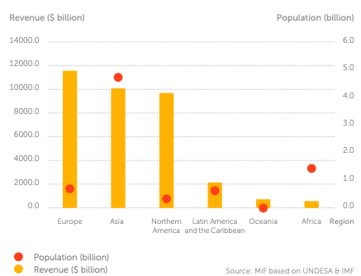

In 2024, only 5 countries accountd for over half of Africa’s total revenue (53.6%). These include South Africa, Algeria, Egypt, Morocco and Nigeria
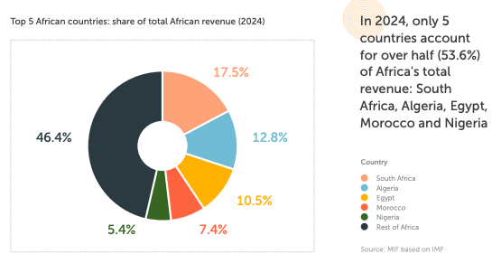
Africa’s tax revenue relative to GDP: half that of OECD countries

African countries: total tax revenues as a share of GDP (2021)
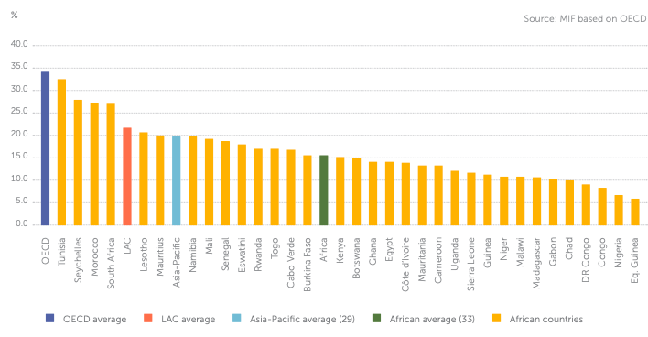
In 2021, the average tax to GDP ratio for 33 African nations was 15.6%, which is almost half of the rate for OECD nations (34.1%). Resource-rich nations like Nigeria and the Democratic Republic of the Congo have tax-to-GDP ratios below 10% (6.7% and 9.1%, respectively). The most recent IIAG (2022) reports that, on average, the continent's taxation capacity has remained unchanged from 2012 to 2021, and since 2017, the efficiency of revenue mobilization has drastically decreased. Mauritius (20.0%), Lesotho (20.7%), South Africa (27.0%), Morocco (27.1%), Seychelles (27.9%), and Tunisia (32.5%) are the only six African nations with a tax to GDP ratio of > 20% in 2021.

Almost half of African citizens favour paying more taxes in exchange for more public services
An average of 49% of respondents from 18 African nations that participated in the 2019/2020 Afrobarometer surveys said they would prefer to pay more taxes in exchange for more public services. In addition, 61% of respondents think that their governments have the authority to impose taxes on citizens.

Higher taxes with more services vs. lower taxes with fewer services, 18 countries, 2019/2020
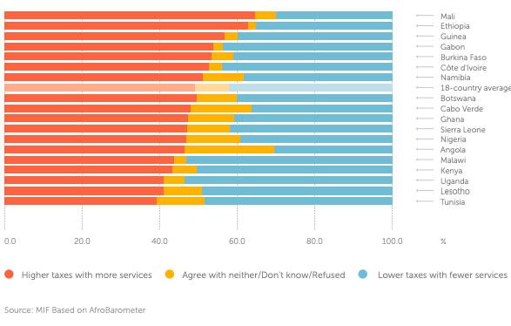
In 2019, fiscal benefits for foreign corporations generated a loss of $46 billion in corporate taxes for Africa. Africa lost $46 billion in corporate tax revenue in 2019 due to fiscal incentives for international corporations. Aid-dependent nations are losing up to 5% of their GDP due to ODA tax exemptions.

Potential levers to increase tax revenue
1.. Improving tax transparency: The detrimental effects of IFFs can be mitigated by putting the OECD's tax transparency guidelines into practice. With the use of these procedures, authorities are able to track and reclaim additional incomes; between 2009 and 2022, African countries identified approximately $1.82 billion in lost revenue.

2. Reconsidering fiscal incentives: Without stable business environments, African fiscal incentives for international investors are ineffective. According to estimates from the Global Tax Expenditures Database, business tax incentives cost sub-Saharan Africa $46 billion in lost revenue in 2019 and 1.8% of GDP annually.

3. Formalising the informal economy: Governments are able to collect taxes and offer legal protection when economic activity is formalized. The IMF estimates that in sub-Saharan Africa, the informal sector accounts for between 25% and 65% of GDP. According to International Labour Organization (ILO) estimates, Africa has the greatest composition of informal employment across all geographical regions, accounting for 85.8% of all employment in 2018, or 71.9%, excluding agriculture.

4. Taxing the digital economy: The African Tax Administration Forum (ATAF) proposed legislation in 2020 that would impose taxes ranging from 1 to 3% of the gross annual revenue from digital services. Between 2019 and 2024, several African countries introduced digital sales taxes, while others applied VAT to digital services.

5. Legislation that would impose taxes ranging from 1 to 3% of the overall annual revenue from digital services was proposed by the African Tax Administration Forum (ATAF) in 2020. A number of African nations implemented digital sales taxes and others applied value-added tax (VAT) on digital services between 2019 and 2024.

6. The Platform for Co-operation on Taxation (PCT) reported in 2022 that ODA tax exemptions are costing assistance-dependent African nations up to 5% of their GDP, which highlights the need to increase the transparency of aid taxation. VAT and other indirect taxes cause some countries to lose more than 1% of their GDP.
7. Other levers: modifying tax rates, combating tax evasion, promoting taxpayer compliance, and expanding the tax base through the implementation of capital gains, consumption, and environmental taxes (such as those on carbon, energy, fossil fuels, transportation, and resources).

Potential levers to increase tax revenue
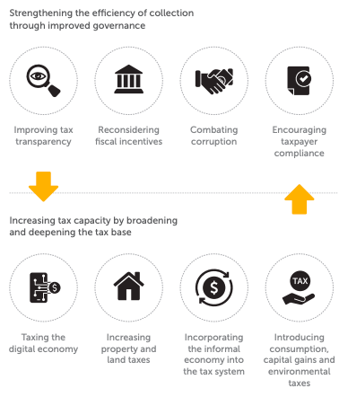

LEVERAGING REMITTANCES, SOVEREIGN WEALTH AND PENSION FUNDS: A COMBINED WORTH OF ABOUT 15% OF AFRICA'S GDP
With around $100 billion in 2022, 12.3% of all remittances worldwide go to Africa. Remittances from Africa more than tripled between 2005 and 2022, reaching $97.6 billion, or 3.5% of the continent's 2021 GDP. Currently, 160 million African-born people reside and work outside of the continent. An estimated 200 million relatives depend on their remittances for their living expenses, making them a significant source of foreign exchange. Africa receives 12.3% of worldwide remittances, with Egypt, Nigeria, and Morocco receiving 61.1% of this total. Remittances are a significant source of income given their share of the African economy. With $28.3 billion in 2022, Egypt is Africa's most significant beneficiary of remittances.

Top 10 African countries: remittances inflows (2022)
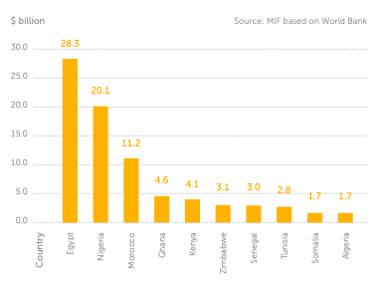
Africa had the most remittances of any area in the world in 2022, totalling $96.7 billion, or 3.5% of the continent's GDP. Remittances accounted for at least 4% of GDP in 19 countries in 2022. This surpassed 20% in four nations: Comoros, Somalia, Lesotho, and the Gambia. In 2022, remittances will account for more than 16% of Africa's total government revenue, twice the second-highest percentage in Latin America and the Caribbean (7.9%). Remittances to Africa account for a larger share of the continent's overall government revenue than taxes collected.

World regions: remittances as a share of total revenue (2022)
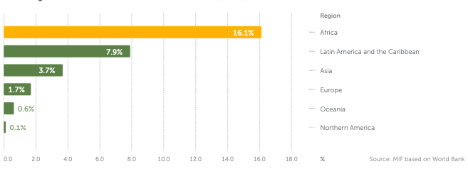

Africa: the most expensive region to send money to
Remittance fees to Africa average 9%, according to Remitscope, compared with the global average of 6.2%. The SDG 10 Inequality target, which calls for reducing transaction costs for migrant remittances to less than 3%, is currently 3 times that level. Credit rating agencies may use hard currency remittances to raise a nation's creditworthiness and sovereign risk ratings if they are correctly reported. They might also serve as a source of foreign exchange. Additionally, remittance flows could be pledged as collateral to raise the ratings of subsovereign debtors. Since 2000, several developing-nation banks have successfully raised over $15 billion from global financial markets through remittance-backed securities.

Africa's sovereign wealth funds: an estimated combined worth of $120-130 billion, the lowest of any world region
State-owned investment entities known as Sovereign Wealth Funds (SWFs) combine transfer payments, fiscal surpluses, and proceeds from resource exports. SWFs should adapt to a nation's demands and pursue a range of goals, including economic growth and financial success. For instance, they can serve as long-term developmental vehicles that complement a nation's overall macroeconomic goals or as strategic sources of short-term funding during emergencies. As early as 1994, Botswana, one of the world's leading diamond producers, established Africa's first SWF, the Pula Fund. In 2023, African SWFs are the second smallest in the world, with a value of $120-130 billion.

African governments have utilised them to prioritise diversification, stabilise economies, mitigate the effects of public spending, and support infrastructure and technology development. Africa attracts little investment, and the data environment for African SWFs is inconsistent. The number of active African SWFs and their corresponding Assets under Management (AuM) vary depending on the source:

The Sovereign Wealth Fund Institute (SWFI) and the International Forum of Sovereign Wealth Funds (IFSWF) identify 31 and 18 SWFs across 21 and 18 countries, respectively. Global SWF records state that there are 15 SWFs in Africa across 14 countries, with a combined value of $120-130 billion in 2023, making it the second-smallest region in the world.
• The growth of AuM has climbed by 76% between 2015 and 2020, while the number of investors has increased by 54%, despite the relatively low overall value of Africa's SWFs.

African SWFs primarily serve as funding for stabilisation.
• The majority of African SWFs operate as stabilisation funds and invest in low-yield assets that can be sold quickly to provide liquidity during economic crises;
• Access to data and transparency among African SWFs is frequently insufficient;
• The primary goals of African SWFs are fiscal stabilisation and intergenerational wealth transfer, with domestic investments ranking lower on their list of priorities. Many funds offer summaries or don't publish thorough portfolio breakdowns.

The LIA, or Libyan Investment Authority
With a portfolio of 72 companies in 26 countries, the LIA is the largest African SWF and has been under UN sanctions since 2011. Just over 22% of investments are in Africa, consisting of fund investments (3.3%) and commercial and real estate assets (19.3%). Europe receives over one-third of the LIA's investments.

Types of African SWFs

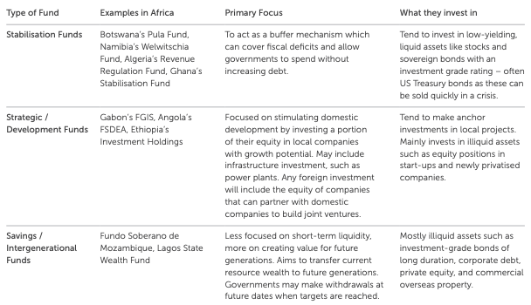
World regions: portfolio distribution of Libyan Investment Authority (2019)
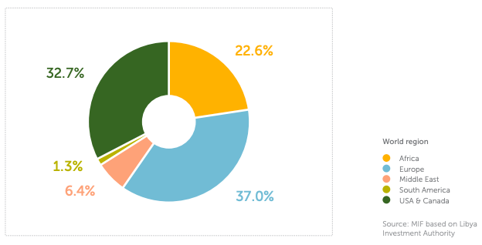

The Nigeria Sovereign Investment Authority (NSIA)
Along with investments in infrastructure and development, the NSIA comprises a mix of short-term liquid assets and longer-term illiquid assets. US Treasury bonds, which make up the majority of the NSIA's holdings, have been given priority under its Stabilisation Fund.

Nigeria Sovereign Investment Authority: portfolio distribution (2022)
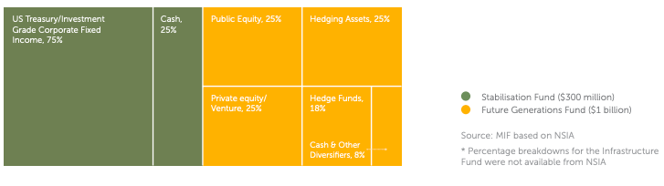
The Sovereign Investors Forum of Africa (ASIF), the African Development Bank, and the SWFs of various African nations joined up with the Kuwait Investment Authority (KIA) and several prominent UAE SWFs in 2022 to form the African Sovereign Investors Forum (ASIF), a platform for promoting investment. Enhancing logistics and connectivity across the continent, encouraging sustainability, and mobilising finance and equity are the main objectives of ASIF. Ethiopian Airlines, Ethiopian Telecom, and over thirty additional state-owned businesses are held by Ethiopia's SWF, Ethiopian Investment Holdings.

African Sovereign Investors Forum attendees: Assets underManagement (2022)
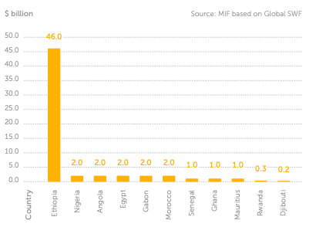

African SWFs' limits and opportunities
African SWFs are criticised for their lack of investment on the continent or for the lack of transparency surrounding their holdings. Three priority areas have been selected by the IFSWF for improvement:
1. Governance: The secret to drawing in private investment is strong, independent governance. In the face of scepticism about government institutions, African SWFs must come across as peers to foreign investors, coordinating interests and maintaining transparency to build public trust.
2. Social Impact: Governments need to have a real influence on people's lives in order to be legitimate. African SWFs should work together on large-scale social and financial projects to attract major foreign investors.
3. Environment: To reduce the effects of climate change, such as food and energy insecurity, which fuel conflict and illness, African sovereign wealth funds should prioritise them.

The Santiago Principles: best practices set by global SWFs
For Africa's emerging SWFs, resource-rich nations like Norway and Kuwait —two of the first to create SWFs —can serve as crucial models of best practices. These SWFs were essential safeguards against the "resource curse," which occurs when nations that experience rapid wealth growth—primarily from the export of natural resources—find it challenging to protect their economies from inflation and instability. The Santiago Principles, also known as the Generally Accepted Principles and Practices (GAPP) of Sovereign Wealth Funds, were developed by the IMF and the OECD in 2008 and contain best practices for SWFs. Essential procedures for every SWF:
- Transparency, governance, and long-term sustainability: SWFs should inform stakeholders and the general public about their performance, risk management, and investment plans.
- Good governance and transparent communication foster trust and allay worries about the fund's goals. SWFs must have clear mandates and oversight procedures in place to guard against political meddling and guarantee policy compliance.
- Prudent investment methods: SWFs ought to use a methodical approach to asset allocation, taking market conditions, liquidity requirements, and risk tolerance into account. Diversification across industries, geographies, and asset classes reduces risk and increases returns. In addition to improving risk-adjusted returns, environmental, social, and governance (ESG) considerations can also support larger societal objectives.

At less than $206 billion, Africa's pension funds are still very tiny, with fewer than 6% of its population over 60. Any kind of fund, plan, or initiative that gives citizens retirement income is referred to as a pension fund. Pension funds often have a lot of money to invest, and their main goal is to find secure assets with steady returns. The OECD defines assets purchased with contributions to a pension plan solely for the purpose of funding pension plan benefits as the assets of pension funds. A collection of assets that constitute a separate legal body is the pension fund.

World regions: total investments by pension funds in $ trillions (2022)
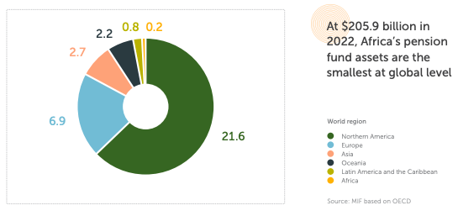

Africa has the lowest overall pension fund assets of any region in the world, at about $205.9 billion. Compared to Asia's overall pension assets, this is about ten times smaller. In Africa, those over 60 make up 5.6% of the population, while in Asia, they make up 14.7%. Northern America tops the world in pension fund assets with over $20 trillion, with 24.7% of the population over 60. Even though they are still relatively modest, African pension funds have expanded quickly, nearly doubling in size from about $30.7 billion in 2012 to $205.8 billion in 2022.
Only 13 African nations have a public pension system, with a total value of about $205.9 billion, according to the OECD. According to OECD data, 41 nations lack one. With assets of about $119.4 billion, South Africa's pension fund is the biggest in Africa. At $32.5 billion, this is over four times the size of Morocco's second-largest pension fund and accounts for approximately 60% of all pension assets in Africa. On a global scale, it is ranked 24th.

Selected African countries: share of Africa's public pension funds (2022)
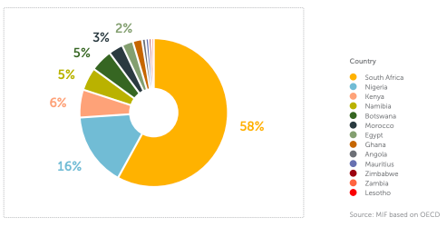
Although Africa's pension fund assets are worth less than Brazil's, they still represent 4.3% of the continent's GDP.
Pension funds could help bridge the infrastructure and climate investment gaps: Because of their consistent revenue flows and long-term outlook, pension funds are perfect for funding projects that require significant resources and longer time horizons, such as infrastructure and climate-resilience projects.

Development projects may present opportunities for investments in pension funds: The 2022 Africa Financial Industry Summit states that pension fund managers use a cautious approach when allocating funds, mostly selecting safe assets like as government and corporate bonds. Governments can still encourage pension funds to invest in key development regions by using local currency to finance infrastructure projects and by collaborating with investors and regulators to assist the emergence of new and more attractive financial assets. Africa receives less than 1% of global investment capital. African pension funds are growing even if they don't attract many foreign investors. Investor confidence is lowered and the cost of capital is higher in Africa than anywhere else in the world due to perceptions of capital risk and ignorance. Even though the total assets under management increased from $48 trillion in 2010 to over $112 trillion in 2021, Africa still contributes less than 1% of global investment capital. It is an amazing notion that Africans themselves may play a role in the advancement of their continent. This will convince potential international investors that it makes sense to invest on the continent, in addition to ensuring significant African ownership.
The three major barriers for African pension funds
1. Lack of investable assets: Pension funds are sometimes encouraged to invest their money outside of Africa because the size of investable assets in Africa is significantly smaller than those found on foreign stock exchanges.
2. Risk perception: According to a 2018 study, SWFs and pension funds surveyed are willing to engage in infrastructure projects in Africa as long as they generate income. This implies that a large number of investors are required to choose projects with stable revenue streams in order to minimize risks. 3. Insufficient frameworks for regulation: Nigeria's 2006 Regulation of Pension Fund Assets raised AuM to $32.3 billion by 2020. By allowing domestic pension funds to engage in unlisted businesses, Namibia's undeveloped capital markets were addressed by the 2017 revision of the "Regulation 29" framework.

SPOTLIGHT: African High-Net-Worth Individuals (HNWIs): $2.5 trillion worth of liquid investable wealth
The 2024 Africa Wealth Report from New World Wealth estimates that the continent's liquid investable wealth is currently $2.5 trillion. This number includes the liquid assets of 342 centi-millionaires with $100 million or more, 21 US dollar billionaires, and 135,200 high-net-worth individuals (HNWIs) with liquid investable wealth of $1 million or more who reside in Africa. Remarkably, this $2.5 trillion in investable wealth is equal to the $2.8 trillion needed to close the funding shortfalls noted in the NDCs of African nations. This dormant potential funding stream might be directed into venture capital, private equity, African SWFs, and other investment firms with an Africa emphasis.
Additionally, in 2024, African private equity firms indicated a wish to work together on long-term investment projects and to unleash the assets of SWFs. Over the next ten years, Africa's millionaire population is expected to rise by 65% to slightly over 223,000.

African Stock Exchanges: only 2% of the global stock market capitalisation
Although they are expanding, Africa's stock exchanges are still little by global standards. 25 exchanges from 37 nations make up the Africa Stock Exchanges Association (ASEA), which is the organization representing stock exchanges in Africa. With more than 1,100 listed businesses, its market capitalization is worth more than $2 trillion. However, whereas major economies like Ethiopia are still working on setting up a stock exchange, South Africa, Morocco, Egypt, and Nigeria disproportionately control this value. Together, the stock markets of South Africa and Nigeria accounted for 87.5% of Africa's market capitalization in 2022. Africa is being urged to establish a pan-African capital market as a foundation for domestic resource mobilization due to the continent's enormous and growing financial demands, particularly climate financing.

Selected African countries: market capitalisation of listed domestic companies (2022)
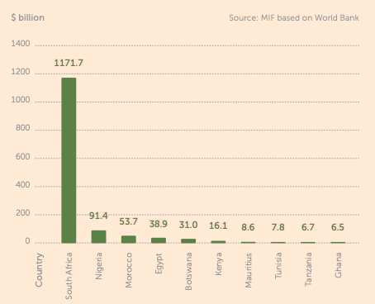

Sustainable bonds to leverage finance for climate and development:
Green and social bonds are among the most promising instruments for releasing substantial funds for investments linked to sustainability. In 2023, green bonds raised $2.5 trillion worldwide, but just around 1% of the market is in Africa. Public entities in Nigeria, South Africa, the Seychelles, Morocco, and Egypt have successfully issued green bonds. With plans to issue more than $10 billion in green and social bonds in 2023 to combat climate change and support socioeconomic development in member nations, as well as to work with the Global Green Bond Initiative to provide technical assistance to advance green bond markets in Africa, the AfDB is becoming more and more involved in the sustainable bond market.

The market capitalisation of the 29 stock exchanges in Africa is approximately $1.6 trillion, which is much less than that of the $25 trillion New York Stock Exchange (NYSE). As of May 2024, Alphabet, the parent company of Google, had a market valuation of around $2.1 trillion, exceeding the total market capitalisation of all African stock markets.

Financing Innovation: Venture Capital's Key Role in Africa
In the African investing scene, a newcomer has emerged, and ideally, it will be here to stay. Foreign aid reached $42 billion (18.8% of the global share), development financing (DFI) about $8 billion (13.4% of the worldwide share), and foreign direct investment (FDI) to Africa totalled $48 billion (3.5% of the worldwide share) in 2023. More investments are desperately needed to support job creation on a continent home to 17.9% of the world's population, 70% of whom are under 30. Venture capital (VC) has grown significantly within FDI in recent years. In 2023, venture capital funding in Africa reached $3.6 billion, representing an average yearly increase of 450% since the early 2010s and $17 billion since 2019.

By taking chances, venture capitalists (VCs) are essential in promoting innovation. Young, transformative businesses that secure funding can develop new strategies, launch products, and acquire resources to expand and scale—a process that has long been elusive in Africa. And we really need this. In terms of start-up risk, financing into the continent was scarce until recently. Due to their limited accountability to taxpayers, DFIs were forced to invest in well-established, larger, and more lucrative companies, like their private equity counterparts, or to provide grants as a workaround.

Generally speaking, foundations, nonprofits, and foreign assistance investors employed impact-led strategies, taking on risk only when necessary. But they frequently prioritise purpose over sustainability and profit, which breeds reliance. To assist entrepreneurs in bringing their ideas to life, venture capitalists (VCs) offer early-stage financing. Their adaptability and willingness to take risks make them innovators who can develop, test, and expand new markets, industries, and technologies. Start-ups with venture capital funding make R&D investments, upskill their workforce, and build essential infrastructure. In certain instances, they support the creation of new laws and regulations, like open banking in the EU and the UK.

But taking risks can come at a price.
VCs work in intricate settings where laws and regulations may obstruct expansion. The Global North's high-profile start-up failures have made it evident that VCs are loosening their corporate governance. In regulated industries like fintech, where fiduciary duties are increasingly prominent, this is a special problem. Second, even though the market is still in its infancy, Africa only accounts for 1.3% of global venture capital funding, with only 23% of that coming from African VCs in 2022. This global exposure is a risk in and of itself. VC financing increased in 2019 and peaked in 2021 at $5.2 billion. Since then, foreign investors have withdrawn to concentrate on their home markets, leaving African entrepreneurs uncertain about future funding.

Finally, mitigating risk to unlock
VC funding is essential in Africa. In contrast to more developed countries with more finance possibilities, this is particularly true for a continent whose economy are less resilient and where systemic repercussions can bite harder. Navigating the prospects requires local knowledge, which incumbent investors have decades of experience with and excel at, although in a more bureaucratic and less flexible manner.

Out of adversity, comes opportunity.
There have been encouraging developments since the drop in venture capital funding. The biggest VC funds devoted to Africa have been observed; some are independent, while others are part of global VC firms. In an effort to foster innovation and take calculated risks, DFIs and foundations have also been investing in local venture capitalists. We hope that this asset class not only survives but thrives. VCs facilitate social and economic progress and innovation, both of which need to be promoted. For African venture capital funding to expand, it needs to be conducted responsibly, cooperatively, and by individuals who are aware of the local environment.

VALUING AFRICA'S ASSETS
Africa's increasing global prominence. With the youngest population in the world and a quarter of the world's workforce, Africa has enormous demographic potential. Population as a whole: Africa currently accounts for 18.3% of the world's population, or nearly a fifth. It will increase to around a quarter (25.5%) by 2050 and to more than a third (37.8%) by 2100. Nearly 60% (59.6%) of Africa's working-age population is composed of youth (15–34 years old). Africa's working-age population will make up 25% of the world's labor force by 2050 and more than 40% by 2100. Africa may have the lowest dependence ratio by 2055, with about 59 dependents per 100 working-age individuals, which is three-quarters that of Europe. Africa will have more than 40% of the world's working-age population by the year 2100.

Africa: share of global working age population (2024-2100)
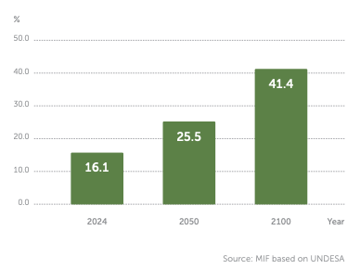
But there are hurdles to overcome:
In Africa's economies, one in four young people are unemployed, untrained, or uninformed (NEET). According to the Ichikowitz Foundation's 2022 Africa Youth Survey, about 50% of participants between the ages of 18 and 24 said they would think about leaving their home country within the next three years because of a lack of work and educational prospects. Africa's youth will overtake those of Asia and account for about half of the world's youth by the year 2100.World regions: share of global youth population (15-34 years)
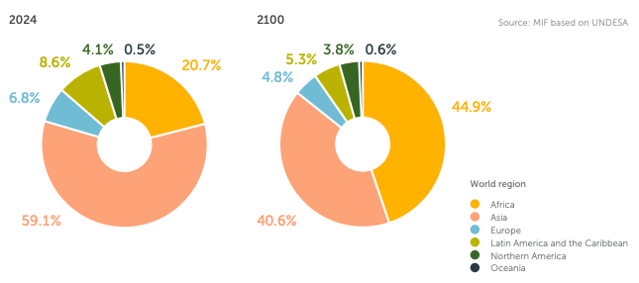

Nine out of the 20 fastest growing economies globally are African

Top 9 African countries: projected real GDP growth (2024)
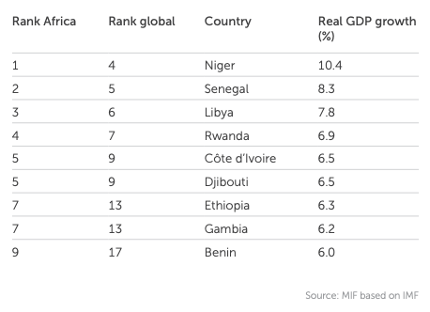
Africa is home to six of the top ten fastest-growing economies in the world in 2024. Real GDP in African economies is expected to grow by 3.5% and 4.0% in 2024 and 2025, respectively, above the global projected average of 3.2% per year for both years, despite the combined setbacks of COVID-19, the Russia-Ukraine conflict, the Israel-Gaza conflict, and general global economic downturns.
After Asia, the continent is expected to continue to grow at the second-fastest rate. Africa still only contributes roughly 3% of the world's yearly GDP, despite having 1.4 billion people and a wealth of natural resources, such as 65% of the world's arable land and the greatest stocks of essential minerals. Leveraging revenue gaps, increasing domestic productivity, and investing in human capital are all necessary to raise Africa's economic contribution of the world economy. Africa still contributes 3% of the global GDP in 2023, despite housing 18% of the world's population.

Africa & selected world countries: GDP & population (2023)
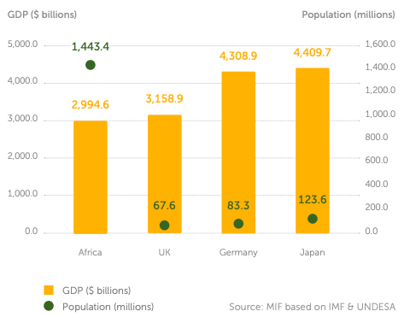
In 2023, the annual GDP for the whole African continent combined was just over $3.0 trillion, lower than those of the UK, Germany and Japan individually. GDP per capita was less than $2,200 per year, the lowest of any world region and almost 18 times less than the EU average.

Upgrading Africa’s place in global value chains
With little presence in advanced manufacturing and services, Africa's role in the global value chain is still primarily limited to mining, resource-based exports, and light manufacturing. In 2023, less than 3% (2.5%) of the value of world exports comes from Africa.

Selected world regions: share of global exports value (2023)
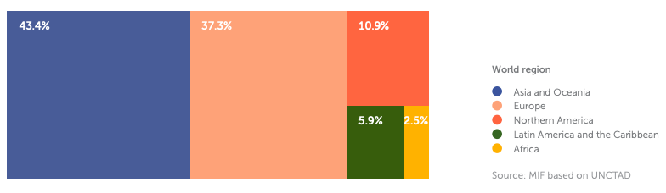

Primary commodities, or unprocessed raw resources, accounted for 78.5% of African exports in 2022, more than twice as much as in North America and more than three times as much as in Europe or Asia. Primary commodities continue to make up more than three-quarters of Africa's exports in 2022, which is a significantly greater percentage than in any other area.

Selected world regions: primary commodities, precious stones & non-monetary gold exports (2022)
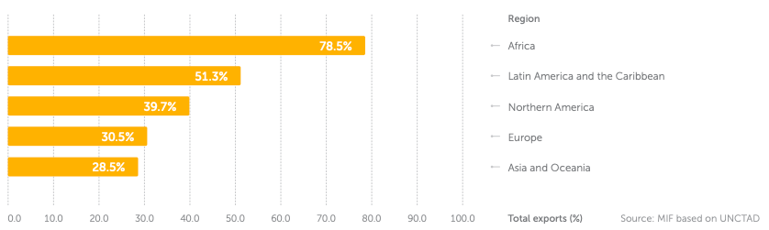
Africa's exports are the least diversified of any area in the world due to the high proportion of primary commodities, making government export earnings susceptible to shocks from across the world.

Selected world regions: Product Concentration Index, exports (2022)
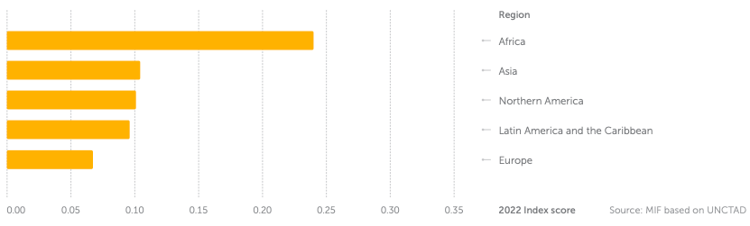

The possibility for creating jobs is minimal in large, capital-intensive extractive economies, particularly when the majority of the minerals are moved from pit to port. Africa's exports are the least varied of any region in the globe as of 2022. Just 0.5% of people in Nigeria, the continent's top producer of crude oil, are employed in extractive industries, whereas 34.7% are employed in forestry, agriculture, or fisheries as of 2020. African nations risk receiving only a portion of the benefits from global value chains if they don't diversify. While manufacturing economies primarily act as suppliers of inexpensive labor and intermediate commodities, Northern and Southern Africa dominate the continent's involvement in global value chains for electronics, metal products, and machinery.

Plants make up the largest portion of Africa's 215 processing facilities (117), followed by smelters (47), refineries (45), and concentrators (6). More than half of all processing facilities on the continent are located in South Africa and the Democratic Republic of the Congo. Copper (37.21%) is the most processed mineral overall.

Nigeria: Africa’s top oil producer imports 95% of its refined oil
Because Nigeria depends on imported refined oil, it was severely impacted by the increased oil prices brought on by the conflict between Russia and Ukraine. Nigeria is Africa's largest oil producer. Nigeria, a member of the Organization of the Petroleum Exporting Countries (OPEC), imports 95% of its refined petroleum since it lacks the capacity to process its own oil while having an abundance of it. Nigeria accounted for the largest portion of Europe's gasoline exports in 2023, with almost one-third going to West Africa. The present value of the gasoline trade between Europe and Africa is $17 billion annually. When the Dangote refinery is completely operating, it is expected to generate approximately 650,000 barrels of refined oil per day. In 2023, it was inaugurated. When operating at maximum capacity, this would supply all of the nation's needs for kerosene, diesel, gasoline, and aviation jet fuel, with 40% of the oil products produced being exportable.

In order to handle 40% of the region's key mineral demands for the energy transition, the EU should increase its own processing capacity, according to the EU's key Raw Minerals Act, which went into effect in May 2024. Since the majority of the minerals required for the global energy transition are found in Africa, nations should oppose export market expansion and instead promote the growth of domestic processing and connect it to investments in industrial sectors.

Western Africa: largest cocoa production in the world but farmers still in poverty
75% of the world's cocoa beans are produced in Western Africa, with 60% of the total production coming from Ghana and Côte d'Ivoire alone. Chocolate firms made $206 billion in 2022, and by 2030, the industry is expected to generate $263 billion. However, cocoa growers frequently make less than $2.15 per day, which is the World Bank's poverty criterion. In nations that produce cocoa, the exploitation by extractive industries, which frequently offer farmers cheap prices, has also led to environmental and human rights violations, such as child labor and human trafficking. Recent spikes in cocoa costs, mostly brought on by the effects of climate change, have forced numerous nations to raise producer prices. In 2023, Cameroon raised its state-guaranteed cocoa prices to farmers by 25%, while Ghana increased them by two-thirds.

Regional integration: markets and value chains are crucial
Regional value networks only made up 2.7% of Africa's overall value chain participation in 2019, compared to 26.4% in Latin America and the Caribbean and 42.9% in developing Asia. This is despite the fact that strengthening regional value chains is essential for growth and the mobilization of local resources. The possibility for the African Continental Free Trade Area (AfCFTA) to become the largest market in the world By increasing intraregional commerce, particularly in manufactured goods, and fostering value and knowledge transfer, the AfCFTA can create local value chains in a market that has a potential population of over 1.4 billion. Compared to 62% in Asia & Oceania and 68.5% in Europe, only 14.1% of African countries' exports are made within the area.

Selected Free Trade Agreements: total population covered (2023)
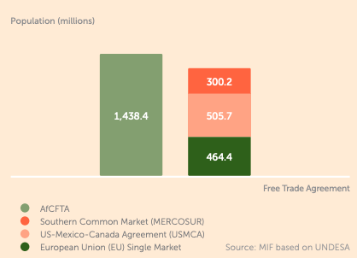
By 2035, it is anticipated that the AfCFTA will boost Africa's income by as much as $450 billion, boost exports by $560 billion, mostly in manufacturing, and help 30 million Africans escape extreme poverty. When fully implemented, the Africa Trade Exchange (ATEX), a digital trade platform built on the foundation of the AfCFTA, is expected to boost intra-African commerce by 400%.

The African Commodity Strategy (AU Agenda 2063)
The AU's Agenda 2063 includes the African Commodity Strategy as one of its main initiatives. In order to help African nations add value, increase the rents they receive from their commodities, integrate into global value chains, and encourage vertical and horizontal diversification based on local growth and value addition, it seeks to identify, create, and implement policies and programs.

Monetising Africa’s green assets
The vital minerals found in Africa are essential to the global green transition. Africa's vital resources are more in demand than ever from the rest of the globe due to the green revolution. 30% of the world's mineral reserves are found in Africa, and many of these resources are essential for low-carbon and renewable energy technologies. The continent will need to manufacture, design, and refine in addition to producing raw materials in order to access higher value chains. The World Bank (WB) estimates that output of metals and minerals like cobalt, graphite, and lithium will need to rise by around 500% in order to satisfy the anticipated increase in world demand. Without the riches of Africa, this would not be possible. The green global economy depends on Africa's portion of the world's mineral reserves. By 2027, at least 10% of the world's lithium supply will come from Africa, including the Democratic Republic of the Congo, Ethiopia, Ghana, Mali, Namibia, and Zimbabwe.
Africa: share of global mineral reserves (2023)
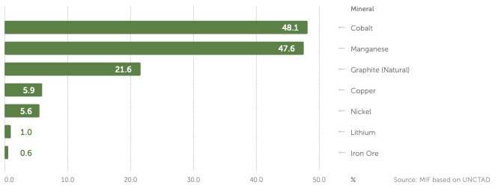

Africa's worldwide resources are essential to the green revolution, particularly in the electric car sector, according to UNCTAD. However, just 4% of the car parts and 43% of the raw materials used in the automobile sector will come from Africa between 2018 and 2020. To capitalize on the shift and demand for green resources, Africa has to make large investments in renewable energy. It must go beyond exploration and extraction to become a location for the production and refinement of components and materials required for green technology. China produces 70% of the world's electric batteries. Africa only supplied 4% of the world's car components supply between 2018 and 2020, despite having vital mineral deposits for electric vehicles. Although DR Congo produces over 70% of the world's cobalt, 68% of the world's cobalt refining capacity is owned by Chinese businesses. Chinese businesses that make higher-end goods like batteries possess over 80% of the DR Congo's cobalt production.

Current green value chain projects in Africa
DR Congo-Zambia battery creation agreement: The two nations inked a historic cooperation agreement with the goal of establishing value chains in the clean energy and electric battery industries as well as providing employment and training opportunities for millions of youth. In February 2023, Angola, Zambia, and the Democratic Republic of the Congo signed the

Lobito Corridor, which connects mining regions like Katanga province and the Zambian copper belt. This agreement enables all three nations to move metals used to make wind turbines and electric vehicles from inland mines to ports, reducing transit times from weeks to days.

Through regulatory regulations, capacity training, finance, and certification, Egypt, Kenya, Mauritania, Morocco, Namibia, and South Africa comprise the Africa Green Hydrogen Alliance, which aims to increase cooperation and production of green hydrogen for both domestic and export markets.
Green hydrogen In carbon-intensive industries that are difficult to reduce, such cement, steel, fertilizers, plastics, and transportation, green hydrogen technology has been heralded as a substitute for fossil fuels. Due to its larger land supply, convenient access to water supplies, and port facilities, Africa is anticipated to be a favorable site for the green hydrogen economy. Numerous African nations are already utilizing this potential: Mauritania inked two large-scale projects in 2022 with 40 gigawatts of capacity, which would power the entire nation for more than a month, while Namibia plans to generate 300,000 tonnes annually by 2026. Giving everyone access to dependable energy must be the top priority for African countries. It is crucial that this objective not be sidetracked by the desire to generate green hydrogen primarily for export.

The 12-member South African Power Pool (SAPP) is an intergovernmental Memorandum of Understanding (MoU) that was established in August 1995 with the goal of creating an electricity power pool that would serve as a competitive, fully integrated energy market and supplier of sustainable energy for the SADC and beyond.

Green industrial policies and restrictions on raw exports
Indonesia: 40% rise in FDI due to export prohibition on unprocessed nickel Indonesia has gradually prohibited the export of nickel ore from 2020, demanding that nickel be processed before export in order to fortify domestic infrastructure. This has generated jobs and restored the supply chain's added value for nickel. Consequently, Indonesia has received $21.6 billion in foreign direct investment (FDI) in the first half of 2022, which is 40% more than during the same period in 2021.

Regarding transition minerals, about 42% of sub-Saharan African nations have imposed limitations on raw exports or Special Economic Zones (SEZ) since 2020. The Base Minerals Control Act, which prohibited the export of raw lithium ore, was implemented in 2022 in Zimbabwe, which possesses the greatest lithium reserves in Africa. Zimbabwe aspires to meet 20% of the global lithium demand. Following suit in June 2023, Namibia prohibited the bulk export of unprocessed minerals, including as cobalt, graphite, and lithium, stating that minerals extracted domestically have to undergo processing locally.

Leveraging Africa’s natural resources wealth: governance is key
The AU established the Africa Mining Vision (AMV) in 2009, and it serves as the main continental framework for advancing development based on mineral resources. The effort, which is managed and directed by AMDC, intends to maximize Africa's limited mineral riches, harness the potential of all stakeholders, including artisanal mining groups, and integrate sustainable development into a single African market.

Selected African countries: Resource Governance Index, mining governance score (2017/2021)
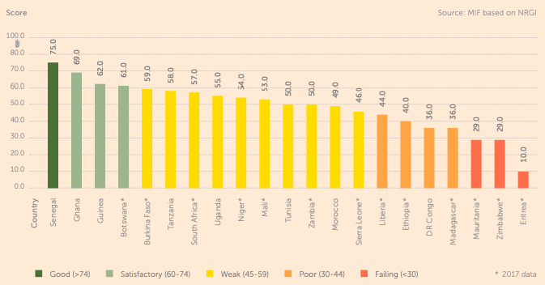

The only two African nations to receive a "good" Resource Governance Index score for the governance of the oil and gas sectors in 2021 were Senegal and Ghana, while Senegal was the only nation to receive a "good" score for the governance of the mining sector, according to the Natural Resource Governance Institute (NRGI). Senegal's strong scores, according to NRGI, were mostly attributable to its excellent revenue management performance as well as its generally sound laws and procedures regarding the sharing of information on debt and the national budgeting of mining earnings.

Selected African countries: Resource Governance Index, oil and gas governance score (2017/2021)

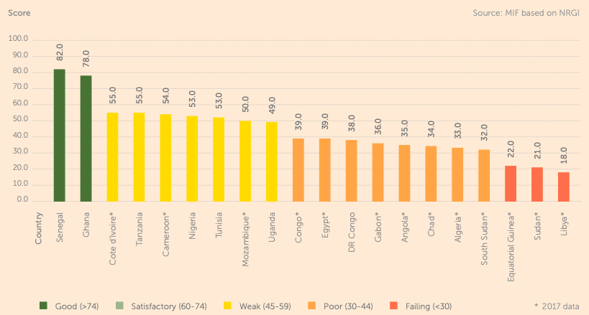

Overall Governance: the need to sustain progress
Between 2012 and 2021, more than half of Africa's population resides in nations with improved overall governance. While over 40 countries have made progress in the IIAG categories Foundations for Economic Opportunity and Human Development, over 30 countries have regressed in the categories Security & Rule of Law and Participation, Rights & Inclusion, indicating that divergent trajectories continue to impede governance progress over the past ten years. Maintaining governance advancement is essential for meeting ESG standards and facilitating FDI.
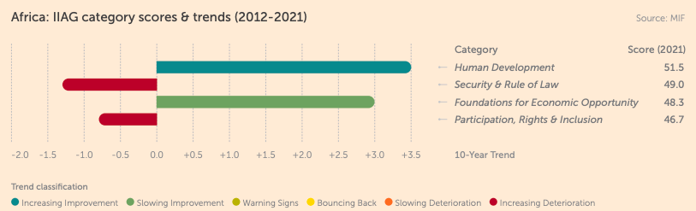

Carbon credits: Africa’s next significant export?
More carbon is sunk by the Congo Basin rainforest than by any other tropical forest. The Congo Basin is the only rainforest with enough standing forest remaining to continue to be a potent net carbon sink, even though it is the second largest rainforest in the world after the Amazon. The Congo Basin rainforest sequesters more net carbon than both the Amazon and Southeast Asia put together. More carbon emissions are offset annually by the Congo Basin forest than by the entire African continent, accounting for 4% of global emissions.
Forests: carbon sinks or carbon sources?
World forests: net greenhouse gas fluxes (2001-2019)
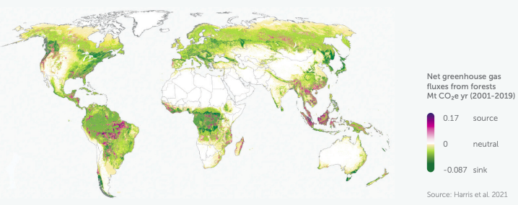
Selected world rainforests: emissions, removals & net carbon sinking capacity (2021)
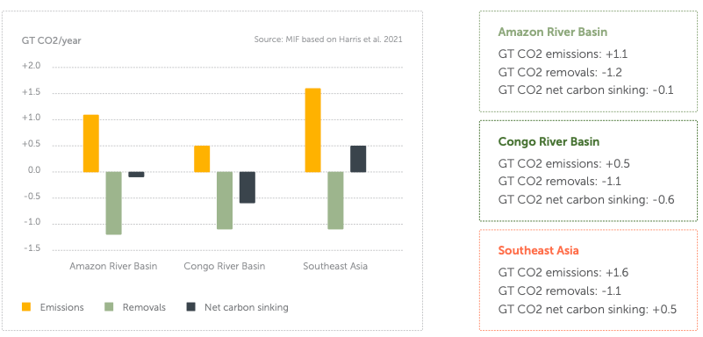

Measured in tonnes of carbon dioxide (tCO2e), a carbon credit is a currency that symbolizes the prevention or removal of greenhouse gas emissions. Businesses, organizations, or institutions working on projects can record how their actions affect the reduction or elimination of emissions and sell carbon credits of the same amount. While the bulk of purchasers are found in higher-income countries, the majority of offsetting activities are occurring in emerging markets or underdeveloped countries. The voluntary carbon market (VCM) and compliance-based market are estimated to be around $2 billion and over $900 billion, respectively, as of 2022. Between 2020 and 2022, their respective values more than doubled, and by 2030, the voluntary market is predicted to rise five to twenty times.

The EU Emissions Trading Scheme (EU ETS), the biggest VCM, is projected to be worth $800 billion in 2022 alone. While they contribute 10% to the credits issued on VCMs, African carbon credits only account for 3% of the credits issued under the Clean Development Mechanism (CDM), the first international carbon market. Africa should strive to sell $100 billion worth of carbon credits annually by 2050, according to the African Carbon Markets Initiative (ACMI), which currently only uses 2% of its yearly carbon credits. By 2050, Africa could sell $100 billion worth of carbon credits annually, but it only utilizes 2% of them. By 2050, Africa could sell $100 billion worth of carbon credits annually, but it only utilizes 2% of them. By 2030, Africa's carbon credit market could grow 19 times, generating up to $6 billion in income and 30 million jobs.

KOKO Networks: cooking fuel start-up raising funds through carbon credits
A Kenyan startup called KOKO is making stoves that run on bioethanol, which is a cleaner and safer cooking fuel than charcoal. More than one-third of Nairobi households currently utilize the start-up, which can produce carbon credits that can be sold on international markets. Prices for consumers refueling at nearby "fuel ATMs" known as "KOKO Points" are kept low by the company's reinvestment of the credit proceeds. Africa has increased cooking-fuel initiatives, which accounted for nearly 25% of African carbon credits granted on the voluntary markets, despite the continent's meager participation to carbon markets.

A highly challenging market: scale, permanence, additionality and governance
Carbon credit markets eliminate only a small portion of the world's total carbon emissions. Furthermore, they are unable to ensure the sustainability of carbon offsetting, particularly for removals dependent on nature. Finally, it is more difficult to quantify the actual additionality that carbon markets would bring to carbon removal or storage because the world is already headed toward net zero as outlined in the Paris Agreement.

The carbon credits scramble for Africa’s forests
Africa's land use and forestry activities account for the majority of its carbon credits (50%). With an annual carbon dioxide absorption capacity of over 600 million metric tons, the rainforests of Africa alone have been recognized as having a greater capacity to absorb atmospheric carbon dioxide than the Amazon rainforest.
The Dubai-based business Blue Carbon most recently inked four memorandums of understanding (MoUs) in Zambia, Tanzania, Zimbabwe, and Tanzania totaling 60 million acres of forest land in Africa, which is equal to the whole geographical area of the United Kingdom. Madagascar became the third country in Africa (after Ghana and Mozambique) to receive payments from the World Bank for reducing emissions from deforestation and forest degradation, or REDD+, as of December 2023, after receiving $8.8 million in carbon credits for lowering 1.76 million tons of carbon emissions.

• Zimbabwe: 18 million acres, or one-fifth of the country's entire land area
• Zambia: 20 million acres, or one-tenth of the country's entire land area
• Liberia: 1/10th of the entire land area, or 2.5 million acres
• Tanzania: 20 million acres, or one-tenth of the country's total area Madagascar became the third country in Africa (after Ghana and Mozambique) to receive payments from the World Bank for reducing emissions from deforestation and forest degradation, or REDD+, as of December 2023, after receiving $8.8 million in carbon credits for lowering 1.76 million tons of carbon emissions.

Bilateral carbon credit markets offer Africa bigger returns
The market for African bilateral financing is expanding despite its youth. The Economist estimates that Africa would receive $800 billion from bilateral carbon credit trading on compliance markets, as opposed to $2 billion on the VCM. The Paris Agreement's Internationally Transferred Mitigation Outcomes (ITMOs) enable nations to purchase credits from other nations in order to partially achieve their NDCs. The United Arab Emirates committed to purchasing $450 million worth of African carbon credits by 2030 during the 2022 Africa Climate Summit in Nairobi. Other agreements have been made between Gabon and South Korea, Ethiopia and Kenya with Japan, while Ghana and Senegal have already sold cookstove-based credits to Switzerland. Africa is expected to get $800 billion from bilateral carbon credit trading on compliance markets, as opposed to $2 billion on the VCM.
The governance dilemma: offsetting claims, double counting, and greenwashing One of the main criticisms of carbon markets is that they have little removal capacity in their current state and rarely address the underlying causes of the climate catastrophe. 90% of the market is over-credited, and less than 4% of credits in the VCM include any removal. Profitable businesses are free to buy more carbon credits rather than being forced to lower their carbon emissions.

The Africa Carbon Markets Initiative (ACMI)
VCMs are essential to the decarbonization process, especially for the private sector. By 2030, the ACMI, which was started at COP27, hopes to create a VCM ecosystem in Africa, generate 1.5 billion carbon credits a year, generate over $120 billion in revenue, and sustain over 110 million jobs by 2050. Despite starting from a low basis, demand for carbon credits of African origin is increasing at a compound annual rate of 36%. Only around 11% of the total credits issued globally between 2016 and 2021 originate from African nations, and the majority of them are from a small number of significant projects.

CONCLUSION: THE MONEY IS THERE, WHAT IS NEEDED IS A COMPLETE CHANGE OF PARADIGM
The good news is that there is money available—both in the private sector, which could benefit from more transparent risk management systems that appropriately price the risks and the huge opportunities of investing in Africa, and in the North, provided nations fulfill their commitments with a spirit of justice and equity. Africa has access to money as well, but improved governance structures are necessary to guarantee that it gets to the places where it is most needed. To combat climate change and assist nations in achieving the Sustainable Development Goals, funding is available. Since development must be sustainable to qualify as development, the two goals cannot be separated.

But as we move in all these directions, we must ensure African countries don’t break under the burden of debt. They are not the most indebted in the world, but they suffer the most onerous conditions of public and private creditors. All this calls for a system change. At a time of heightened geopolitical tensions, of fragmentation and polarisation, we should ensure Africa remains a priority and a point of cooperation for Africa, for the rest of the world.

1. Reconciling development and climate change instead of using a "trade-off" approach for nations that are still developing (and still require universal access to energy)
2. A cooperative strategy (knowledge and data on IFFs, tax systems, green asset processing, etc.) as opposed to a "aid/charity" approach ("how much more can you/we give us/you").
3. A "better money" objective (a drastic overhaul of the current global financial system) as opposed to a "more money" strategy
4. A more African-owned growth and development paradigm that makes use of the continent's primary resources in place of "donor dependency"
External resources: better processes
1. A greater willingness to make concessions
2. More African presence in international financial organisations' decision-making bodies
3. Increased flexibility and agility in lending for Bretton Woods institutions
4. Better techniques for assessing risk (such as those used by the Credit Rating Agency, Bretton Woods debt sustainability studies, and concessionality assessments based on climate vulnerability)
5. Prompt fulfilment of international obligations, including the Loss and Damage Fund
6. Examining surcharges and conditionalities unique to the Bretton Woods system
7. Disbursement of unused ODA money

Domestic resources: increased African ownership
1. Stopping leaks via illicit financial transactions
2. Making tax systems stronger
3. Making use of African pension funds, African sovereign wealth funds, and African remittances
4. Improving Africa's position in international value chains
5. Making money out of Africa's green resources

Decades of economic and social progress in Africa have been severely undermined by the interconnected pandemic, political, security, and climate issues, which has led to a deepening of inequality throughout the continent. The Covid-19 pandemic has affected industries that are vital to nations' economies, pushing 55 million Africans into abject poverty in 2020, according to UNECA data. Furthermore, Africa is experiencing the worst effects of climate change, such as rising sea levels, drought, land degradation, and deforestation, despite having a negligible contribution to global emissions. According to a recent World Bank Group assessment, more than 86 million people would have to flee Africa by 2050 if there were no measures in place to adapt to climate change. These difficulties are compounded by the problem of young employment throughout the continent. Each month, two million

Two million young people join the workforce each month. By 2050, that figure might rise to 3 million. Therefore, it is crucial in this situation to consider unconventional other options for funding the continent of Africa's growth. Here are some suggestions regarding "where the money is."

Conclusion
Debt Chains: Breaking Free from Africa's Financial Struggles, Chapter 5, highlights the long-standing and intricate connection between Africa's debt and its colonial past. The current debt crisis in Africa is not solely a contemporary issue or the product of recent financial mismanagement, as this chapter makes evident. Rather, it is the result of a lengthy history of colonial dominance, exploitation, and enduring global inequality that have molded the economic and social fabric of the continent.

One of the most significant takeaways from this chapter is that debt is a highly political and historical issue in Africa. Strong nations, organizations, and businesses have utilized debt as a means of control and extortion. The chapter questions the widely held belief that corruption or bad governance are the only causes of Africa's debt. Although these have a role, they are but one aspect of a much bigger picture. The slave trade, colonial invasion, and the establishment of artificial borders that still divide African nations today are the historical causes of Africa's debt crisis.

The chapter describes the methodical restructuring of African economies by colonial powers for their personal gain. African communities were compelled by European rulers to prioritize the export of raw goods, including cash crops, minerals, and oil, at the expense of indigenous industries and self-sufficiency. They constructed ports and railroads, but their primary function was to get resources out of Africa, not to foster community development or connection. African economies consequently grew overly reliant on a small number of exports, leaving them open to fluctuations in world prices and economic shocks.

The imposition of unfair debts is another aspect of colonialism's legacy. The chapter uses Haiti as an example, which was compelled to pay France a huge amount in exchange for its freedom. This debt destroyed Haiti's economy and took more than a century to pay back. In a similar vein, South Africa and its neighbors owed £28 billion in debts associated with apartheid and regional instability, while Zimbabwe inherited a $700 million debt from the colonial Rhodesian government. These debts, which are frequently referred to as "odious debts," were accrued by authoritarian or colonial governments and transferred to succeeding ones, placing a significant weight on them that hindered their capacity to make investments in development and enhance the quality of life for their constituents.

The CFA franc monetary zone, which still links 12 former French colonies to the French treasury, is a noteworthy example of this in the modern day. These nations' economic independence and crisis-reaction capabilities are limited because they must maintain a sizable amount of their foreign reserves in France. This structure, which has its roots in agreements made during the colonial era, still depletes Africa's resources and restricts its members' options for policy.

The terrible effects of the slave trade, which forcefully transported millions of Africans and severely damaged societies, are also covered in this chapter. Underinvestment in education, ongoing warfare, and weakened institutions are only a few of the long-lasting consequences of population decline, trust erosion, and social structure disturbance. These issues were made worse by the arbitrary borders established during the Scramble for Africa, which divided ethnic groups and produced fictitious states that have suffered from instability and violence ever since.

African nations faced new difficulties after gaining their independence. The reality of the global economy and the burden of debt swiftly dampened the euphoria of the independence era. Both Western and Soviet nations gave loans to African governments throughout the Cold War, which exacerbated the situation by frequently endorsing authoritarian administrations that left their nations worse indebted. With little regard for the money's intended use or potential benefits to the populace, many of these loans were purposefully made to dishonest officials.

The chapter also looks at the effects of the World Bank and IMF's structural adjustment plans from the 1980s and 1990s. African governments were compelled by these schemes to sell state assets, reduce public spending, and allow foreign competition in their economies. Despite their stated goal of fostering stability and progress, these policies frequently resulted in the loss of jobs, decreased access to healthcare and education, and a rise in poverty and inequality. Whole communities were left without assistance, and social safeguards were undermined. Due to restricted prospects and increased unemployment, women and young people were disproportionately affected.

The impact of Africa's debt crisis on common people is arguably its most catastrophic outcome. The most vulnerable—women, children, and the impoverished—suffer the most when governments are compelled to spend more on debt repayments than on necessary services. Social discontent, hunger, and unemployment have all increased as a result of austerity measures. Disillusioned by the lack of prospects, many young people are motivated to travel overseas in search of better opportunities, frequently running the risk of being used and hurt.

In conclusion, Chapter 5 demonstrates that justice, dignity, and human rights are at the heart of Africa's debt dilemma, which goes beyond economics. Ordinary people are most affected by the problem, which has its roots in centuries of exploitation and outside domination. More is needed to address Africa's debt problem than new loans or technology solutions. It calls for a serious examination of the effects of colonialism and a dedication to creating a more fair and just global economic structure, one that puts the interests of creditors and businesses second to the welfare of people and the environment. The only way for Africa to escape the bonds of debt and create a future that genuinely benefits its people is to acknowledge and address this history.

SPOTLIGHT: The potential of the Fourth Industrial Revolution (4IR)
Artificial Intelligence (AI), the Internet of Things (IoT), Big Data, 3D printing, blockchain, and drones are examples of fourth industrial revolution technologies that have the potential to revolutionize the continent's economy, productivity, and people's quality of life. Five primary areas of application for these technologies were identified in a recent African Development Bank report titled "Unlocking the Potential of the Fourth Industrial Revolution in Africa." These categories are: (1) agriculture; (2) energy; (3) industry; (4) regional integration; and (5) wellness. All of these industries have the capacity to quicken the continent's development. However, new technologies also give nations the chance to increase domestic income mobilization.

Adopting govtech in fiscal operations can improve public finance on both the revenue and spending sides. The implementation of electronic fiscal devices and e-invoicing, for instance, might increase revenue mobilization by as much as 0.7% of GDP, according to this estimate. According to the African Development Bank, $100 billion will be required to invest in digital infrastructure in order to fully realize the potential of 4IR. This investment will be used to unlock the power of digitalization through the growth of mobile networks, data centers, and fiber-optic infrastructure. Google, Apple, Facebook, and Amazon (GAFA) have a social obligation to fund these infrastructures, but more significantly, it makes perfect financial sense. For instance, Google's predicted US$ 305.6 billion in income in 2023 was mostly derived from advertising. Europe, the Middle East, and Africa accounted for 30% of Alphabet's revenue during that time.
The African Union has the chance to discuss these important problems with GAFA, including the taxation of activities produced in Africa, thanks to the implementation of the Digital Transformation Strategy for Africa, or DTS (2020–2030). Africa must also seize the chance presented by these technologies to start updating its training programs and implementing reforms.
The 2 million young Africans who join the workforce each month would suffer greatly from inaction in the absence of these reforms. However, we also require energy for these investments to be successful. We applaud the World Bank and AfDB's collaborative efforts to give 300 million Africans access to energy by 2030.

- Access to financial markets, credit ratings, robust data
It makes sense that the empirical evidence about the detrimental effects of credit ratings on African economies is expanded upon in this book. This makes it more difficult for them to mobilize FDI and access financial markets. According to a recent UNDP research, if those evaluations were based on more open guidelines, the continent might actually save up to $74.5 billion. Africa must intensify its demands for rating agencies to be more open, equitable, and impartial. African nations ought to make investments to improve the caliber of their statistics infrastructure. They now have the chance to obtain high-quality data at reduced prices thanks to 4IR technology. There are also major financial benefits to having access to high-quality data.

For instance, data center revenues were projected by Allied Market Research to be US$ 187.4 billion in 2020 and may grow to US$ 517.2 billion in 2030. In 2023, the African continent accounted for less than 2% of sector revenues from these data center revenue prospects. However, certain African nations must take advantage of their advantageous geographic locations, which offer competitive advantages. Enhancing the capabilities of the African statistical system will not only improve the continent's perception of risk but also provide doors for the growth of SMEs on the continent. If these suggestions are followed, adopting the AU's Digital Transformation Strategy is once more a significant milestone.

3. More concessional resources
Africa requires concessional resources as a workable alternative in the face of formidable development obstacles, expanding funding requirements, and restricted access to the financial markets. By offering interest-free credits and grants, the World Bank's International Development Association (IDA) helps the world's poorest nations and their most crucial concessional financing window. This essential tool, which is based on a cutting-edge financial model that blends capital market borrowing with donor funding and lending, must be maintained. Actually, every dollar donated equals almost four dollars in development funding. For IDA20, therefore, a total replenishment volume of $93 billion was supported by $23.5 billion in donor contributions, with 77% of these promises going to African recipients.
The current IDA21 discussions present a significant chance for donor nations to increase their contributions and improve IDA's operational capabilities for the benefit of African nations.
- The economic and branding potential of African sport
Even while sport has enormous potential for the creative industries, it only accounts for 0.5% of GDP in Africa, compared to over 2% of the global GDP (1,200 billion euros). Making the right investments backed by sector reforms could help boost the financial contribution of sport in general and football in particular to funding African development in a continent that has demonstrated its potential in this area by providing talented players to the biggest clubs in the world. The local economy is stimulated by the influx of tourists and the international attention that World Cup events garner, which leads to the creation of jobs and an improvement in a number of economic sectors, including retail, transportation, and hospitality. In this sense, Morocco's co-hosting of the FIFA 2023 World Cup and Dakar's hosting of the 2026 Youth Olympic Games offer enormous opportunities for positive branding and highlighting Africa's boundless potential and resource generation.

- Strengthening implementation of commitments and coordination of initiatives
Sub-regional, regional, or international organizations typically announce new projects or commitments to fund the continent's development every ten years. Africans become skeptical of international institutions' capacity to promote African development as new projects are added to older ones over time. As a result, the international community must fulfill its obligations. For aid to be effective, we also require coordination, coherence, and synergies among the different players, particularly among MDBs. In this regard, we applaud the recent pledge made by the heads of ten multilateral development banks (MDBs), led by the World Bank, to improve their cooperation and look for more effective ways to increase co-finance.
REF: https://mo.ibrahim.foundation/sites/default/files/2024-06/2024-forum-report.pdf

SPOTLIGHT: SOVEREIGN DEBT MANAGEMENT
In addition to financing a variety of projects and programs for the wellbeing of their inhabitants, nations take on debt to make up for fiscal imbalances. This involves funding both productive investments that increase the nation's economic potential, like infrastructure, and social spending, like health and education. In a broader sense, all corporations and enterprises functioning under a sovereign's authority rely, to varying degrees, on the sovereign's capacity to issue debt and its legitimacy to repay it. Therefore, a nation's economic success depends on its sovereign debt, and its management should benefit a wide range of stakeholders. Transparency and effective communication with all parties involved, both domestically and internationally, are therefore crucial. Collective trust and ownership are served by debt management organizations that are strong, open, and responsible.

A strategy for controlling a government's debt must be established and implemented as part of the process known as sovereign debt management. In order to meet the government's current finance needs, including the repayment or refinancing of existing debt obligations, it seeks to raise the necessary amount of cash at the lowest cost commensurate with appropriate risk management. When choosing the best debt instruments for this aim, debt managers need to take a number of factors into account. Achieving debt sustainability goals, minimizing debt servicing expenses, and supporting monetary, fiscal, and economic policies are some of these factors. An effective, strong, and deep domestic securities and financial market will also be developed, maintained, and benefited from with the support of a healthy and long-term debt management plan.
All central and subnational government liabilities should be included in the scope of sovereign debt management. Debt management should also keep an eye on the liabilities of undercapitalized SOEs and contingent liabilities, whether explicit or tacit. At worst, inadequate debt management can negatively impact the evaluation of external stakeholders (investors, rating agencies, and multilateral organizations), increase the danger of debt distress, and compromise a sovereign's fiscal sustainability. At the very least, prudent sovereign debt management can promote fiscal discipline, ease the coordination of monetary and fiscal policy, and reduce the cost of debt servicing for a government.

At its best, prudent sovereign debt management will also (a) encourage economic growth and the expansion of domestic capital and credit markets, (b) enhance social outcomes by releasing funds for social spending, (c) expand government revenue collection pools, (d) encourage economic and monetary stability, (e) lower the risk to the government budget from shifts in financial conditions, and (f) help avoid debt distress. This creates a positive feedback loop by instilling confidence in all parties involved, including domestic companies, external creditors, and regular citizens.
Governance Framework for Effective Sovereign Debt Management
This chapter examines the governance requirements for effective sovereign debt management, particularly the legal, regulatory and institutional requirements and policies that support effective sovereign debt management.

LEGAL AND REGULATORY FRAMEWORK
A clear legal and regulatory framework is necessary for effective sovereign debt management in order to support the accomplishment of debt management goals. At both the national and subnational levels, there should be a complete legal framework with a consistent set of regulations embodied in a comprehensive public financial management act, or at the very least, legislation pertaining to fiscal responsibility and sovereign debt. Rules governing public and subnational organizations, such as the procedures that ought to be adhered to in order to direct their securities issue and other borrowing activities, may also be included in this legal framework. The procedures required to create authorization to borrow, carry out particular debt transactions, and provide government guarantees on behalf of the central government should be outlined in the legal framework. With laws and regulations for each institution involved in sovereign debt management functions, as well as a collection of operations manuals, procedures manuals, and job descriptions for all the institutions and persons involved, an institutional framework should ideally be constructed.

ESG-RELATED FRAMEWORKS
Certain debt issuances related to ESG outcomes may necessitate additional frameworks tailored to specific markets, such as a green bond framework, in addition to the standard legal and regulatory framework. Usually, responsible government agencies collaborate with debt managers and other interested parties to establish these frameworks. A green bond framework serves a number of vital purposes. First of all, it makes it clear and transparent how the money raised from green bonds will be used to fund ecologically friendly projects. This openness promotes trust in the issuer and helps investors understand how their investments affect the environment. Second, a green bond framework aids in standardizing green bond issuances, guaranteeing uniformity and comparability throughout time and across various projects. Investor uncertainty is lessened by this standardization, which also makes it possible to assess green bonds' environmental performance more accurately. Thirdly, a green bond structure can draw in a wider range of investors, including institutional investors with particular sustainability requirements and those who are concerned about the environment. By increasing demand for green bonds and lowering borrowing costs for issuers, this enlarged investor base can help finance green initiatives.

Last but not least, a green bond structure shows a dedication to sustainability, which can improve the issuer's reputation. In order to encourage transparency, standardization, investor confidence, and sustainable finance, debt managers must use a green bond structure. Where such instruments are being examined, other frameworks pertaining to blue, social, and other sustainability ties may also be constructed.

SUBNATIONAL DEBT MANAGEMENT: Subnational entities may borrow in both the domestic and foreign debt markets, depending on the fiscal relationship between the governments of a nation. These could be issued by (a) political subdivisions or subnational governments (such as states in a federal system, provinces, and/or municipalities) or (b) businesses that are owned or controlled by the sovereign (SOEs like national oil companies, water and waste management companies, or electricity producers and distributors).

The subnational political organs under fiscally decentralized governments may be legally and/or constitutionally empowered to directly contract for specific types of domestic loans, but they are usually prohibited from borrowing abroad. The federal government lends money to the subnational governments in certain situations. Furthermore, subnational entities' capacity to raise debt is influenced by and primarily dependent upon the sovereign's capacity to do so. In order to maintain and deliver the key duties and services expected of the underlying entity, the sovereign may be required to take on the burden of subnational debt, either explicitly through guarantees or tacitly.

No matter how it is carried out, borrowing from subnational entities adds another level of accountability for debt managers: competent subnational debt management and national oversight. Despite being legally separate from the sovereign, the debt of subnational entities must be taken into account by the national debt manager in any continuing monitoring and evaluation of the sustainability of the sovereign's debt. Subnational debt management must adhere to the best practices outlined for central governments in this chapter, particularly when it comes to making sure that loans satisfy existing legal requirements for economic, social, or other development goals.

Subnational organizations must also follow the loan management cycle and due process as required by their governance structure, as well as put comprehensive debt management policies into practice. The ability of these entities to accurately record, monitor, and report their local debts, as well as the ability and experience to incur debts on appropriate terms, are key difficulties to both central sovereign debt management and subnational debt management. Without a suitable framework, loans might not be transparently contracted, or they might be subject to political interference, and it is difficult to assess the level of risk involved. Collaborative capacity-building programs for national and subnational debt management can enhance reporting quality, increase information sharing between the two tiers of government, and ultimately lower the risk associated with subnational liabilities.
INSTITUTIONAL FRAMEWORK FOR DEBT MANAGEMENT
Each actor involved in debt management operations must have their roles and duties clearly defined in order for processes to be effective (see FIG.5, Debt Management Governance Framework). The constitutional framework of a nation, which may include a parliament, congress, or national assembly, will usually specify the governance arrangements, including the body to which the fiscal accounts are periodically presented. From this authority, the Ministry of Finance/Council of Ministers and/or the Central Bank are given the necessary powers for different debt management functions.

The division of duties among the front, middle, and back offices, each with specific roles and responsibilities, is the foundation of a contemporary debt management office's (DMO) organizational structure. These offices are dispersed throughout the Central Bank and the Ministry of Finance in certain African nations, while in others they are combined into a single DMO. Effective debt management requires openness, accountability, policy coordination, information sharing, and a clear understanding of roles and duties, regardless of the institutional structure.

FRONT OFFICE
The front office is in charge of quickly and cheaply mobilizing resources from both internal and external sources. The front office generally carries out the borrowing plan in accordance with the government-proven debt management strategy (DMS); bargains with creditors; communicates with market participants; regularly assesses market conditions; and disseminates information to donors, creditors, international financial institutions, commercial banks, and others.

This is particularly true for the credit rating agencies, who must be regularly involved in the evaluation process. Investor relations (IR) is becoming a more significant and independent function of the front office, requiring special attention as more African nations routinely join the global capital markets. IR necessitates a comprehensive strategy that includes constant marketing, communication, and compliance in order to promote productive dialogue between the financial industry and the sovereign institution.
Notably, IR includes creating monthly investor presentations or conducting international investor calls, as well as maintaining a specialized website with current financial and statistical data (please refer to the Chapter "Recording, Reporting, and Maintaining Good Debt Data"). Depending on the issuer's goals, in-person engagement (deal or non-deal roadshows) may involve different target geographies and investor groups. Banks, who may be appointed on an as-needed basis or as part of a bond issuing procedure for deal-related roadshows, typically arrange roadshows.

MIDDLE OFFICE
The government can meet its funding needs at the lowest feasible cost while taking on a reasonable amount of risk thanks to the analysis and guidance provided by the middle office. The middle office keeps an eye on the front office's adherence to the selected approach, budget, and risk thresholds. Market, refinancing, liquidity, credit, operational, and contingent risks are all evaluated and managed by it. Determining government borrowing caps in accordance with monetary and fiscal policy requirements, creating a debt strategy, supplying accurate debt servicing projections that inform fiscal projections, and routinely conducting debt sustainability analyses are a few instances of middle office duties. Middle office duties may also include keeping an eye on contingent liabilities.

BACK OFFICE
In addition to managing transaction confirmations, settlements, and payments, the back office is in charge of debt registration and keeping accurate and current records of all debt contracts, payments, disbursements, debt restructuring agreements, on-lending arrangements, issued guarantees, transaction settlements, etc. In order to form the budget planning process and ensure that debt managers are held accountable for their actions, the back office is also responsible for generating predictions of debt servicing and disbursements. Sovereign debt performance audits can improve debt management efficiency and provide openness regarding the advantages and disadvantages of sovereign debt.

By analyzing current reporting practices, SAI audit reports can improve debt management in three ways: (1) strengthening internal control in sovereign debt programs to lower the risk of fraud and corruption; (2) modernizing the sovereign debt legal framework by analyzing best practices found in the International Standards of Supreme Audit Institutions (ISSAI) sovereign debt audit guidelines; and (3) improving transparency and accountability in sovereign debt. The legislature must receive SAI audit reports every year, and they must be made publicly accessible for public review.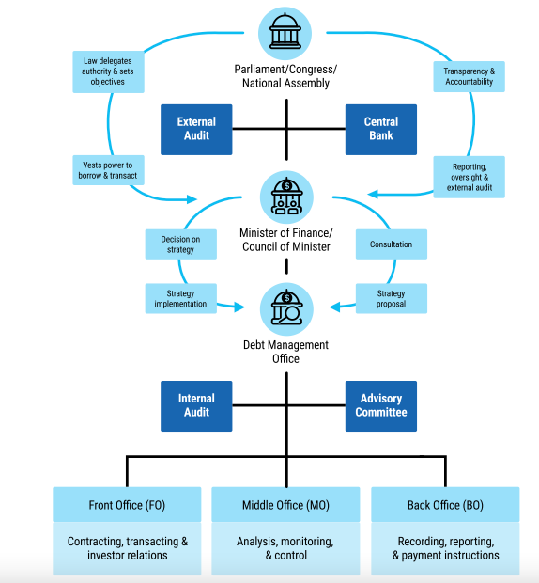

SOVEREIGN DEBT AUDIT
If public borrowing is not effectively managed, there are serious hazards involved. Supreme Audit Institutions (SAIs) can prevent unsustainable levels of national debt and greatly enhance sovereign debt management. To ensure stability, regular audits of sovereign debt's finances and performance (value for money) are crucial.

CHAPTER 7: EXTERNAL RESOURCES: BETTER MONEY, RATHER THAN JUST MORE MONEY

The lack of adequate public and private foreign finance is not unique to Africa. Low domestic savings rates exacerbate its predicament, but the continent continues to suffer at the hands of an international financial system that is still grounded in the past rather than the present. It is not inaccurate to say that this type of finance is still descending from Western capitals and giving the Global North's financial requirements priority before reaching the Global South's lower reaches. As a result of the economic circumstances in the North, the Global South has been forced to learn to make do with what is left, which is never enough and especially too little when the tap is tightened.

With alternative money flows, new competitors—led by China but also comprising the Gulf States, Turkey, and others—are upending this long-standing monopoly. However, excessive governmental spending leaves behind remnants of a nearly imperial mentality. Its ideology is still partially based on an aid model that sounds more like charity than investment. Credit risk agencies have emerged as the system's new scrooges on the private side, discouraging investment flows by threatening sovereign downgrades and making it as simple as football referees to eject players with their red cards.

As a result, debt relief and new flows have been repressed. The world is far from meeting the Sustainable Development Goals or ensuring the shift to a new green energy economy, which is vital for our shared future, because the public officials and private investors involved are not blind to these issues, but rather are mired in historical assumptions and historical data about volume and risk. Our needs are enormous, but our financial tools are pygmies. Our financial system needs to be drastically reorganized at this turning point in order to serve as a springboard for a huge increase in ambition.

The bad news is that the globe is at a crossroads, with conflict dividing Europe and the Middle East, and international trade and investment issues taking on a more protectionist, nationalistic bent.
A polycrisis that combines political, social, security, and economic crises is engulfing us.
The good news is that these tensions have not affected the UNFCCC or the Bretton Woods Institutions as much as they have affected the Security or Human Rights Councils. Additionally, each has astute and aspirational leaders who understand that although these organizations lack the direct financial influence that the IMF and World Bank, at the very least, once possessed, they can serve as the hub of financial and policy networks that can advance global enlightenment.

Eight decades have passed since the New Hampshire conference that gave rise to the Bretton Woods Institutions. They are therefore feeling more introspective and ambitious. A global economy built on a 21st-century vision of green, inclusive growth for all might be revived by using this straw, which some may believe is like grabbing at straws as people drown. A vision that enables us to address the distorting disparities that are dividing societies and the world while also allowing us to live within our planetary means.

We won't begin to confront the challenges to our shared future until public and private finance flows are in line and supported by coordinated international public policy. We have waited too long for political leaders to take action, but it appears that the crises that are crashing at their own doors have rendered them intellectually bankrupt. Remarkably minded economists and policy heavyweights John Maynard Keynes and Harry Dexter White came up with the idea for the original Bretton Woods Institutions, which, despite their mixed history since then, were pillars of the post-World War II recovery and intended to avoid the mistakes of the First World War. Keynes had completely changed the way public spending was done, permitting deficits when they led to growth. Politicians followed the ideas that escaped from his pen. Today, we require a comparable source of motivation.

ODA TO AFRICA: AROUND 10% OF THE CONTINENT’S TOTAL FINANCIAL RESOURCES
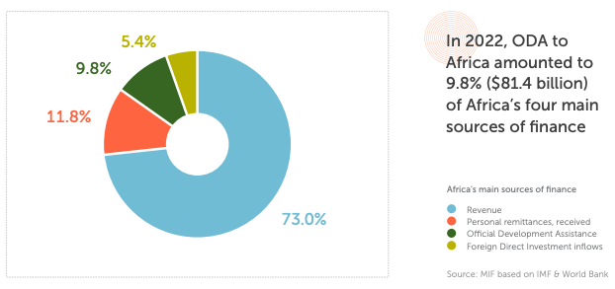

The primary metric used in almost all aid targets and performance evaluations is official development assistance, or ODA. The majority of ODA flows go to multilateral organisations and nations and territories listed as ODA recipients by the Development Assistance Committee (DAC). State and municipal governments are among the official agencies that supply the transactions. All of them are concessional in nature (grants and soft loans) and are handled with the primary goal of advancing the economic development and welfare of developing nations. Based on per capita income, the DAC list of nations eligible for ODA is updated every three years. The combined total of Africa's four primary funding sources in 2022 was $829.7 billion.

To help implement the UN's Agenda 2030 for Sustainable Development—which includes inclusive and sustainable economic development, the advancement of equality within and among nations, the eradication of poverty, the improvement of living standards in developing nations, and a future in which no country will rely on aid—DAC donors' overarching goal is to promote development cooperation and other pertinent policies. In order to increase the amount and efficacy of official resource transfers to poor nations, the DAC gathers and evaluates development statistics and offers a platform for the world's leading bilateral aid donors to convene and discuss aid policy. The European Union, Estonia, Finland, France, Germany, Greece, Hungary, Iceland, Ireland, Italy, Japan, South Korea, Lithuania, Luxembourg, the Netherlands, New Zealand, Norway, Poland, Portugal, Slovak Republic, Slovenia, Spain, Sweden, Switzerland, the United Kingdom, and the United States are among the 32 members of the DAC.

Non-DAC donors are nations that are not members of the OECD's DAC. They are sometimes called "new," "emerging," "nontraditional," "non-Western," or "non-DAC," although these terms oversimplify a very complicated and varied group. Many of these nations saw themselves as development partners that promote South-South collaboration rather than as "donors."

Non-DAC donors come in a variety of forms: nations that have previously received aid (like Malta), are currently receiving aid (like Nigeria), respond to disasters at home (like India), host an increasing number of refugees (like Turkey), have been supporting international development programs and systems for several decades (like the United Arab Emirates), and some have been doing so for longer periods of time and with larger aid budgets than some DAC donors. A UN goal of allocating 0.7% of national output to charity was accepted by the majority of donor nations in 1970. A UN goal of allocating 0.7% of national output to charity was accepted by the majority of donor nations in 1970.

Most donors are far from the 0.7% of national income to the aid target

A United Nations (UN) goal of allocating 0.7% of gross national income to aid (ODA/GNI) was accepted by the majority of nations in 1970. The nations of the European Union (EU) reaffirmed their commitment to this goal in 2005 and again in 2015. Despite this, only a small number of nations have since attained and sustained 0.7%. Only four DAC donors—Luxuria (1%), Sweden (0.89%), Norway (0.86%), and Germany (0.85%)—spent more than 0.7% of their national revenue on aid in 2022. Only four DAC nations—Luxuria, Sweden, Norway, and Germany—met or surpassed the UN target of 0.7% ODA/GNI in 2022.

Africa received over 28% of global ODA in 2022
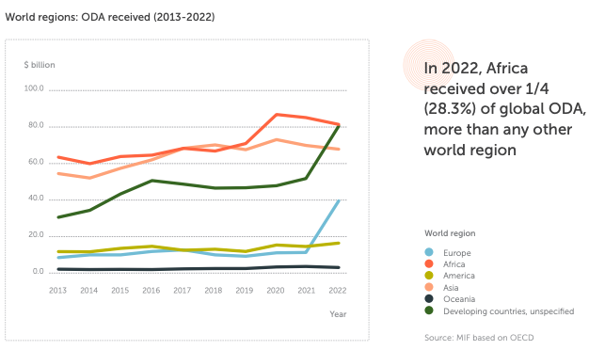
Africa got more ODA than any other region in the globe between 2013 and 2022, with the exception of 2018. However, from $86.4 billion in 2020 to $81.4 billion in 2022, Africa's overall ODA receipts decreased. Europe was the only continent in the world to have an increase in ODA in 2022, going from $11.3 billion in 2021 to $38.8 billion in 2022—more than tripling in just one year—due to the effects of the Russia-Ukraine conflict. In 2022, the amount of ODA given to "Developing countries, unspecified" was nearly equal to the amount given to Africa ($79.7 billion and $81.4 billion, respectively). Due to the Russia-Ukraine crisis, ODA to Africa decreased from 36.0% of worldwide ODA in 2021 to 28.3% in 2022, while ODA to Europe increased during the same time period.
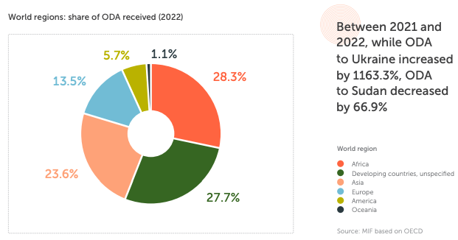

10 countries capture nearly 50% of total ODA to the continent
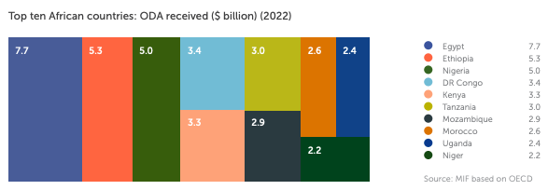

Top 10 ODA recipients in Africa (2022)
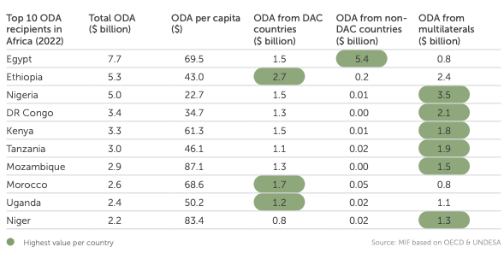
Egypt got $7.7 billion in ODA in 2022, more than any other African nation, with non-DAC nations accounting for 70.2% of that total.
• With $5.3 billion, Ethiopia received the second-largest sum of ODA in Africa, with DAC nations accounting for more than half of this total.
• With $5.0 billion, Nigeria got the third-highest amount of ODA of any African nation, with multilaterals accounting for 69.9% of the total.

10 African countries, hosting over 70% of the continent’s population, received nearly half (46.4%) of total ODA to the continent in 2022. Global net financial transfers to developing countries (including new lending and ODA) will fall by over $100 billion in the next two years. Nearly half (46.4%) of all ODA to the continent in 2022 went to 10 African nations, which are home to more than 70% of the continent's population. Over the next two years, there will be a decline of more than $100 billion in net financial transfers to developing nations, including new lending and ODA.

African countries have the highest net ODA received as a share of central government expenditure.

Top 10 ODA recipients in Africa in per capita terms (2022)
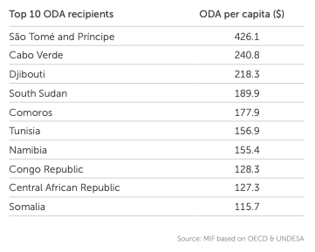
Still leading, DAC countries and multilaterals slowly decrease support to Africa, while non-DAC countries steadily increase, making it a priority

Africa: ODA received by donor type (2013-2022)
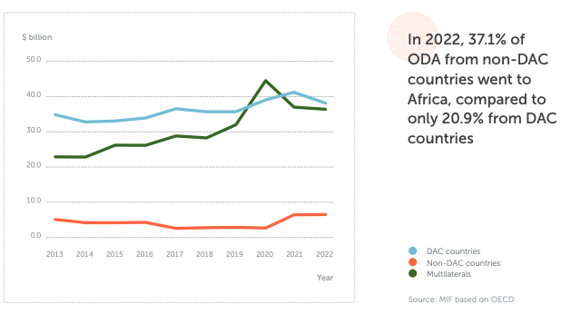
ODA to Africa from DAC nations decreased by -7.3% between 2020 and 2022, whilst ODA from non-DAC nations increased by +136.3%.
$38.3 billion in ODA was given to Africa in 2022 by DAC nations, $36.5 billion by multilaterals, and $6.6 billion by non-DAC nations.
• Africa received 20.9% ($38.3 billion) of the world's ODA from DAC nations.
• Multilaterals gave Africa 42.4% ($36.5 billion) of the world's ODA.
• Africa received 37.1% ($6.6 billion) of the world's ODA from non-DAC nations.
Between 2013 and 2022:
• Multilaterals' overall ODA to Africa increased from $23.0 billion to $36.5 billion (+58.8%).
• Africa's overall ODA from non-DAC nations increased from $5.2 billion to $6.6 billion (+25.4%).
• Africa's overall ODA from DAC nations increased from $35.0 billion to $38.3 billion (+9.5%).
Over recent years (since 2020):
• Africa's overall ODA from non-DAC nations increased by 136.3% from $2.8 billion in 2020 to $6.6 billion in 2022.
• Between 2021 and 2022, Africa's overall ODA from DAC nations decreased from $41.3 billion to $38.3 billion (-7.3%).
• Between 2020 and 2022, Africa's overall ODA from multilaterals decreased by 18.2%, from $44.6 billion to $36.5 billion.
• However, it is necessary to include a prior augmentation brought on by the start of COVID-19 when evaluating the decreases in ODA from both DAC nations and multilaterals.
In 2022:
• DAC countries accounted for 47.1% of Africa's total ODA (up from 55.3% in 2013).
• Multilaterals accounted for 44.8% of Africa's overall ODA, up from 36.3% in 2013.
• Non-DAC nations accounted for 8.1% of Africa's total ODA (up from 8.3% in 2013).

African nations are the top recipients of net ODA as a percentage of central government spending worldwide, according to the World Bank: In Somalia, the percentage was 16572524.6% in 2020; in the Central African Republic, it was 222.4% in 2021; in Rwanda, it was 74.2% in 2020; in Madagascar, it was 68.3% in 2021; in Mali, it was 61.8% in 2020; in Mozambique, it was 59.8% in 2021; in Ethiopia, it was 58.6% in 2020; and in Malawi, it was 54.3% in 2021. Africa's top three recipients of ODA per capita in 2022 were São Tomé and Príncipe ($426.1), Cabo Verde ($240.8), and Djibouti ($218.0).

Of the top 10 ODA donors to Africa in 2022:
• The World Bank Group ($17.1 billion), EU Institutions ($7.0 billion), Global Fund ($4.1 billion), and United Nations ($3.0 billion) were the four multilateral organizations.
• Japan ($2.8 billion), Canada ($1.8 billion), France ($5.9 billion), Germany ($6.3 billion), and the United States ($12.4 billion) were the five DAC nations.
• Saudi Arabia ($5.5 billion) was one of the non-DAC nations.
With $17.1 billion, or 21.0% of all ODA received by Africa in 2022, the World Bank Group was the continent's largest ODA donor. The United States was the biggest donor to Africa in 2022, contributing $12.4 billion, or 15.2% of the continent's total ODA. Saudi Arabia, a non-DAC member, is one of the top 10 contributors to Africa in 2022, contributing $5.5 billion, or 6.8%, of all ODA received by the continent.

Top 10 ODA donors to Africa (2022)
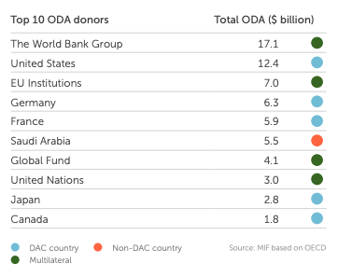

China’s ODA
Chinese President Xi Jinping launched a new Global Development Initiative (GDI) at the 2021 UN General Assembly (UNGA) meeting. Its goals include addressing the needs of COVID-19-affected nations, preparing for climate change, and expediting the implementation of the UN's Agenda 2030. The Global Development and South-South Cooperation Fund will be upgraded and restocked to $4 billion as part of the 32 measures in the GDI that aim to promote global development and close the North-South divide.

Korea’s ODA
Of the 48 African nations that attended the first Korea-Africa Summit in Seoul from June 4–5, 2024, 25 heads of state and government were present. In order to spur projects for collaboration with Africa, the Republic of Korea declared at the event that it will expand its official development assistance (ODA) to $10 billion by 2030. By 2030, it also plans to provide 14 billion US dollars in export finance to Korean businesses to support their operations on the continent and promote investment and trade with Africa. Critical minerals were a major topic of discussion at the summit, and leaders from South Korea and Africa decided to start a "critical minerals dialogue." The Republic of Korea pledged $10 billion in ODA to Africa by 2030 at the first Korea-Africa Summit, which took place in Seoul from June 4–5, 2024.

Top 10 global ODA recipients by donor type
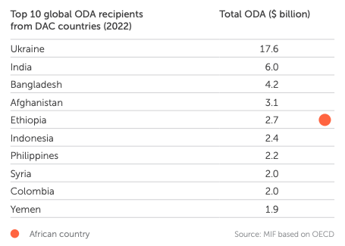
Ethiopia was the only African nation to receive ODA from DAC nations in 2022, ranking sixth internationally with a total of $2.7 billion. Of all African nations, Nigeria received the highest ODA from multilaterals in 2022 ($3.5 billion, ranking second globally), followed by Ethiopia ($2.4 billion, ranking fifth globally) and the Democratic Republic of the Congo ($2.1 billion, ranking sixth globally).
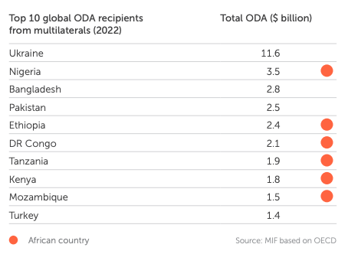

More than 80% of ODA transfers to Africa from non-DAC nations went to Egypt in 2022 ($5.4 billion, the second-largest beneficiary globally), closely followed by Ethiopia ($0.2 billion, the sixth-largest recipient globally).
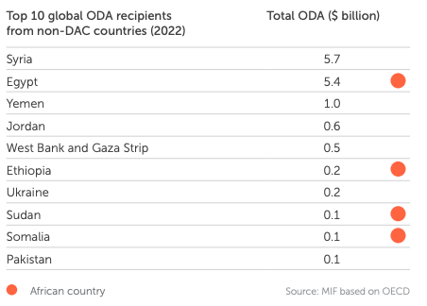
In 2022:
• Only Ethiopia ($2.7 billion) was an African nation among the top 10 recipients of ODA from DAC nations worldwide.
• Nigeria ($3.5 billion), Ethiopia ($2.4 billion), DR Congo ($2.1 billion), Tanzania ($1.9 billion), Kenya ($1.8 billion), and Mozambique ($1.5 billion) were the six African countries that received the most ODA from multilaterals worldwide.
• Four African nations—Egypt ($5.4 billion), Ethiopia ($0.2 billion), Sudan ($0.1 billion), and Somalia ($0.1 billion)—were among the top 10 receivers of ODA worldwide from non-DAC nations.

Is ODA money getting lost?
Dormant ODA funds: Many countries find it difficult to effectively absorb ODA assistance because of a range of administrative and political problems with project management. According to estimates, depending on the recipient country, between 10% and 70% of ODA—more especially, project financing—is not utilized.

When it comes to loans, beneficiaries suffer with the underutilization of the financial resources allotted, while donors find their money trapped up with no return. An estimated $13.3 trillion is the total amount of unpaid aid and funding for climate action to developing nations from the G7.

Undistributed and mislabeled aid: In 2022, the OECD reported that ODA donor countries actually retained 14.4% of aid, totaling more than $193 billion, that was supposed to be distributed but was not, and that approximately $30 billion was returned to donor countries' accounts as a result of mislabeling aid. Underutilization of ODA monies by partner nations is a significant issue that is frequently disregarded, despite the difficulty in locating trustworthy sources on the topic.

For instance, underspending in Tunisia is close to 50%. A World Bank project currently takes an average of 27 months before any money is released. A protracted implementation phase and project construction come next. Too frequently, it takes more than ten years before the initial advantages become apparent. That's a lifetime. We need to perform better. Additionally, we have valuable time to spare.

Health and education remain the main priorities of ODA to Africa from official donors
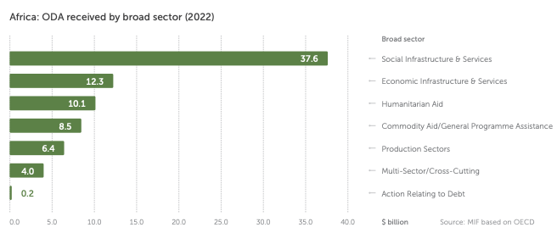

Africa's top ODA recipient in 2022 was Social Infrastructure & Services ($37.6 billion), followed by Economic Infrastructure & Services ($12.3 billion) and Humanitarian Aid ($10.1 billion).

ODA broad sector definition
Social Infrastructure & Services: Education, Health, Population Policies/Programmes & Reproductive Health, Water Supply & Sanitation, Government & Civil Society and Other Social Infrastructure & Services.
Economic Infrastructure & Services: Transport & Storage, Communications, Energy, Banking & Financial Services and Business & Other Services.
Production Sectors: Agriculture, Forestry & Fishing, Industry, Mining & Construction, Trade Policies & Regulations and MultiSector/Crosscutting.
Commodity Aid/General Programme Assistance: General Budget Support, Development Food Assistance and Other Commodity Assistance.
Action Relating to Debt: Action Relating to Debt, Debt Forgiveness, Relief of Multilateral Debt, Rescheduling & Refinancing, Debt for Development Swap, Other Debt Swap and Debt Buy-Back.
Humanitarian aid includes disaster prevention and preparedness, emergency response, and reconstruction relief and rehabilitation.

CLIMATE FINANCE SPOTLIGHT:
Climate finance for Africa, which averages $29.5 billion annually, is 11% less than what is needed. Despite spending an estimated $277 billion annually to accomplish its climate commitments, Africa's climate financing supply averages $29.5 billion annually (10.6% of demands).
• In 2022, Africa had access to $29.5 billion in climate funds.
• Multilateral development finance institutions (DFIs) contributed the most ($11.6 billion), followed by government ($6.4 billion) and bilateral DFI ($5.3 billion) flows.
• The private sector made a 14.1% contribution of $4.2 billion.
• Of the $14.5 billion allocated to mitigation programs, $11.3 billion (38.5% and 49.4%, respectively) went to adaptation. The remaining amount was split between diverse (10.8%) and undetermined (1.2%) objectives.

Africa: supply of climate finance (annual average for 2019-2020)
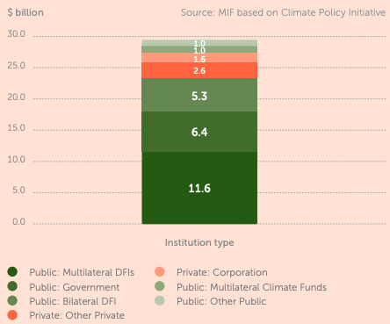

Significant climate funds supporting sub-Saharan Africa
- The combined amount of $8.8 billion allocated to climate action in sub-Saharan Africa by 25 distinct climate funds as of 2022.
As of 2022, the Green Climate Fund (GCF), created by the United Nations Framework Convention on Climate Change (UNFCCC) to support adaptation and mitigation projects in developing nations, was the largest fund operating in sub-Saharan Africa.
- The following three most significant funds are the Least Developed Countries Fund (LDCF), which was established following COP7 in 2001, the Clean Technology Fund (CTF), and the Central African Forest Initiative (CAFI).
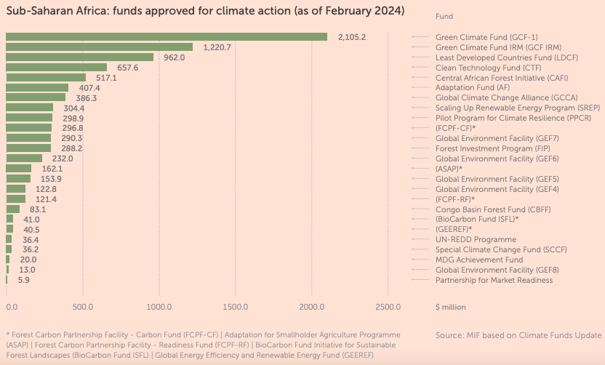
According to the Climate Policy Initiative (CPI), Africa needs $277 billion annually to implement its Nationally Determined Contributions (NDCs) and meet 2030 climate goals. The amount of climate finance for Africa accounted for less than 11% of annual needs on average in 2019 and 2020. According to the Overseas Development Institute (ODI), only seven countries provided their "fair share" of climate finance in 2020, based on the $100 billion commitment, historic emissions, GNI and population: Sweden, France, Norway, Japan, the Netherlands, Germany and Denmark. According to ONE, in 2023, 49% of the climate finance committed by bilateral providers between 2013 and 2021 was reported as disbursed or was meaningfully related to climate.

Conclusion
Debt Chains: Breaking Free from Africa's Financial Struggles, Chapter 7, addresses a key topic in the discussion of African development: Is a shortage of funding the only issue facing the continent, or are the structure and quality of outside resources more critical? The chapter makes the case that although Africa undoubtedly needs resources to combat poverty, construct infrastructure, and handle emergencies, the actual difficulty lies not just in obtaining more funding from outside sources but also in making sure that these resources are equitable, just, and genuinely beneficial to African development. Alternatively, "better money" is more significant than "just more money."
The chapter starts by refuting the widely held belief that corruption and poor management are the only causes of Africa's debt crisis, or that it is a technical or financial problem. Instead, it presents debt as an instrument of power, one that rich nations, organisations, and businesses have historically and still do today in order to siphon off riches from Africa and keep control of its future.

Historical examples demonstrate this idea. In the early 1900s, France used debt as a pretext to occupy Morocco, while Thomas Jefferson once proposed using debt to compel Native Americans to cede their territory. Massive debts were imposed on newly independent nations in Africa by colonial powers. For example, Haiti was obligated to pay France $150 million for its freedom, and Zimbabwe inherited $700 million from Rhodesia. These debts were intentional measures to maintain the dependence and control of former colonies, not merely financial obligations.

The chapter highlights that the current international financial system remains structured in a colonial manner. In organisations such as the IMF, the World Bank, and the G20, wealthy nations make most of the decisions, while African perspectives are frequently ignored. Investments, aid, and debt are usually set up to benefit donors and lenders rather than the African populace. As a result, a large share of the billions of dollars that Africa receives in loans and aid flows back out as capital flight, profits, and debt repayments.

One of the main takeaways from Chapter 7 is that development is not always the result of merely increasing the flow of outside resources, such as loans, aid, or investment. In fact, poorly designed or exploitative financial arrangements may cause more harm than good. The chapter discusses the experience of the World Bank and IMF-imposed structural adjustment programs in the 1980s and 1990s. African governments were compelled by these policies to privatise state-owned enterprises, reduce public spending, and allow foreign competition in their economies. Despite being designed to foster stability and progress, the actual results were frequently disastrous: social protections were undermined, unemployment skyrocketed, and poverty increased. Austerity policies that reduced funding for social, health, and educational services particularly affected women and young people.

When help and investment are poorly planned, the same issues occur. The influence of foreign aid on local economies might be limited when it is linked to the purchase of goods and services from donor nations. In other instances, rather than establishing local enterprises or good jobs, investment is concentrated on resource extraction or making money off of African markets. The chapter argues that these trends point to a more serious issue: that outside resources are frequently created to benefit foreigners rather than Africans.

The CFA franc monetary zone, which links 12 former French colonies to the French treasury, is among the most notable examples covered in the chapter. Member nations have little control over their own finances under this system since they are required to maintain up to 70% of their foreign reserves in France. Europe, particularly France, benefits from the fixed exchange rate and capital outflows, while African nations' capacity to respond to crises and invest in development is limited. The chapter demonstrates that the CFA franc system is a living illustration of how external financial agreements can jeopardise African development and sovereignty, rather than merely a holdover from the past. The approach restricts policy options and wastes resources rather than enabling African nations to make their own economic decisions.

The chapter emphasises how unmanageable debt and inadequately managed external resources have a significant negative human impact. Several African nations spend more on debt repayment than on infrastructure, education, or health care. Ordinary people bear the cost: essential services are not provided, schools lack adequate funding, and hospitals lack medication. Women, children, and the impoverished bear the brunt of the load.
Social discontent, hunger, and unemployment have increased due to austerity measures and debt repayment. Young people are frequently compelled to look for work overseas, sometimes risking exploitation and danger, because they are dissatisfied with the limited options available to them. The chapter argues that these results are expected and not coincidental, stemming from a system that puts the needs and rights of Africans last and gives preference to creditors and investors.

What does "better money" actually mean, then? The chapter presents several ideas for changing how outside funding is given to Africa:
1. Fairness and Justice: Instead of being designed to preserve reliance or extract riches, external resources should be arranged to promote African development. This entails offering African nations a genuine role in international financial institutions, guaranteeing equitable credit terms, and eliminating repugnant and colonial-era debts.

- Transparency and Accountability: Clear terms and conditions should be included in loan, aid, and investment agreements so that the public can examine them. African citizens must decide the utilisation of resources and the beneficiaries.
- Focus on Human Rights and Social Development: Instead of either fostering economic growth or catering to foreign interests, external resources should place a higher priority on investments in social protection, health care, and education.
- Support for Local Economies and Value Addition: Instead of merely extracting raw materials or functioning as new marketplaces for imported commodities, aid and investment should support the development of indigenous industries, the creation of excellent jobs, and the strengthening of African economies from within.
- Sovereignty and Self-Determination: The autonomy to determine their own development goals and make economic choices that represent the needs and ambitions of their citizens is essential for African nations.

Book Conclusion: Towards a New Global System
In its conclusion, Chapter 7 urges a fundamental change in how the world views Africa's development and outside resources. The chapter calls for solidarity with African efforts for justice and self-determination rather than depending on the same colonial and neo-colonial institutions and decision-makers. It demands a new global economic structure that puts the welfare of people and the environment ahead of the interests of businesses and creditors.

The chapter's main takeaway is that Africa needs better money, not just more money from outside sources. Africa can only escape the bonds of debt and create a future that really benefits its people by changing the institutions and ideologies that control external resources.

Summary: Africa has the Capital it needs
Based on recent experience, nations must maintain an investment rate of 30% of GDP for at least 20 years to achieve economic takeoff. Africa's national savings rate is 20%, and its investment rate is 22%. When applied to Africa's $3 trillion GDP, the 30% investment criterion compared to the 20% saving rate results in a financing shortfall of 10% of GDP, or $300 billion annually.

Climate finance estimates, which are still quite uncertain, appear to agree on the need for $250 billion to $300 billion a per year, or an additional 8 to 10% of GDP. There will inevitably be some overlap, such as in the energy sector, where the two investment requirements are not additive. Even so, these general guidelines still point to a funding shortfall of almost 15% of GDP, or $450 billion annually. This is not a significant sum of money in terms of global capital available. Of the $120 trillion in assets under management (AUM) held by international institutional investors, it represents only around 0.4%. Seven years of the baseline investment needs equals a GDP-proportionate share, or $3.2 trillion. African nations have issued more than $160 billion in sovereign bonds since they first entered the markets in 2007. In what may have been the most challenging market conditions since Africa's introduction into the bond markets, three nations—Cote d'Ivoire, Kenya, and Benin—raised $4.85 billion.

Clearly, the issue is not one of money. What is it? Macroeconomic stability and the public debt's ability to be carried are two factors. Both refer to a solvency constraint. The savings-investment disparity is still far too broad. The savings-investment gap is equivalent to the current account balance in economic accounting. It is just not financially feasible to maintain a current account deficit of 15% of GDP over time. The amount of the investment gap that may be sustainably financed externally is limited by macroeconomic stability and debt sustainability, possibly not exceeding 5% of GDP. This implies that at least half of the financing shortfall must be covered by domestic savings. In both theory and reality, the question of what public policy may do to increase domestic saving is not simple. Approaching the topic by breaking it down into three parts—household, business, and public savings—is beneficial.

The main structural factors that affect household saving are income and demographic changes, both of which change gradually. Nevertheless, one area where public policy can help mobilise household savings is the establishment of pension plans. With just 10% of the population covered by pensions, Africa has an extremely low pension coverage rate, mainly due to the country's informal sector on the one hand and its payroll deduction-based pension plan structure on the other.

In the face of rising urbanisation and the resulting deterioration of traditional kinship-based systems of old-age security, it is imperative to develop a pension plan model that is effective for Africa's largely non-payrolled workforce, both to mobilise savings and to avert widespread old-age poverty.

Conclusion:
Africa's debt dilemma is a centuries-old story shaped by the aspirations of empires, the hardships of nations, and the everyday lives of millions of people. It is not only an economic or financial issue. We must examine the lengthy historical trajectory—from the time of the slave trade and colonial conquest to the present, when global financial systems continue to reflect historical inequalities—to comprehend why so many African nations are currently beset by debt.

Numbers like Africa's external debt exceeding $700 billion or the fact that in certain nations, more than 20% of government revenue is used solely for loan repayment are frequently the focus of the news. However, these figures represent actual individuals—young people compelled to travel in pursuit of opportunity, families unable to pay for healthcare, and pupils whose schools lack resources. How Africa got here, what keeps it there, and what needs to happen for the continent to break free will all be covered in this conclusion.

Africa's colonial past is inextricably linked to its economic history. European powers ignored local realities and established borders that divided ethnic groups when they partitioned the continent in the late 19th century. "We have been engaged in drawing lines upon maps where no white man's feet have ever trodden; we have been giving mountains and rivers and lakes to each other, only hindered by the small impediment that we never knew exactly where the mountains, rivers, and lakes were," as British Prime Minister Lord Salisbury famously remarked. These fabricated borders have contributed to underdevelopment and warfare, with long-lasting consequences.

Colonial rulers reshaped African economies to suit European objectives. They built roads and railroads only to transport goods to ports for export, extracting minerals, crops, and other resources. The intention was always to enrich Europe, not to develop Africa for Africans. The majority of African nations consequently became reliant on a small number of exports, leaving them open to price fluctuations and external shocks.

Debt as a Tool of Control
Power over African nations has traditionally been maintained through debt. Many countries incurred debt from colonial rulers after gaining independence. For instance, only for the "crime" of gaining its independence, Haiti was forced to pay France 150 million francs —an amount so large that it took 122 years to repay. While South Africa and its neighbours were burdened with £28 billion in obligations associated with apartheid and the region's instability, Zimbabwe inherited $700 million from the Rhodesian government. Another illustration of continuous financial supervision is the CFA franc monetary zone. Up to 70% of the foreign deposits of twelve former French colonies must remain in the French treasury. This system was designed to benefit France and has limited the economic independence and the growth of member states.

The Lasting Impact of the Slave Trades
African societies suffered greatly as a result of the slave trade, both within and across the Atlantic. Millions more were enslaved in the trans-Saharan, East African, and Red Sea trades, while over 12 million Africans were transported to the Americas. The severity of the slave trade and the current economic well-being are strongly negatively correlated, according to research. The deep wounds of population decline, distrust, and inadequate educational funding still hamper Africa's development.

The Post-Independence Era: Hope, Betrayal, and New Chains
There was hope for a fresh start when Africa experienced a wave of independence in the middle of the 20th century. Leaders like Kwame Nkrumah in Ghana and Julius Nyerere in Tanzania envisioned creating contemporary, thriving countries. In an effort to bring their people together and overcome the effects of colonialism, they adopted concepts of nation-building and pan-Africanism.
But the realities of the world economy quickly emerged. The prices of these items were fixed in far-off markets, and African nations continued to rely on exporting raw materials. Government revenues decreased in tandem with pricing declines. In an effort to industrialise and raise living conditions, several leaders took out large loans to fund development projects.

The Cold War and the Rise of Debt
Both Soviet and Western nations fought for influence in Africa throughout the Cold War. They provided aid and loans to friendly governments, often with little thought about how the funds would be used. A portion of these loans was given to autocratic or corrupt governments, who utilised the money to stifle dissent or benefit themselves. New governments were left to pick up the pieces when these regimes fell because their debts remained.
There was a global debt crisis in the 1980s. African nations found it far more costly to repay their debts when interest rates in the US and Europe skyrocketed. The decline of commodity prices at the same time reduced government revenue. The debt crisis worsened as many nations were unable to make their payments.

Structural Adjustment and Its Consequences
International organisations such as the World Bank and the International Monetary Fund (IMF) intervened in response. They provided debt relief and additional loans, but only if nations agreed to put "structural adjustment programs" into place. These initiatives forced governments to open their economies to international competition, privatise state-owned businesses, and reduce spending.
Restoring economic stability was the aim, but the reality was frequently disastrous. Spending on social services, education, and health was drastically reduced. As state businesses were shut down or sold off, jobs were lost. Inequality and poverty increased, and many nations' reliance on foreign loans and aid increased. The strategies of the IMF and World Bank have drawn significant criticism for imposing a model that did not suit local realities and for failing to address the underlying causes of Africa's debt problems.

The Human Cost of Debt: Debt and Human Rights
Human rights are significantly affected by unsustainable levels of debt. Ordinary citizens suffer when governments spend more on debt repayment than on necessary services. Families struggle to pay for food and housing, schools lack teachers and books, and hospitals lack medication. Women, children, and the impoverished bear the brunt of the load.
Social discontent, poverty, and unemployment have increased due to austerity policies. Opportunities are scarce, especially for young people. Many are compelled to migrate in pursuit of employment, risking exploitation and harm in the process. Africa's ability to participate fairly in the global economy is restricted, and dependency is maintained through the ongoing use of debt as an extraction weapon.

Human rights and democracy are also threatened by debt. Governments may overlook the needs of their own people when they are preoccupied with satisfying the expectations of their creditors. Austerity measures can worsen societal discontent and undermine the credibility of government institutions. Debt has occasionally been used as a weapon to pressure governments into implementing policies preferred by companies or foreign powers over those selected by their own citizens.

4. The Scale and Structure of Africa's Debt
Africa has more than $700 billion in external debt as of right now. In many nations, more than 20% of government income goes toward debt servicing —the annual payments made to creditors. This implies that a large percentage of every dollar collected by the government is immediately used to settle outstanding debts, leaving less money for infrastructure and human capital development.
Not everyone bears the weight equally. Due to their requirement to maintain sizable amounts of their foreign reserves in the French treasury, several nations—particularly those in the CFA franc zone—face additional restrictions. This restricts their capacity to invest in development or respond to emergencies. Additionally, the composition of Africa's debt has evolved. Historically, governments and international organisations provided the majority of loans. These days, private lenders and bond markets account for an increasing portion, frequently at higher borrowing rates and with less transparency. When issues emerge, negotiating debt reduction or restructuring becomes more difficult.

Case Studies: Zimbabwe and South Africa
Zimbabwe's experience is a potent illustration of how past debts can shape a nation's future. Zimbabwe inherited a $700 million debt from the colonial government upon becoming an independent nation in 1980. Due to its short duration and high interest rate, this loan placed a significant burden on repayment during the early years of independence. The nation found it difficult to pay its debts to creditors and make growth investments. The debts from South Africa's apartheid era also loom large. Neighbouring states borrowed £17 billion to address the destabilisation and aggressiveness brought on by apartheid, while the nation borrowed £11 billion to uphold the regime. The region's capacity to invest in development and meet its citizens' needs is still constrained by these debts.

The Global Dimension: Debt as a Tool of Power: Debt and Global Inequality
The debt crisis in Africa is a worldwide one, not just an African one. The interests of powerful nations and businesses shape the frameworks and regulations that govern global finance. Wealth can go from the poorest to the wealthiest nations through the use of debt as an extraction tool. Debt payments deplete billions of dollars annually, even as Africa needs resources to address pressing issues such as health, education, and climate change.

Discussions concerning Africa's debt are dominated by narratives that frequently accuse African countries of corruption or poor management. Even though these problems exist, they are not the whole picture. It is also necessary to acknowledge the roles of colonialism, international institutions' policies, and global economic systems. Debt is about power—who has it, how they use it, and who gains from the status quo. It is not merely a technological problem.

The Role of International Institutions
Africa's debt situation has been significantly shaped by international organisations such as the World Bank and the IMF. The historical background of African economies and local realities have been occasionally overlooked by policies that were frequently created in Washington or Paris. In particular, structural adjustment plans have come under fire for enforcing privatisation and austerity without tackling the underlying causes of underdevelopment.
In addition, these organisations have been crucial in times of crisis, as demonstrated by the Debt Service Suspension Initiative during the COVID-19 pandemic. To build a more equitable and efficient global financial system, however, much more work must be done.

6. The Struggle for Change: Resistance and Hope: Civil Society and the Demand for Justice
People are organising and calling for change throughout Africa. Activists, civil society organisations, and regular people are demanding a new approach to development, transparency, and debt justice. Some governments are attempting to renegotiate terms and are retaliating against unjust loans. The idea that Africans, not foreign institutions or creditors, should determine the continent's future is increasingly accepted.
Debt cancellation, fair trade, and economic justice movements are becoming increasingly powerful. These movements are about dignity, autonomy, and the freedom to choose one's own destiny; they are not just about money. Together, African nations and their allies can overthrow the systems that trap them in debt and create a fairer and just society.

International Solidarity and the Path Forward
The world community is starting to react as well. Debt relief has been attempted, particularly for the poorest nations. For instance, during the COVID-19 pandemic, the G20 provided short-term respite with the Debt Service Suspension Initiative. To address the root causes of the debt crisis and establish a more equitable global financial system, however, much more work must be done. The key is solidarity. Africa is confronted with worldwide issues, such as inequality, pandemics, and climate change. Together, we can create a future that is equitable, inclusive, and sustainable for everybody.

7. Lessons Learned and the Way Forward: A Holistic Approach to Debt
The necessity of comprehensive, people-centred solutions is one of the most important lessons to be learned from Africa's debt experience. The issue cannot be resolved solely by financial engineering or technical solutions. The way that debt is perceived and handled needs to change fundamentally.
First, it is essential to recognise the crisis's historical origins. This entails acknowledging the role of colonialism, unfair trade, and financial exploitation. It also entails dealing with the legacy of odious debts, loans made to autocratic or corrupt governments, often with the approval and cooperation of other nations.

Secondly, accountability and openness are critical. High expectations must be placed on both lenders and borrowers. Public disclosure of loans and citizen participation in the borrowing and spending of funds are both necessary. Governments must answer to their constituents, not only creditors, and corruption must be opposed head-on.
Third, it is essential to diversify the economy. Africa's growth cannot be financed by borrowing or a small number of exports. Building resilient economies that can withstand shocks and offer opportunities to everyone requires investments in human capital, technology, and industry.

Fourth, there must be reform of the global financial system. This entails granting African nations greater influence in international organisations, ensuring equitable loan terms, and establishing systems for prompt, efficient debt reduction. The planet's and people's interests must take precedence over creditors' financial gain.

A Call to Action
Africa's debt story is far from over. The decisions we make now will have a lasting impact on future generations, and the future is continuously being written. The debt crisis is a product of decisions, policies, and systems that can be altered, as this book has demonstrated.
Although it won't be simple, debt freedom is achievable. Honesty about the past, the guts to question the established quo, and a dedication to justice and unity will all be necessary. It will necessitate fresh perspectives on finance, development, and the function of institutions and governments.

Above all, it will need hope—the conviction that we can work together to create a better future. It is possible to break Africa's debt ties. Now is the moment to take action.

Reference List

Acemoglu, D, T Reed, and J A Robinson (2014), "Chiefs: Economic Development and Elite Control of Civil Society in Sierra Leone", Journal of Political Economy 122(2).
Akyeampong, E (2017), "African Socialism; or the Search for an Indigenous Model of Economic Development", AEHN Working Paper No. 36/2017.
Alesina, A., S Hohmann, S Michalopoulos and E Papaioannou (2021), "Intergenerational mobility in Africa", Econometrica 89(1).
Allen, T. and Dave Donaldson (2020), "Persistence and Path Dependence in the Spatial Economy".
Alsan, M (2015) "The Effect of the TseTse Fly on African Development", American Economic Review 105(1): 382-410.
Berger, D, W Easterly, N Nunn and S Satyanath (2013), "Commercial Imperialism? Political Influence and Trade during the Cold War", American Economic Review 103(2): 863-96.
Broadberry, S and L Gardner (2022), "Economic growth in Sub-Saharan Africa, 1885–2008: Evidence from eight countries", Explorations in Economic History 83: 101424.
Easterly, W (2008), "Can the West save Africa?", NBER Working Paper No. 14363.
Fenske, J (2012), "Ecology, trade and states in pre-colonial Africa", MPRA Paper No. 44754.
Fenske J (2013a), "Does Land Abundance Explain African Institutions?", The Economic Journal 123(573).
Fenske J (2013b), "African polygamy: Past and present", VoxEU.org, 9 November.
Fourie, J and N Obikili (2019), "Decolonising with data: The cliometric turn in African economic history", Working Papers 02/2019, Stellenbosch University, Department of Economics.
Frankema, E and M Van Waijenburg (2019), "The Great Convergence: Skill Accumulation and Mass Education in Africa and Asia, 1870-2010", CEPR Discussion Paper 14150.
Garcia-Ponce, O and L Wantchekon (2017), "Critical Junctures: Independence Movements and Democracy in Africa".
Garcia-Ponce, O and L Wantchekon (2018), "The Long-Term Effects of Colonial Repression in Madagascar".
Huillery, E (2009), "History Matters: The Long-Term Impact of Colonial Public Investments in French West Africa", American Economic Journal: Applied Economics 1(2): 176-215.
Jedwab, R, E Kerby and A Moradi (2015), "History, Path Dependence and Development: Evidence from Colonial Railways, Settlers and Cities in Kenya", The Economic Journal 127(603).
Lowes, S and E Montero (2020), "Concessions, Violence, and Indirect Rule: Evidence from the Congo Free State".
Lowes, S, N Nunn, J A Robinson and J L Weigel (2017), "The Evolution of Culture and Institutions: Evidence from the Kuba Kingdom", Econometrica 85(4): 1065-1091.
McGuirk, E F and N Nunn (2021), "Transhumant Pastoralism, Climate Change and Conflict in Africa".
Michalopoulos, S and E Papaioannou (2017a), "Spatial Patterns of Development: A Meso Approach", NBER Working Paper No. 24088.
Michalopoulos, S and E Papaioannou (2017b), The Long Economic and Political Shadow of History - Volume I. A Global View, CEPR Press.
Michalopoulos, S and E Papaioannou (2017c), The Long Economic and Political Shadow of History - Volume II. Africa and Asia, CEPR Press.
Michalopoulos, S and E Papaioannou (2017d), The Long Economic and Political Shadow of History - Volume III. Europe and the Americas, CEPR Press.
Michalopoulos, S and M. M. Xue (2021), "Folklore", The Quarterly Journal of Economics 136(4): 1993–2046.
Miguel, E (2011), "Tribe or Nation? Nation Building and Public Goods in Kenya versus Tanzania", World Politics 56(3).
Moscona, J and A. A Seck (2021), "Social Structure and Redistribution: Evidence from Age vs Kin Based Organisations".
Moscona J, N Nunn and J A Robinson (2020), "Segmentary Lineage Organisation and Conflict in Sub-Saharan Africa", Econometrica 88(5): 1999-2036.
Murphy, K M, A Shleifer, and R W Vishny (1989), "Industrialisation and the Big Push", Journal of Political Economy 97(5): 1003-1026.
Nunn, N (2008), "The long-term effects of Africa's slave trades", The Quarterly Journal of Economics 123(1): 139–176.
Nunn, N (2010), "Religious Conversion in Colonial Africa", American Economic Review: Papers & Proceedings 100: 147–152.
Nunn, N (2012), "Gender and Missionary Influence in Colonial Africa".
Nunn, N (2014), "Historical Development", in P Aghion and S Durlauf (eds), Handbook of Economic Growth, Vol. 2, North-Holland.
Nunn, N (2017), "Understanding the long-run effects of Africa's slave trades", VoxEU.org, 27 February.
Nunn N and N Qian (2014), "US Food Aid and Civil Conflict", American Economic Review 104(6): 1630-66.
Okoye, D. (2020), "Things Fall Apart? Missions, Institutions, and Interpersonal Trust".
Rodrik, D. (2021a), "Economics Has Another Diversity Problem", Project Syndicate, 9 August.
Rodrik, D. (2021b), "How Economists and Non-Economists Can Get Along", Project Syndicate, 9 March.
Wantchekon, L, M Klasnja and Natalija Novta (2014), "Education and Human Capital Externalities: Evidence from Colonial Benin".



